THE EFFECT OF REPLACING SOYBEAN MEAL WITH SWEET LUPINE (Lupinus angustifolius L.) GRAIN SUPPLEMENTATION ON THE PERFORMANCE OF WASHERA SHEEP FED NATURAL GRASS HAY BASAL DIET

M.Sc. THESIS

DAGNE WASSIE WORKINEH

MAY 2024
DEBRE MARKOS UNIVERSITY, ETHIOPIA

The Effect of Replacing Soybean Meal with Sweet Lupine (Lupinus angustifolius L.) Grain as Supplementation on the Performance of Washera Sheep Fed Natural Grass Hay Basal Diet

A Thesis submitted to the Department of Animal Sciences
College of Agriculture and Natural Resources
DEBRE MARKOS UNIVERSITY

In Partial Fulfilment of the Requirement for the Degree of MASTER OF SCIENCES IN ANIMAL PRODUCTION

Dagne Wassie Workineh

MAY 2024
DEBRE MARKOS UNIVERSITY, ETHIOPIA
DEBRE MARKOS UNIVERSITY
COLLEGE OF AGRICULTURE AND NATURAL RESOURCE

We hereby certify that we have read and evaluated this Thesis entitled “The Effect of Replacing Soybean Meal with Sweet Lupine (Lupinus angustifolius L.) Grain as Supplementation on the Performance of Washera Sheep Fed Natural Grass Hay Basal Diet” prepared under our guidance by Dagne Wassie Workineh. We recommend that it be submitted as fulfilling the Thesis requirement.

Almaz Ayenew (PhD)_____________ _______________
Major Advisor Signature Date

Workinshe Tiruneh (Assistant Prof.) ______________ ___________________
Co-Advisor Signature Date

As a member of the Board of Examiners of the MSc. Thesis opens Defense Examination, We certify that we have read and evaluated the thesis prepared by Dagne Wassie Workineh and examined the candidate. We recommended that the thesis be accepted as fulfilling the thesis requirement for the Degree of Master of Animal Science Specializing in Animal Production.
______________________ _______________ __________________
Chair Person Signature Date
_____________________ ______________ __________________
Internal Examiner Signature Date
______________________ _______________ __________________
External Examiner Signature Date

Final approval and acceptance of the Thesis is contingent upon the submission of its final copy to council of Graduate studies (CGS) through the candidate department or school Graduate (DGC or SGC).

DEDICATION

I dedicate this thesis manuscript to my beloved mother Emahoy Tiru Wubetu, to my beloved wife Fentanesh Alamiraw and my lovely daughters Betelihem and Mahilet Dagne.

STATEMENT OF THE AUTHOR

I declare that this thesis is my own work and that all sources of materials used for this thesis have been duly acknowledged. This thesis has been submitted in partial fulfilment of the requirements for MSc degree at Debre Markos University and is deposited at the University Library to be made available to borrowers under rules of the Library. I declare that this thesis is not submitted to any other institution anywhere for the award of any academic degree, diploma, or certificate. Brief quotations from this thesis are allowable without special permission, provided that accurate acknowledgement of source is made. Requests for permission for extended quotation from or reproduction of this manuscript in whole or in part may be granted by the Head of the Major Department or the Dean of the School of Graduate Studies when in his or her judgment the proposed use of the material is in the interests of scholarship. In all other instances, however, permission must be obtained from the author.

Name: Dagne Wassie Workineh Signature: _______________
Place: Debre Markos University,
Date of Submission: ____________________

BIOGRAPHICAL SKETCH

The author, Dagne Wassie, was born in Hullet Ejju Enessie Woreda, East Gojjam Zone in Amhara National Regional State on October 12, 1980. He attended his elementary school education in Enemay Elementary school and his junior and secondary school at Motta Junior School and High School at Motta town. After completion of his high school education, he joined Shire Edesilassie Agricultural Technical, Vocational, Educational and Training (ATVET) College in September 1995 in the Diploma program and graduated in Animal Science in August 1997. Soon after graduation, he was employed by Hullet Ejju Enessie woreda agricultural office at Kebele level. He worked in different Kebeles as development Agent and supervisor. He joined at Bahir Dar University for under graduate course from 2002 up to 2004. After successful graduation in BSc, he came to Hullet Ejju Enessie woreda agricultural office served as V/head office and head office. He also worked as vice administrator of Hulet Ejju Enesie woreda. After eight year of service, he joined the School of Post Graduate Studies of Debre Markos University in November 2021 to pursue his MSc degree in Animal Production.

AKNOWLEDGEMENT

First and foremost, I would like to thank the Almighty GOD for giving me health, strength and tolerance throughout the study. This work was made possible through the coordinated efforts and willingness of many large hearted individuals. I only mentioned a few of them. I am highly indebted to my major and co- advisors Dr. Almaz Ayenew and Worknesh Tiruneh (Ass. prof.) for their guidance, technical advice and excellent cooperation from my research proposal work to the completion of this thesis, which enabled me to complete the study. I would like to express my deepest gratitude to Debre Markos Agricultural Research Center and staff members and East Gojjam Zone Agriculture Office especially Ato Abebe Mekonin for the sweet Lupine seed grain support. I also express my heart-felt thanks to Ato Yaregal Getachew who supported me financially not only for me but also for my family from the beginning to the end, and my colleagues at Hullet Ejju Enessie woreda for the research material support and their kindness.

ABBREVIATIONS AND ACRONYMS

ADF | Acid Detergent Fiber
ADG | Average Daily Gain
ADL | Acid Detergent Lignin
ANOVA | Analysis of Variance
BW | Body Weight
BWG | Body Weight Gain
CP | Crude Protein
CSA | Central Statistics Agency
DM | Dry Matter
DMI | Dry Matter Intake
FAO | Food and Agriculture Organization
FBW | Final Body Weight
FEC | Feed Conversion Efficiency
GDP | Growth Domestic Product
IBW | Initial Body Weight
ILRI | International Livestock Research Institute
IVOMD | In-vitro Organic Matter Digestibility
MRR | Marginal Rate of Return
NCFR | Non-Conventional Feed Resources
NDF | Neutral Detergent Fiber
NSC | Noug Seed Cake
NR | Net Return
OM | Organic Matter
RCBD | Randomized Complete Block Design
SAS | Statistical Analysis System
SBM | Soybean Meal
SEM | Standard Error of Mean
SLG | Sweet Lupine Grain
TDMI | Total Dry Matter Intake
TDN | Total Digestible Nutrients
TR | Total Return
TVC | Total Variable Cost
TWG | Total Weight Gain
WB | Wheat Bran

TABLE OF CONTENT
DEDICATION iii
STATEMENT OF THE AUTHOR iv
BIOGRAPHICAL SKETCH v
AKNOWLEDGEMENT vi
ABBREVIATIONS AND ACRONYMS vii
TABLE OF CONTENT ix
LIST OF TABLES xi
LIST OF FIGURES xii
LIST OF APPENDIX TABLE xiii
LIST OF APPENDIX FIGURE xiv
ABSTRACT xv
1. INTRODUCTION 1
2. LITERATURE REVIEW 4
2.1. Current Status and Socio-Economic Importance of Sheep in Ethiopia 4
2.2. Sheep production and breeds of Ethiopia 5
2.3. Washera sheep breed 6
2.4. Challenges and Opportunities of Sheep Production in Ethiopia 7
2.5. Nutrient Requirement of Sheep 8
2.5.1. Energy requirements 8
2.5.2. Protein requirements 9
2.6. Major Feed Resources of Sheep 9
2.6.1. Natural pasture 10
2.6.2. Crop residue 10
2.6.3. Grass hay 11
2.7. Supplementation 12
2.7.1. The effect of supplementation on the performance of sheep 13
2.7.2. Concentrates as supplement 15
2.8. Description of Sweet Lupine (Lupinus angustifolius L.) 16
2.9. Soybean meal as a supplement 18
3. MATERIALS AND METHODS 20
3.1. Description of the study area 20
3.2. Experimental Feed Collection and Preparation 20
3.3. Experimental animals and their management 21
3.4. Experimental Design and Treatments 22
3.5. Feed Intake and Body Weight Measurements 22
3.6. Digestibility Trial 23
3.7. Chemical Analysis 24
3.8. Partial budget analysis 24
3.9. Statistical Analysis 25
4. RESULTS AND DISCUSSION 26
4.1 Chemical composition of treatment feeds 26
4.2. Dry matter and nutrient intake 27
4.2.1. Dry matter intake 27
4.2.2. Nutrient intake 28
4.3. Dry matter digestibility 29
4.4. Body weight change and feed conversion efficiency 30
4.5. Partial Budget Analysis 33
5. SUMMARY AND CONCLUSION 35
6. REFERENCE 37
7. APPENDIX 43

LIST OF TABLES
Table Page
1. Major groups and sheep types in Ethiopia 6
2. Energy and protein requirement of growing male sheep 9
3. Coverage in Proportion of Animal Feed Resources in Ethiopia 10
4. Concentrations of rumen degradable protein (RDP) and metabolisable energy (ME) in feed Grains 16
5. Chemical Composition and Digestibility of Various Forms of Sweet Lupine Grains 17
6. Average seed yield, protein and alkaloid content of Sweet Lupine 17
7. Experimental treatments 22
8. Chemical composition of treatment feeds 27
9. Daily dry matter and nutrient intakes of Washera sheep fed natural pasture hay basal diet supplemented with different proportions of sweet lupine and soya bean meal 29
10. Apparent dry matter digestibility of Washera sheep fed natural pasture hay basal diet supplemented with different proportions of sweet lupine and soya bean meal 30
11. Body weight parameters and feed conversion efficiency of Washera sheep fed natural pasture hay basal diet supplemented with different proportions of sweet lupine and soya bean meal 31
12. Partial budget analysis of experimental feeds and experimental animals 33

LIST OF FIGURES
Figure Page
1. Washera sheep breed body conformation 7
2. Raw sweet lupine grain 17
3. Crude protein contents in different plant origin meals 19
4. Location of the study district 20
5. Weight gain across treatment periods 33
6. Daily body weight change of Washera sheep across the measurement days 33

LIST OF APPENDIX TABLE

1 Summary of ANOVA for Body weight change of Washera sheep fed on natural pasture hay as a basal diet and supplemented with different proportions of sweet lupine grain and soya bean meal 43
2. Summary of ANOVA for Apparent digestibility (%) of dry matter of Washera Sheep fed on natural pasture hay as a basal diet and supplemented with different proportions of sweet lupine grain and soya bean meal. 43

LIST OF APPENDIX FIGURE

1. Animal purchasing and transportation 44
2. Experimental feeds (Soybean meal, sweet lupine grain, natural pasture hays and soybean meal from left to right). 44
3. Materials used to weight, identify animals and deliver feed and water 44
4. Experimental animals arranged for the feeding trial 45
5. Weighing of experimental animals with suspended weighting balance 45

The Effect of Replacing Soybean Meal with Sweet Lupine (Lupinus albus) Grain as Supplementation on the Performance of Washera Sheep Fed Natural Grass Hay Basal Diet

ABSTRACT

This experiment was carried out to evaluate the effect of replacing soybean meal by sweet lupine grain on feed intake, digestibility, body weight (BW) gain, and economic feasibility on feeding of Washera sheep based on a natural pasture hay basal diet. Twenty five intact yearling male Washera sheep with initial body weight (IBW) of 23.41±0.21 were arranged in a randomized complete block design (RCBD) consisting of five treatments and five blocks. The sheep were blocked based on their initial body weight (BW) and they were randomly assigned to one of the five treatment feeds within a block. The five experimental treatment feeds were Natural pasture hay (NPH) + 300g sweet lupine grain (SLG) (T1), NPH + 225g SLG + 75g soybean meal (SBM) (T2), NPH + 150 g SLG + 150 g SBM (T3), NPH + 75g SLG + 225 g SBM (T4) and NPH + 300 g SBM (T5), on dry matter basis. The NPH was offered adlibitum. The feeding trial was conducted for ninety days; and 10 days of digestibility trials periods. All the collected data were analyzed using SAS (Version 9.1). The laboratory analysis for experimental feeds for dry matter (g/kg/DM) of sweet lupine (SL), soybean meal (SBM) and hay was 947.2, 946.1 and 967.4, respectively. The crude protein for similar feed samples was 365, 385 and 56. There was no significant difference (P>0.05) in hay DM intake among the five treatment groups. There was a significant (P<0.05) difference in dry matter intake (gram/day) in supplement feeds. The higher dry matter intake was observed for treatment groups four and three. It was observed that there was no significant difference (P>0.05) in total dry matter intake in % (% of live body weight) among treatment group. According to the experimental result, a significant (P<0.05) differences in nutrient intake (g/day) was observed for crud protein (CP), organic matter (OM) and acid detergent fiber (ADF); while there was no significant difference in intake of nutrient detergent fiber (NDF) and acid detergent lignin (ADL). According to the result, except NDF apparent digestibility, all the considered parameters were significantly (P<0.05) different across treatments. The average daily weight gain (ADWG) had shown a statistical significant (P<0.01) difference across treatments and higher ADWG was higher for treatment four (76.11±3.84g/day) and treatment five (73.56±5.21g/day). The growth curve indicated that up to the 40 day weight, there is an increasing trend in body weight change while it became increased with a decreasing trend for the rest of the experimental periods. Based on the partial budget analysis, net income was higher in T5 followed by T4 and T3; this difference might be attributed the higher body weight gain observed in T5, T4, and T3. From the study it was concluded that while the average daily weight gain of T2-T5 were similar, treatment three and four were recommended for further demonstration as fattening of Washera sheep. As this activity was conducted with sweet lupine grain, further research could be done in a concentrate level as a substitution for different livestock species.

Keywords: Feed intake, Performance, Sweet lupine, Soybean meal, Washera sheep

INTRODUCTION

Ethiopia has the largest animal population in Africa, with 70.3 million cattle, 42.9 million sheep, 52.5 million goats, 8.1 million camels, and 57 million chickens (CSA, 2021). The livestock sector contributes about 15–16 % of GDP and 35–49 % of agricultural GDP (excluding draught power, transportation, and manure), and it employs about 37–87 % of the population of Ethiopia (CSA, 2021). When compared to large ruminants, sheep have greater environmental adaptability, shorter production cycles, faster growth rates, ease of management, low investment capital, and low feed requirements, making them a source of protein and extra income for many poor farmers/pastoralists around the world (Gebregziabhear et al., 2019). Ethiopian sheep production is exceedingly low due to a multitude of factors. Among the key difficulties, the lack of quality and quantity of feed is the most significant. The quantity and quality of available feeds, particularly during the dry season, are the main limiting factors in boosting small ruminant production and productivity in most Ethiopian agro-ecological zones (Haile et al., 2017).

Natural pasture, crop residues, improved forages, and agro-industrial byproducts are all available as feed in Ethiopia. Sheep obtain the majority of their feed from natural pasture and crop residues. According to studies conducted in some parts of the mixed crop-livestock farming system of Ethiopia the total annual contribution of crop residues in livestock feed is 31.53% from the total annual livestock feed supply (Bogale et al., 2008). Natural pasture and crop residues, on the other hand, are often fibrous, low in digestibility, and devoid of the majority of essential nutrients such as proteins, energy, minerals, and vitamins (Tesema and Kaleab, 2020).

The nutritional content of such low quality feeds can be improved by supplementing with high-quality feeds (McDonald et al., 2002). Concentrate feeds, such as grains and agro-industrial byproducts, have the potential to supplement poor-quality feeds, but they are extremely expensive, in short supply, and may not be readily available to Ethiopian smallholder farmers (Tadesse et al., 2014). On the other hand, to maximize the potential of animals, it is critical to identify and implement multiple supplementation sources that can be utilized by smallholder farmers at a low cost. Hence, home grown legume protein sources are the other options to solve the problem (Tefera, 2010). The high protein and high oil contents of sweet lupine seeds encourage their use in livestock diets. They have been used as substitute protein and energy sources for commercially produced concentrate feed (Gebru et al., 2015).

The CP content of sweet lupine is 34 to 38% (Mussema et al., 2021). In addition to its use as livestock feed, lupine being leguminous plant can help to adjust the soil pH and there by improve soil fertility and crop productivity. According to the report of Yeheyis et al. (2012), sweet annual lupins grown in Ethiopia have a potential to be used as a protein supplement in livestock feed; and it was also reported that among sweet lupine cultivars, blue lupine seed (cultivar Sanabor) had the lowest alkaloid content (178 mg/kg dry matter) which is characterized as sweet (500 mg/kg dry seeds). Sweet lupine as a feed additive, replacement and substitution level had done for sheep (Yeheyis et al., 2012b; Ephrem et al., 2015). These authors had done the sweet lupine as feed substitute in the commercial concentrate mixture at different proportion to increase the sweet lupine and minimize high cost protein sources. Sweet lupine had produced in midland agro ecological areas of the Amhara region mainly in South and North Achiefer, Dangila, Yelmana Densa, Gonji Kollela and other districts for fattening of Washera sheep (Yenesew et al., 2015; Zeru, 2022). Besides, Berhanu et al. (2020) and Haile et al. (2017) had indicated that fattening of Washera sheep had demonstrated to different areas and scaling out activities were conducted in different districts of the Amhara region.

All these works recommended that sweet lupine could be a best choice of proteins source in livestock feed based on its cost and productivity. However, these achievements had not well demonstrated and address to small holder farmers and sheep fatteners in Hullet Ejju Enessie district; and the higher feed cost for Soybean had also minimized the practices of fattening as income. And these all indicated that there is inadequate information about the use and the effect of sweet lupine on the diet of local sheep in these areas. In the study area there is serious feed scarcity both in quality and quantity. Small holder farmers and sheep fatteners mostly used industrial by products but the cost of the by products are very high. Thus, to recommend best feed types with economic benefit, partial budgeting allows a planning and decision-making framework used to compare the costs and benefits of alternatives faced by a farm business. It focuses only on the changes in income and expenses that would result from implementing a specific alternative (Sarah, 2002). Partial budget analysis is important to show the effect of supplementation on change in net return and for optimal marginal rate (MRR). It involves tabulating the costs and benefits of small change in the farm practice. Due to feed cost and accessible problem sheep fattening is not cost effective in the study area, so another home grown feed like sweet lupine is best alternative through evaluating its profitability. Hullet Ejju Enessie woreda has optimum agro ecology for sweet lupine production, however the utilization of sweet lupine for sheep fattening has lower performance. Therefore, this study is design to evaluate the effect of replacing soya bean meal with sweet lupine grain on the performance of Washera sheep fed natural grass hay as based diet.
General objective
The general objective of this study was to replace soya bean meal with sweat lupine grain for hay based sheep fattening.
Specific objective
- To evaluate the effects of replacing soya bean meal with sweet lupine grain on feed intake, digestibility and body weight gain of Washera sheep fed on grass hay as basal diet.
- To evaluate the economic feasibility of replacing soya bean meal with sweet lupine grain for fattening Washera sheep fed on grass hay as basal diet.

2. LITERATURE REVIEW

2.1. Current Status and Socio-Economic Importance of Sheep in Ethiopia

Approximately 75% of the sheep are kept in small scale mixed farms in the highland regions, which cover regions of over 1500 altitude and receive over 700 mm of annual rainfall, while the remaining 25% are found in the lowlands (Tibbo, 2006). Sheep are traditionally kept in smallholdings and are associated with the small-scale resource poor livestock keepers providing both tangible and intangible benefits. Ethiopia has a large population of small ruminants (sheep and goats) which are mostly kept in traditional subsistence production systems that are poorly described. The small ruminant population has grown in the past 10 years with an average annual growth rate of 4.6% for sheep and 6.7% for goats (Jemberu et al., 2022). Ethiopia has a huge range of agro-ecological zones with a large and diverse sheep population of over 42,914,865 (CSA, 2021).

Small ruminants also play a complementary role to other livestock in the utilization of available feed resources and provide one of the practical means of using vast areas of natural grassland in regions where crop production is impractical (Markos, 2006; Kenfo, 2021). Currently, sheep production in Ethiopia generates household income through the sale of live animals, provides meat (animal protein) for families, manure for fertilizing cropping land and meets socio-economic needs. Besides, sheep and sheep products are also exported to provide much needed foreign exchange for the country. Sheep are excellent financial sources for their owners as well as living banks. Sheep are also important in providing export items such as live animals, mutton, and hides/skins to earn foreign currency, despite the fact that the cost of hide and skin is currently dropping (Science and Abdurehman, 2020). Sheep account for 19 percent of all livestock exports and 95% of all small ruminant live animal exports (Geleta, 2022). Ethiopian sheep production has constrained by lack of adequate feed and nutrition, widespread disease and health difficulties, poor management and marketing system (Abdurehman, 2019). The current sheep production system is unable to meet expanding domestic demand due to population growth and urbanization. In neighboring countries such as Sudan and North Africa, there is also a rising market for sheep and sheep products, providing opportunities for both farmers and our country (Taye et al., 2010).

2.2. Sheep production and breeds of Ethiopia

The sheep production system in Ethiopia has been categorized as a highland sheep-barley system, mixed crop-livestock system, pastoral and agro-pastoral production system, ranching, and urban and peri-urban sheep production system (Azage et al., 2010; FAO, 2019). The sheep enterprise in the Ethiopian highland, where crop and livestock production are integrated, it is the most important form of investment and cash income and provides social security in bad crop years (Kenfo, 2021). The dominant sheep production system in Ethiopia is traditional and subsistence. So far, only very limited efforts have been exerted to promote market-oriented sheep production in the country and hence the current income generating capacity of the sector is not at all justifiable (Markos, 2006).
The highland sheep-barley system is found in the highlands above 3000 meters above sea level and the major crop grown around this are barley and pulse as pea, faba bean, etc. The main feed resource bases in this system are grazing, straw, and stubble. Sheep are reared mainly for meat, skin, and coarse wool production (Solomon et al., 2011). In the mixed farming system of the highlands, sheep mostly depend on fallow grazing lands, natural pasture, and crop residues with extra supplements and receive minimum health care (Markos, 2006). In this system integration of crop-livestock is high and it is characterized by independency between crop and livestock activities (Solomon et al., 2009). In a mixed farming system livestock in general and small ruminants play an important role in food security and food self-sufficiency. In the low land areas of the country, small ruminants are associated with a pure livestock-based nomadic and transhumance pastoral production system, based largely on a range primary using vegetation. In the pastoral system, though there is cultivation in some areas, livestock production forms an integral part of socio-economic life for the vast and diverse human population (Alemayehu, 2003).

There are at about 9 breeds of sheep and 14 populations of traditional sheep in Ethiopia, based on their ecological distribution, geographic proximity, tail type (fat-tail versus thin-tail), tail form/shape (short versus long), and fiber type. Sub-alpine short-fat-tailed, highland long-fat-tailed, lowland fat-rumped and lowland thin-tailed sheep were split into four groupings (Hussein, 2018).

Table 1. Major groups and sheep types in Ethiopia
Major group | Sheep types | Tail type/shape | Fiber type
Short-fat-tailed | Washera | Fatty and short | Short hair
Short-fat-tailed | Sekota, Farta, Tikur, Wollo, Menz | Fatty and short | Wool/fleece
Short-fat-tailed | Semien | Fatty and short | Wool/fleece
Long-fat-tailed | Horro | Fatty and long | Short hair
Long-fat-tailed | Arsi-bale, Adilo | Fatty and long | Short hair
Long-fat-tailed | Bonga | Fatty and long | Short hair
Fat-rumped sheep | Afar | Fat-rump with fat tail | Short hair
Fat-rumped sheep | Black head Somali | Fat-rump with thin tail | Short hair
Thin-tailed sheep | Gumz | Thin and long | Short hair
Source: (Solomon Gizaw, 2008)

2.3. Washera sheep breed

Washera sheep is among the promising sheep breeds (kept by Amhara and Agew communities) reared under the mixed crop-livestock production system (Solomon et al., 2010). Washera sheep breed has remarkable genetic qualities, better productivity and is among the best local breeds with immense potential for export market (Mengistie et al., 2009). Because of the better productivity and the wider adaptation in other areas of the region, the regional bureau of agriculture has been distributing Washera rams into different zones to improve the productivity of other local sheep breeds of the region including Farta sheep.

Phenotypically Washera sheep are a short-fat-tailed, short-haired, mostly brown, and polled sheep breed native to Ethiopia. With a huge body size and litter size of 1.11, Washera sheep have a high rate of twinning and it is one of the most productive sheep breeds in the country (Getachew et al., 2019). The breed is mostly found in the wetter, warmer mid-highlands (1,600–2,000 m. a.s.l.) of the Amhara Regional State (W. Gojjam, E. Gojjam, and Awi zones, and Alefa Takusa district in the N. Gondar zone) and Benishangul-Gumz Regional State (Dangur and Madura districts) in Ethiopia (Habtemariam et al., 2012). Sheep are a vital source of income for local farmers and because of their rapid growth potential, they have the ability to benefit the national economy. At birth, weaning, and six months of age, Washera sheep weigh about 2.8, 13.8, and 22.7 kg, respectively (Mengistu, 2020). The breed has the ability to produce commercial mutton for both domestic and international markets (Tesfaye et al., 2011). Washera breed is preferred by smallholder farmers in Hullet Ejju Enessie district, and they go to Washera market and bring ewes and Washera rams not only for fattening purpose but also for rearing purpose. Besides, non-governmental organization had also distributed this breed for pro-poor farmers for assuring food security and nutritional status of them.

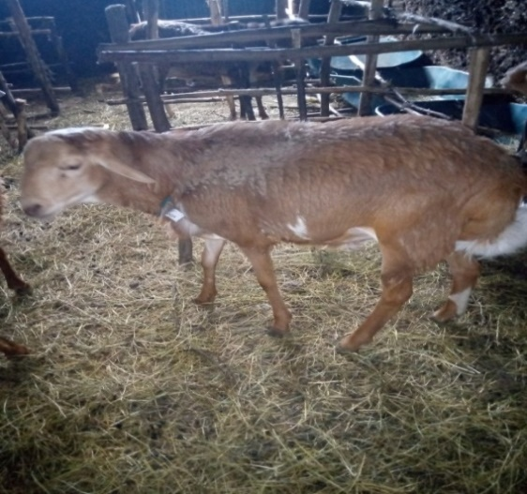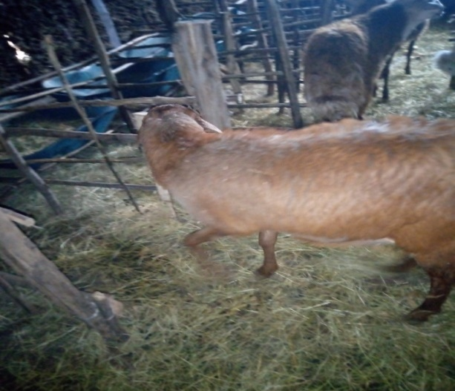
Figure 1: Washera sheep breed body conformation (Hullet Ejju Enesie woreda livestock office, 2022)

2.4. Challenges and Opportunities of Sheep Production in Ethiopia

Even though sheep and goats play a vital role in enhancing livelihood of the farmers, Sheep productivity is influenced by a variety of factors, including feed and water availability, endemic disease and parasites, housing facilities, breed types available for raising, and the market and marketing system for products (Addis, 2015). During fattening feed expenses account for 60-65 percent of total sheep output. Feed scarcity has become a major stumbling block for sheep fattening (Getachew et al., 2019). The steady reduction of grazing land and tiny land holdings, land degradation, and poor productivity all contributed to a feed crisis (Gebregziabhear et al., 2019), some of the hurdles for sheep and goat production include limited technology dissemination, excessive concentrate feed costs, and a mediocre extension system. Growing domestic and export demand for live small ruminants, as well as mutton, rapid population increase, urbanization, and the availability of varied forage production systems, as well as skilled people, are all opportunities for greater production and usage of existing sheep resources (Mengistu, 2020).

2.5. Nutrient Requirement of Sheep

In Ethiopia, local sheep's performance in terms of daily body weight (BW) gain and carcass yield is poor due to insufficient nutrition and a reliance on natural pastures, crop residues, and stubble grazing, where the quality and quantity of nutrients are typically low and subject to large seasonal variations (Melese et al., 2014). Primarily Sheep require a variety of nutrients, including energy, protein, vitamins, water, and minerals, with energy being the most limited item in a diet in order to maintain life, produce, and production. A ration made consisting of high-quality forage and concentrate mix can provide higher energy. Protein promotes the growth of rumen microbes, which aid in the digestion of fibrous diets while also providing a source of microbial protein.

2.5.1. Energy requirements

In order to maximize genetic potential for development and carcass output, energy is determined to be a limiting factor (Yadete, 2014). The pace of growth of a young sheep is determined by the energy density of its diet. When a sheep eats a poor-quality diet, its energy intake is low for two reasons: its feed intake is low and the energy density of the feed is low. Because it uses its bodily tissues to stay alive, the sheep loses weight if its calorie intake falls below that required for upkeep. The lowest energy density is between 8 and 10 MJ/kg DM (Tadesse et al, 2016).

Energy requirements are influenced by their body weight (BW), rate of growth (gain), breed type, age, environment, and ration protein content. Sheep get most of their energy from pasture, hay, silage, by-product feeds, and grains. Lower growth or weight loss, reduced reproductive efficiency, reduced milk or fiber production, increased susceptibility to infectious illness and parasites, and increased mortality are all symptoms of energy deficiency, which the sheep does not lose weight (Hussein, 2018).

2.5.2. Protein requirements

Growth, weight for age, body condition, and pace of increase, and protein to energy ratio all influence the protein requirement of growing sheep. Reduced hunger, lower feed intake, and poor feed efficiency are all signs of a protein shortage. There are digestive problems, nutritional anemia, and Oedema in extreme cases (Sheep et al., 2020). Ruminal synthesis protein does not provide all of the amino acids necessary by animals in the quality and amount required (Science and Abdurehman, 2020). The developing sheep of 20 kg BW gaining 0, 50, 100, and 150 g/day has daily metabolizable protein requirements of 21, 47, 61, and 76 g/day, respectively, with a daily DM consumption of 837 g/day (Geleta, 2022). David (2014) clearly indicated that sheep require the major minerals sodium, chlorine, calcium, phosphorus, magnesium, sulfur, potassium, and trace minerals, including cobalt, copper, iodine, iron, manganese, molybdenum, zinc, and selenium.

Table 2. Energy and protein requirement of growing male sheep
Sheep class | Nutrient | Daily weight gain (g/day) |  |  |  | DM intake (kg/day)
Sheep class | Nutrient | 0 | 50 | 100 | 150 | DM intake (kg/day)
Female | ME(MJ) | 3.4 | 4.5 | 5.8 | 6.5 | 0.56
Female | CP(g) | 21 | 45 | 58 | 71 | 0.56
Castrated male | ME(MJ) | 3.4 | 4.5 | 5.7 | 6.2 | 0.56
Castrated male | CP(g) | 21 | 47 | 61 | 76 | 0.56
Growing male sheep | ME(MJ) | 3.9 | 4.8 | 5.8 | 6.4 | 0.56
Growing male sheep | CP(g) | 21 | 47 | 61 | 76 | 0.56
(Source: McDonald, 2002)

2.6. Major Feed Resources of Sheep
Natural pasture, crop residues, agro industrial by-products, multipurpose trees and shrubs, stubble grazing, cultivated forage and conserved forages are major feed resources in Ethiopia (Berhanu et al., 2009; Adugna et al., 2012; Dawit et al., 2013; Geleti et al., 2014; Derbe, 2015). Feed resources availability depends on the intensity of crop production and amount and distribution of the rain fall (Jimma et al., 2016). The description of most common animal feeds is listed below (CSA, 2021).

Table 3. Coverage in Proportion of Animal Feed Resources in Ethiopia
No. | Type of feed resources | Coverage in percent
1 | Green fodders/grazing | 54.54
2 | Crop residue | 31.13
3 | Improved feeds | 0.57
4 | Hay | 7.35
5 | Agro industrial by-products | 2.03
6 | Other feeds | 4.37
(Source: CSA, 2021)

2.6.1. Natural pasture

Natural pasture is the most important livestock feed resource yet, due to the conversion of grazing lands to crop lands, urban residential areas and also irrigation purpose its coverage is falling dramatically (Shenkute et al., 2010). The amount of herbage biomass produced in a given season determines the grazing capacity of natural pasture. The grazing capacity of a given pasture land is low during the dry season but great during the rainy season. Animals are compelled to forage on farm lands with minimal litter cover due to the deterioration of natural pastures, resulting in over-degradation of land, damage to physical and biological soil and water conservation structures, and a negative impact on crop land productivity and crop residual biomass. As a result of this circumstance, food crop yields have decreased, and annual costs for the construction and maintenance of natural resource conservation structures have increased. Natural pasture area that has been degraded can be rehabilitated through good management and/or the removal of freely ranging livestock. Controlled grazing or a cut-and-carry feeding method, good animal management, are an option for natural pasture land to have rapid and possible re-growth so that adequate forage can be harvested to be fed fresh or saved as hay. Soil acidity is now another bottleneck that has an impact on agricultural and livestock productivity. Planting of acidity resistant legume crops is one of the best treatment methods for soil acidity prevention (Yeheyis et al., 2012a).

2.6.2. Crop residue
Crop residues – cereals (teff, barley, wheat, maize, sorghum, and millet) – pulse crop residues (faba bean, chickpea, haricot bean, field pea, lentil), oil crop residues, and reject vegetables – provide a significant amount of dry season feed in the highlands and mid-altitude. The usage of crop wastes is expanding in Ethiopia due to the rapid increase in human population and extension of arable area, as well as the gradual decrease in grazing land (Alemayehu et al., 2017).

Crop residues are fibrous by-products of grain, pulse, oil plant, root, and tuber cultivation that can be used as a major feed resource for ruminant production, particularly in subsistent farming. Currently, the conversion of grazing land to crop land is increasing, resulting in more biomass of crop residues, which contribute about 50% (and up to 80%) of ruminant feeds during the dry season of the year, and are becoming the most important feed resource covering a significant amount of livestock feed in Ethiopia's highlands, particularly during the dry season (Hussein, 2018). However, quality and digestibility are poor, with less than 50% digestibility, a high fiber content (more than 70% NDF), and a low crude protein level (less than 5% CP) (Gizachew and Smit, 2005). The nutritional content of straw varies according on species, cultivar, rainfall, and harvesting, mixing, and storage procedures (ICARDA, 2020). Crop residues from barley, teff, wheat, maize, sorghum, lentil, faba bean, field pea, chickpea, haricot bean, and other grains are extensively utilized for animal nutrition in Ethiopia. These crop residues are either grazed by animals on field in situ or collected and stored for stall feeding ( Gebru et al. 2015).

2.6.3. Grass hay

Hay is a form of feed that is gathered and dried throughout the growing season to keep it fresh. Hay is made by reducing the moisture content of green crops to 15-20% in order to prevent plant and microbial enzymes from acting (Singh, 2020). Hay has numerous advantages, but it also has some disadvantages. Its nutrient content and palatability vary, and late hay harvest affects its quality (Mengesha and Tsega, 2012). Hay is often obtained in Ethiopia's central highlands after the pasture's CP has reached peak production and the protein content has reached a certain level. Content obtained on a DM basis is typically less than 5%, which is below the level of ruminant maintenance requirements (Solomon et al., 2010). Feeds low in digestible protein such as mature dry native grasses require supplementation with some kind of nitrogenous feed. Natural pasture would be sufficient for body maintenance and weight gain during the rainy season, but not for the rest of the year (Haile et al. , 2017). Hay is used for feeding during the time of year when grazing is not available or for feeding confined animals, and it may also be sufficient for maintaining mature ruminant animals, even if their productive requirements are modest.

According to FAO (2017) annual and perennial grass from natural pasture consumed during the dry season and often at late stage of maturity together with the straw and stalk from cereal crops constitutes low quality forages, with high lignified cell wall and poor nitrogen. Therefore, for reasonable level of production, animals subsisting on hay require supplementary protein, which can be obtained from different sources such as from oil seed cakes or non- protein nitrogenous (NPN) and energy sources (Tadesse, etal.,2016).The quantity of grass legumes in the forage, the leaf-to-stem ratio, and the physiological development of the forage up to harvest all influence the quality of the hay produced. Mature grass is poor in digestible energy and protein, as well as soluble carbohydrate, carotene, and certain minerals, especially if it has been weather leached or bleached (Etiopía, 2019). Mulu et al. (2008) indicated that sheep fed hay alone lost 3 g/day compared with other treatments done on intact Wogera Sheep.

2.7. Supplementation

Fibrous feeds with low digestibility, as well as protein, mineral, and vitamin deficits are common in small ruminant diets. Intake and productivity suffer as a result of these characteristics (Tilahun et al. , 2014). It is vital to offer appropriate supplementary feedstuff throughout critical times of the year in order to boost productivity or, at the very least, minimize weight loss. This is especially true for animals given low-quality pasture or crop residue diets. A supplement is a concentrated source of one or more nutrients, such as protein, energy, vitamins and minerals that is added to a base feed to improve its nutritional value. Supplements for minerals and proteins supplements come in a number of shapes and sizes, and they can be utilized for a variety of reasons. It may be carried out to ensure survival, maintenance, growth or production and reproduction. Supplementation can be accomplished by providing a complete diet or by administering specialized medications (Tadesse et al., 2014).

Supplementation with nutrients can help animals ingest more fodder, digest the same amount of forage more efficiently, or overcome a nutrient shortage that is limiting their performance. To prevent nutritional problems, grazing stock may be offered freely with hay or straw. When the pasture is exceptionally lush with high moisture content, bypass nutrients are derived from rather expensive feeds that are either in demand for human nutrition (cereals) or exported for foreign exchange (oil seeds). However, because recent research has demonstrated that including these extra feeds at a moderate rate in the diet is helpful, they should be cost-effective in many instances. The majority of supplements are costly, and their usage in ruminant nutrition competes with that of monogastric animals and/or humans. As a result, making the best use of these limited resources is critical. This method of supplementation is known as "strategic supplementation," and it is intended to have the greatest impact and provide the best value (FAO, 1991).

2.7.1. The effect of supplementation on the performance of sheep

2.7.1.1. Effects of supplementation on feed intake.

The first parameter that impacts animal production is feed intake, which is influenced by the animal, feed properties, and other environmental conditions (Hussein, 2018). Many factors influence dry matter intake, including the density of energy in the diet, digestibility, succulence, crude fiber content, and the physical structure of the feed (Mengesha and Tsega, 2012). The degree of rumen fill, which is directly connected to the rate of digestion and passing of fibrous particles from the rumen, determines feed intake in ruminants eating fibrous forages (Tilahun et al., 2014). According to Figueiras et al. (2016) reported increased forage intake can be reached by maintaining a balanced protein-to-energy ratio in the diet, while the supplementation of protein can improve dietary equilibrium. This can reduce the metabolic discomfort of the animal and result in greater forage intake. In feeding system where straws and grass hay are the basic diet of ruminants, the low intake of these roughages requires supplementation to meet the requirements for production. Addition of crude protein supplement may stimulate efficient rumen fermentation, more passage rate and intake (Awet, 2017).

2.7.1.2. Effect of supplementation on digestibility

The digestibility of a feedstuff is the proportion of the feed or of any single nutrient of the feed which is not recovered in feces (Tadesse et al., 2014). Although the potential value of a feed can be approximately determined by proximate analysis, the actual value of the feed to the animal can be determined only if the digestibility is known. The digestibility coefficients of various nutrients from the same feedstuffs is affected by species of the animal, age of the animals, level of feeding, feed composition and ration composition. The primary chemical composition of feeds that determines the rate of digestion is neutral detergent fiber which is itself a measure of cell wall content; thus there is a negative relationship between the neutral detergent fiber content of feeds and the rate at which they are digested (Tadesse et al., 2014).

The fiber fraction of feed has the greatest influence on its digestibility. Digestibility of a feed is influenced not only by its composition, but also by the composition of other feeds consumed with it. For the ruminant to express their full genetic potential for growth, the apparent digestibility should exceed 70% on dry weight basis. When apparent digestibility is 60%, performance will be intermediate and the minimum range of apparent digestibility to assure body maintenance needs is 42-45%, whereas at lower digestibility of feeds animals lose weight (Kenfo, 2021).

Mulu et al. (2008) reported that supplementation of brewery dried grain improved the digestibility of CP, DM, OM, NDF, and ADF. Tesfaye and Solomon (2009) indicated that increasing supplementation (0, 150, 250 and 350 g) improved the digestibility of DM (50.1, 67.1, 68.5 and 66.6%), OM (53.0, 69.3, 70.6 and 69.3%), and CP (32.6, 71.9, 75.0 and 83.3%), respectively.

2.7.1.3. Effect of supplementation on growth rate and feed conversion efficiency in sheep

Growth performance is an important character in evaluating a sheep for meat production potential since it impacts the total productivity of the flock and the economic return from the sheep production enterprise. While heredity determines the maximum amount of growth and development, diet and other environmental factors determine the actual rate of growth and degree of development (Solaimanet et al., 2018). However, any additional input above what is required for regular physiological demands may not cause the animal to develop beyond its genetic potential (Seid and Reader, 2021). Nutrition is one of the factors that affect live weight gain. Poor nutrition results in low rates of growth. But, the degree of response varies with breed type (Shashie et al., 2017). Early growth in sheep is influenced by breed, sex, litter size, season of birth as a reflection of seasonal fluctuation in feed availability and also milk yield of the dam (Markos, 2006). Due to season fluctuation of forage availability in the tropics, animals lose weight during the dry season and gain weight during feed abundance in the wet season. Under most tropical condition, where roughage is the basal diet, the availability of nutrients to the animals is the main factor limiting growth and productivity (Teaching, 2018).

The CP requirements of growing and fattening sheep with 20 kg body weight are 85 and 127 g/day, respectively (Mengistu, 2020). Similarly, Cheeke (1999) indicated that early-weaned sheep with 10 and 20 kg body weight have CP requirements of 127 g/day and 167 g/day with 262 and 167 CP of 100 percent DM diet, respectively. Supplementation with readily digestible fiber may improve utilization of basal diet and animal performance (Teshome et al. 2019).

The feed conversion efficiency (FCE) was higher for the sweet lupine supplemented treatments compared to the control. The feed conversion efficiency trend observed among the treatments indicated that as the proportion of total DM intake consumed increased, the feed conversion efficiency (FCE) also improved (Retta and Derseh, 2021). Another feeding trial also showed that high level of wheat bran supplementation (350 g/day) resulted in significantly higher feed conversion efficiency (FCE) compared to the low level of supplementation (150 g/day) (Awet, 2007). Feed conversion efficiency in the control treatments were 0.023, 0.01 and 0.01 for Black head Ogaden sheep fed haricot bean haulms, Dangila sheep fed urea treated finger millet straw and Horro sheep fed on natural grass hay alone, respectively (Melese et al. , 2014).

2.7.2. Concentrates as supplement

Grains, grain screenings and agro-industrial byproducts are the most common sources of concentrate feeds. By-products from wheat mills, oil refineries, breweries, and sugar mills are examples of agro-industrial by-products (Tadesseand Abebe, 2016). Concentrates are feed ingredients that are easier for the rumen to digest and contain more energy and protein than roughages. They are often made up of very small particles and have low crude fiber content. As a result, they have a poor fibrous structural value. Grain concentrates include Sweet Lupine, maize, and other grains. sorghum, wheat, barley, and oats, as well as grain processing by-products such as noug seed cake, wheat bran, rice bran, maize gluten, and others, From the listed ones, Sweet lupine is one used for sheep feeding as protein source (Yadete, 2014)

Table 4. Concentrations of rumen degradable protein (RDP) and metabolisable energy (ME) in feed Grains
Grain | ME (MJ/kg) | CP (%) | Degradability (%) | RDP (g/kg) | RDP:ME (g/MJ)
Sweet Lupine | 11.3 | 38 | 72 | 221 | 19.6
Sorghum | 12.4 | 10 | 45 | 45 | 3.3
Maize | 13.5 | 10 | 45 | 45 | 3.6
Oats | 10.5 | 11 | 70 | 77 | 7.4
Barley | 11.6 | 12 | 69 | 92 | 7.9
Source: Holst et al., 2004

2.8. Description of Sweet Lupine (Lupinus angustifolius L.)

Sweet lupine (Lupinus angustifolius L.) has been cultivated for over 2000 years; everything began in the Mediterranean region (Gebru et al. 2015). Lupine, like other legumes, aids in nitrogen fixation and soil fertility improvement. The grain has high protein content. Despite the fact that the genus Lupines has over 300 species, many of them contain significant levels of alkaloids (bitter taste chemicals) that make the seed unpleasant and, in some cases, harmful to the animals (Tadele et al., 2014). Sedláková et al. (2016) found that sweet lupine of the local type had more alkaloids (5-20g kg-1 DM) than the sweet lupine. However modern lupine varieties, particularly sweet lupine, have low alkaloid amounts (0.02% DM) (Riga et al., 2021). The alkaloids in lupine seeds were traditionally removed by soaking them in water for an extended period of time (Yeheyis et al. 2012b). Sweet lupine is a legume crop which can be used as feed for fattening. It has high in CP content and is very easy to digest. It has a CP content of 34 to 38% percent and a DOM content of 86.28 percent (Retta et al., 2021).

Table 5. Chemical Composition and Digestibility of Various Forms of Sweet Lupine Grains
Forms of processing Grain
Forms of processing Grain | DM | CP | NDF | ADF | ADL | IVOMD
Roasted and coarsely Grounded | 93.4 | 36.1 | 30.2 | 16.8 | 1.9 | 80.6
Whole Soaked | 93.3 | 39.3 | 30.3 | 14.7 | 1.1 | 84.7
Whole Steamed | 93.1 | 28.2 | 38.7 | 25.3 | 1.6 | 72.8
Source: Tilaye et al. (2016)

Ethiopia is a country in Africa where sweet lupine has the potential to replace cereal grains and commercial concentrate feed supplements such as soybean meal, noug seed cake and wheat bran. According to Yeheyis et al. (2012a) Sweet lupine productivity and adaptability vary by location, depending on a variety of environmental and socioeconomic conditions. There are different types of sweet lupines as described in Table 6.

Table 6. Average seed yield, protein and alkaloid content of Sweet Lupine
Breed | Variety | Origin | Yield(Ql/ha) | Protein content | Alkaloid Content (%)
White Lupine | Local | Ethiopia | 31 | 39 | 1.1
Blue Lupine | Sanabor | Germany | 37 | 33 | 0.02
Sweet Lupine | Vitabor | Germany | 38 | 31 | 0.02
Blue Lupine | Bora | Germany | 33 | 31 | 0.10
Blue Lupine | Probor | Germany | 32 | 34 | 0.04
Source: Yeheyis et al. 2012a

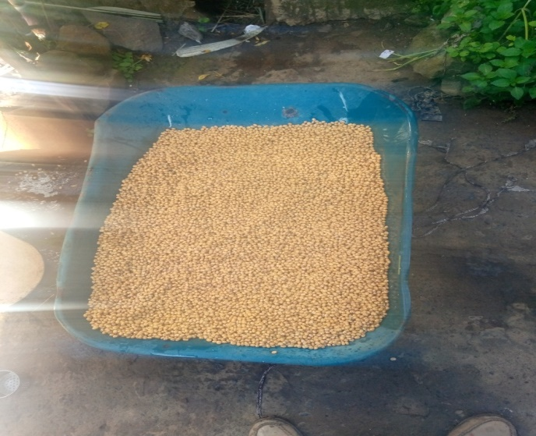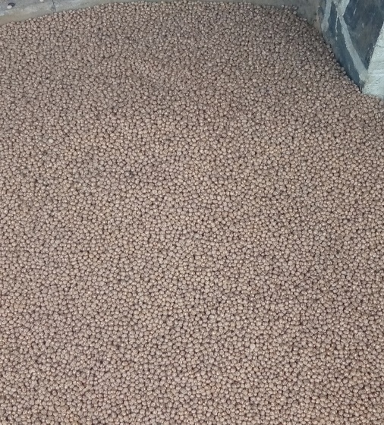
Figure 2: Raw sweet lupine grain (Tilahun et al. 2014)

2.9. Soybean meal as a supplement

Soybean is one of the most important crops in Ethiopia. It contributes nearly 18% to the country’s total oilseed production and accounts for only 6% of the area planted to oilseeds (Mussema et al., 2021). The area allocation for soybean, and its production, as well as productivity, are increasing under private investors in Ethiopia; production increased about 18-fold between 2007/2008 -2018/19, and the yield was 1 ton and increased to 2.3 tons per hectare in the same period. The soybean production is expected more than Niger seed production in 2020/21; estimated to increase by 14 and 2%, respectively, over 2019/2020 (Mussema et al., 2021).

Ethiopia’s oilseed sector plays an important role in generating foreign exchange earnings. Oilseed crops are the third largest foreign exchange-earners, next to coffee and cut flowers. Sesame, soybean, and Niger seed contribute to nearly 17% of Ethiopia’s agricultural exports; the volume of soybean export increased more than double between 2013/14 and 2018/19. Soybean has a long history in Ethiopia and its research started in the 1970s. About 26 varieties were released between 1981 and 2016; however, few of the varieties reached the producers (Delele, 2021).

Soybean is also the most important oil crop worldwide. Demand for soybeans is projected to continue growing in the coming years, due to the consumption of meat and soy-based health products are on the rise, while population figures are scheduled to increase, and policy-makers are supportive of biodiesel as a fuel alternative. Soybean is increasingly becoming popular and serving as an alternative food and cash crop in the local and international markets have allowed getting the attention of the government and considered in the ECX market since December 18, 2018, in Ethiopia. Since January 2019 soybean, which is considered an industrial product, it is trading at ECX. Despite its position and potential, and recognition the crop faces several challenges related to production which include; shortage of improved seed, the limited number of technologies were used by farmers, limited extension service, weed, the occurrence of diseases, pests (Delele, 2021). Even though the production and productivity of soybean meal increased at private investors level, the accessibility to the smallholder farmers and youth enterprise is limited and the cost of the feed increased alarmingly from time to time as it is a factory and export product (Tadesse, 2016). Besides these facts, the access, distance from processing factories, and increased cost had limited its wider application for animal feed and replacement feed type was mandatory.

Figure 3. Crude protein contents in different plant origin meals (Mussema et al., 2021)

MATERIALS AND METHODS

Description of the study area
The experiment was conducted in Motta town which is the center of the Hullet Ejju Enesie district in the East Gojjam zone of the Amhara National Regional State (Figure 3). Motta town is 195 kilometers far from the zone town, Debre Markos, 120 kilometers from the regional town, Bahir Dar, and 375 kilometers from the capital city of Ethiopia, Addis Ababa. The study area is situated at 11°5′ N latitude and 37°52′ E longitude with an elevation of 2,487 meters above sea level. The rainfall and temperature of the district ranged from 1200- 1800 mm and 7.5-22.5 ^{O}C, respectively. With regarding to the climate the district had 18% Dega, 52% Woynadega and 30% Kola (Bantayehu, 2012). The total livestock population of the districts was 275,062 cattle of which 34896 were cows, 44967 oxen, 18357 calves, 17904 heifers; 79121 sheep; 54722 goats, 18514 donkeys, 5946 mules, and 635 horses, 65292 local chicken, and 44325 cross breed chicken. The district has also 10695 bee colony in local hive, 401 in transitional hive and 2409 in modern hive (HEDLFDO, 2022). The major crops that grown in the woreda include teff, maize, barley, wheat, bean and others. Sheep fattening is a common practice and main source of income in Hullet Ejju Ensie district.
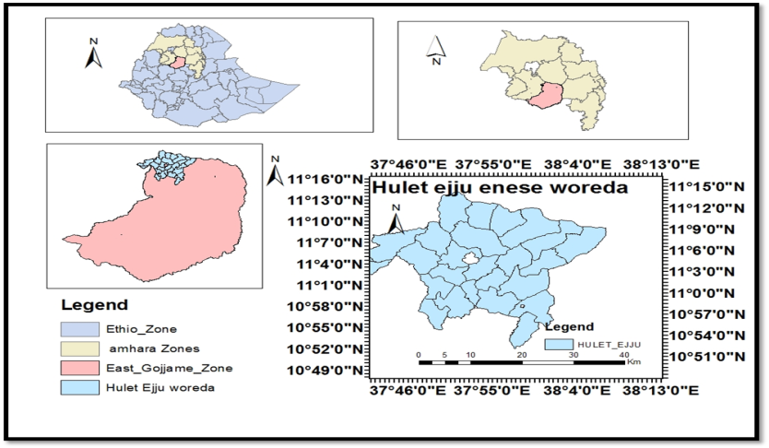
Figure 4. Location of the study district

Experimental Feed Collection and Preparation

Natural pasture hay was purchased from the surrounding farmers and transported to the experimental site. The hay was stored under shade to maintain its quality and used as a basal diet throughout the experimental period. Before feeding to the animals, it was chopped to 5-10 cm size manually to minimize wastage and encourage the intake. Sweet lupine and soybean meal was purchased from Debre Markos Agricultural Research Center and WA Oil Factory and Distribution PLC at Debre Markos town, respectively. During the experimental period, all of the feeds were stored in well ventilated room to avoid formation of mold and spoilage. Sweet lupine grain and soybean meal were mixed properly before offered to the animals.

Experimental animals and their management

For the experiment, twenty-five yearling Washera male sheep were purchased from the local market. The age of sheep was determined by dentation and information obtained from the owners. The experimental sheep were quarantined and acclimatized for 21 days to monitor their health condition in the new environment. During the quarantine period, all animals were sprayed with Acaricide (Dizininone) against external parasites and dewormed by broad spectrum Albendazol and Ivermectin against internal parasites, and also vaccinated against common diseases of the area like Sheep pox and Foot rot based on the recommendation of veterinarian. At the end of the quarantine period, all animals were neck-tagged for identification purpose.

At the end of the quarantine period, the sheep were grouped into five blocks of five sheep each based on their initial body weight, and one sheep from each of the blocks was distributed to each of the treatment groups. Therefore, a total of five sheep were assigned in each treatment group. After assigning the sheep into treatment groups, they were transferred to individual pens and sheep were offered the respective treatment diets for 15 days to get them adapted to the feeds prior to the beginning of the actual experiment. The experimental sheep were offered grass hay ad libitum allowing refusal of 20% and supplemented with the treatment feeds (Table 7). The supplements were offered at 400 g/head/day on DM basis in equal portions at 08:00 and 16:00 hours. Clean water was delivered ad libitum to the animals at all times throughout the experimental period. Common salt was available to the animals all the time throughout the experimental period; and sheep were closely observed for the occurrence of any ill health and disorders throughout the experimental period.

Experimental Design and Treatments

The design of the experiment was randomized complete block design (RCBD) using five treatments. At the end of acclimatization period, weights of the sheep was taken for the two consecutive days after overnight fasting of feed and water. Then the animals were arranged into five blocks of five animals based on initial body weight (BW). Each sheep within a block was assigned to one of the five dietary treatments randomly. A total of 300 gram per day was delivered for each sheep with the proportions indicated in Table 7.
Table 7. Experimental treatments
Treatments | Natural pasture hay | Supplementary feed proportion
Treatments | Natural pasture hay | SLG | SBM
Treatment 1 | Ad libitum | 100% (300 g) | -
Treatment 2 | Ad libitum | 75% (225 g) | 25% (75 g)
Treatment 3 | Ad libitum | 50% (150 g) | 50% (150 g)
Treatment 4 | Ad libitum | 25% (75 g) | 75% (225 g)
Treatment 5 | Ad libitum | - | 100% (300 g)
SLG = sweet lupine grain; SBM = soya bean meal

Feed Intake and Body Weight Measurements

The feeding trial was conducted for 90 days. Daily feed offered to the experimental animals and the corresponding refusals of each animal was measured and recorded during the experimental period to determine daily feed intake. Samples of feed offered from each feed and refusal from each animal was collected daily, mixed at the end and sub-sampled for laboratory analysis. Daily dry matter (DM) and nutrient intake of individual sheep was determined as the difference between the amounts of feed offered and refused.

The weight gain change including the initial and final body weights of experimental sheep were measured using suspended weighing balance. The weight change was measured in every 10 days interval to better understand the effect of replacement feeds across the treatments. Animals were weighted in ten days intervals after overnight fasting and the results were recorded throughout the experimental period to determine the trend of body weight change. The feed offered and refused was measured using kitchen scale sensitive balance. Average body weight gains (BWG), and Body weight changes (BWC) were calculated with the following formulas.
$$Body Weight Change \left(BWC\right)=Final body weight \left(FBW\right)-Initial body weight (IBW)$$
$Daily Body Weight Gain (DBG)=\frac{Body Weight Change \left(BWC\right)}{Number of expermental days}$
Feed conversion efficiency (FCE), as the measure of feed utilization was determined as a unit of body weight gain per unit of feed consumed (Taylor and Field, 2001).
$$Feed Conversion Efficiency (FCE)=\frac{Daily weight gain \left(DWG\right) in gram}{Daily feed intake \left(DFI\right) in gram}$$

Digestibility Trial

The digestibility trial was conducted after the 90 days of feeding trial with the same animals used for the feeding trial. The animals were fitted with fecal collection bags and adapted to carrying of the fecal bags for 3 days followed by total collection of feces for seven consecutive days. Samples of feces were collected every day in the morning. The total feces voided in the harness per animal were weighed daily during the fecal collection period. From the daily collected feces about 10% representative samples were taken from each sample to form a weekly composite of fecal sample for each animal and stored at −20 °C. At the end of collection period a weekly composite fecal sample was thawed, thoroughly mixed and about 20% was sub sampled from each animal and taken to Andassa Livestock Research Center for an oven drying and was partially dried at 60 °C for 72 hours. The partially dried fecal samples were ground to pass through a 1-mm sieve and kept in air-tight containers until required for chemical analysis. The apparent digestibility of Dry Matter (DM), Organic Matter (OM), Crude Protein (CP), Non-Detergent Fiber (NDF), and Acid Detergent Fiber (ADF) were determined by the following formula:
$$Apparent DM Digestibility (\%)=\frac{Dry matter intake-Fecal dry matter}{Dry matter intake}×100$$
$$Apparent Nutrient digestibility (\%)=\frac{Nutrient intake-Nutrient in faces}{Nutruent intake}×100$$

Chemical Analysis

Feed offered, refused and fecal samples were ground to pass through a 1-mm sieve after drying at 60 °C for 72 hours in a forced draft oven. Samples were analyzed for DM, ash and N contents according to the procedures described by AOAC (1990). The CP contents were calculated as CP = N%×6.25. Organic matter (OM) content was determined as 100 - ash. Neutral detergent fiber (NDF), acid detergent fiber (ADF), and acid detergent lignin (ADL) only for feed sample were determined according to Van Soest and Robertson (1985). The chemical analysis was conducted at Animal nutrition laboratory of Bahir Dar University College of Agriculture and Environmental Science, Zenzelema campus.

Partial budget analysis

At the end of the experiment, partial budget analysis was performed to evaluate the economic benefits, and profitability of the different treatments and the analysis involves the calculation of the variable costs of experimental sheep and feeds, and benefits gained from the result (Upton, 1979; Mekcha, 2019). Total return (TR) was calculated as the difference between selling and purchasing price of the experimental animals.
Net income (NI) was calculated as the amount of money left when total variable cost (TVC); purchasing price of sheep, feed cost and treatment costs are subtracted from total returns (TR);
NI = TR - TVC or NR = TR – TVC
The change in net income (ΔNI) was calculated as the difference between the change in total return (ΔTR) and the change in total variable costs (ΔTVC);
∆TR = TR of T2, T3 and T4 – (TR of T1)
∆TVC = TVC of T2, T3 and T4 – (TVC of T1)
ΔNI= ΔTR-ΔTVC or ΔNR = ΔTR – ΔTVC
The marginal rate of return (MRR) measure the change in net income (ΔNI) associated with each additional unit of expenditure (ΔTVC) and expressed in percentage as;
MRR = (ΔNI) / (ΔTVC) × 100 (Mekcha, 2018)

Statistical Analysis

The data obtained on feed intake, initial and final body weight, body weight change and feed conversion efficiency were subjected to analysis of variance (ANOVA) using the general linear model procedure of (SAS, 2002). Differences among treatment means were tested by using least significance difference (LSD). The model used was:

Y_{ij} = µ + β_{j} +$τ$_{i} + $ε$_{ij}
Where, Y_{ij} = the observation in i^{th} treatment and j^{th} block
µ = Over all mean
β_{j} = the j^{th} block effect
$τ$_{i} = the i^{th} treatment effect
$ε$_{ij} = the random error

RESULTS AND DISCUSSION

4.1 Chemical composition of treatment feeds
The chemical composition of experimental feeds used in the feeding and digestibility trials are presented in Table 8. The CP content of natural pasture was low while the NDF, ADF and ADL were high as compared to other experimental feed ingredients. This implies that the natural grass hay was not collected at appropriate time and may be stored for long time before use. The low CP content of natural pasture hay straw used as a basal diet in the current study was below the CP requirement for ruminant animals for proper rumen function (McDonald et al., 2002). The CP content of hay used in the current study was comparable to the values 52.8g/kg reported by Dessie et al. (2010) but lower than the value 43 and 36g/kg reported by Ephrem et al., (2015) and Yeheyis et al. (2012b), respectively. The observed differences between the current study and the aforementioned authors might be the composition of the grass, and the soil type difference where the grass hay was collected. The NDF and ADF component of natural pasture hay used in the current study was lower than the values 755.5 and 666 g/kg, 756.8 and 510g/kg and 794.6 and 533.1g/kg reported by Ephrem et al., (2015); Dessie et al. (2010) and Yeheyis et al. (2012b), respectively.

The sweet lupin grain had high NDF, ADF and ADL content than, soybean meal, but comparable in CP content. The high CP content (365g/kg) of sweet lupin indicated the potential of this grain to be used as a supplement for poor quality roughage in ruminant diets. The crud protein content of sweet lupine was higher than the reports 343.5 g/kg/DM for blue lupine (Yeheyis et al., 2012b), 309.4 g/kg DM (Brand et al., 2019), 308.6 g/kg DM (Ephrem et al., 2015); while higher crud protein content for sweet lupine 583, and 436 was reported in Raw- soaked- dehulled, and Raw soaked forms of the grain, respectively (Gebru et al., 2015). The finding reported by Tadele et al. (2014) indicated that the CP content of sweet lupine was 361 in Roasted and coarsely ground, 393 (Whole soaked), and 282 (Whole steamed) forms; those are done for minimizing the anti-nutritional factors in the feed.

According to the result of Kiflay et al. (2014), the CP content (33.36 %DM) of soybean meal was lower than the current study; while the NDF of the current study for soybean meal was lower than the report of Kiflay et al. (2014) which was 23.07 (%DM).

Table 8. Chemical composition (g/kg/DM) of feed offered during the experiment
Feed type | Nutrient content (g/kg/DM)
Feed type | DM | CP | OM | NDF | ADF | ADL | Ash
Sweet Lupine | 947.2 | 365 | 935.1 | 373 | 178.6 | 57.4 | 64.9
Soybean meal | 946.1 | 385 | 925.7 | 223.9 | 105.1 | 24.3 | 74.3
Natural pasture Hay | 967.4 | 56 | 892.6 | 724.4 | 480.1 | 114.7 | 107.4
Refusal (NPH)
Treatment 1 | 967.1 | 51 | 890.4 | 732.8 | 501.0 | 128.4 | 102.1
Treatment 2 | 961.5 | 50 | 887.2 | 718.5 | 489.0 | 119.4 | 116.8
Treatment 3 | 961.5 | 53 | 891.6 | 727.0 | 498.1 | 124.3 | 109.3
Treatment 4 | 962.1 | 53 | 889.1 | 729.6 | 493.9 | 134.0 | 108.7
Treatment 5 | 965.0 | 49 | 893.2 | 728.2 | 513.4 | 121.0 | 104.0
DM = dry matter, OM = organic matter, CP = crude protein, NDF = neutral detergent fiber, ADF = acid detergent fiber, ADL = acid detergent lignin; NPH = natural pasture hay; Treatment 1= NPH adlib + 100% sweet lupine grain (SLG); Treatment 2 = NPH adlib + 75% SLG + 25% soybean meal (SBM); Treatment 3 = NPH adlib + 50% SLG+ 50% SBM; Treatment 4= NPH adlib + 25% SLG + 75% SBM; Treatment 5= 100% SBM

4.2. Dry matter and nutrient intake

4.2.1. Dry matter intake

The mean daily dry matter and nutrient intake of Washera sheep fed natural pasture hay supplemented with sweet lupine, soybean and there mixtures are presented in Table 9. The result showed that there was no significant difference (P>0.05) in hay DM intake among the five treatment groups (Table 9) which might be due to free offer for all animals in each treatment groups. However, there was a significant (P<0.05) difference in dry matter intake (gram/day) in the supplement feeds that a higher dry matter intake was observed for T3, T4, and T5; this might be due to the three treatments are a combinations of both supplement feeds. The complementary of feeding soybean by sweet lupine was due to minimizing the cost related for purchasing the soybean meal which is costly compared with sweet lupine. It was observed that there was no significant difference (P>0.05) in total dry matter intake (% live body weight) and for hay dry matter intake (Table 9).

Compared with the current study, the overall total dry matter intake was lower than 744 g/day in Sidama sheep (Dessie et al., 2010) and 720 g/day in Farta sheep (Nega and Melaku 2009). Similarly, the overall average total dry matter intake as percentage of body weight (3.29%) observed in the current study was lower than 3.7% (Nega and Melaku, 2009) in Farta sheep and 3.6% (Dessie et al., 2010) in Simada sheep. The observed difference might be attributed to the difference in experimental sheep breed, feed type (including the grass hay composition) and proportions of rations offered. A comparable total dry matter intake (g/d) and higher range (3.36 to 3.62) total dry matter intake (%LBW) was reported for Washera sheep feed of different forms of lupine ration (Tadele et al., 2014).

4.2.2. Nutrient intake

According to the experimental result, a significant (P<0.05) differences in nutrient intake (g/day) was observed for crud protein (CP), organic matter (OM) and acid detergent fiber (ADF); while there was no observed significant difference in neutral detergent fiber (NDF) intake (Table 9). A similar significant difference (P<0.05) was reported for all nutrient intake parameters (Tadele et al., 2014). The higher CP intake was observed in treatment 3, 4 and 5. This might be attributed due to the increased proportion of soybean meal in treatments 3 and 4 which in turn had resulted increased the CP intake. Even though the chemical compositions reported for sweet lupine and soybean meal used for the experiment was comparable, the digestibility and protein by-pass level contributed higher intake in treatments containing higher proportion of soybean meal. The organic matter intake had also higher in treatment taking combined rations (3, 4 and 5) than sole treatments (1 and 5).

Table 9. Daily dry matter and nutrient intakes of Washera sheep fed natural pasture hay basal diet supplemented with different proportions of sweet lupine and soya bean meal
Variables | Treatments |  |  |  |  |  | P-value
Variables | T1 | T2 | T3 | T4 | T5 | SEM | P-value
Dry matter intake
Hay DMI (g/day) | 444.36 | 435.53 | 428.48 | 430.87 | 424.25 | 3.11 | 0.451
Supplement DMI (g/day) | 209.2^{d} | 246.4^{c} | 281.3^{ab} | 293.5ª | 269.7^{b} | 2.88 | 0.024
TDMI (g/day) | 653.56^{d} | 681.93^{c} | 709.78^{ab} | 724.37ª | 693.95^{b} | 1.53 | <0.001
TDMI (%LBW) | 3.15 | 3.21 | 3.33 | 3.44 | 3.35 | 0.29 | 0.541
Nutrient intake
CP intake (g/day) | 91.02^{b} | 94.31^{b} | 110.45ª | 111.63ª | 109.6ª | 1.98 | 0.013
OM intake (g/day) | 590.94^{d} | 666.64^{c} | 711.98^{b} | 763.36ª | 551.2^{d} | 2.07 | <0.001
NDF intake (g/day) | 419.1 | 446.96 | 474.54 | 513.36 | 400.7 | 3.27 | 0.092
ADF intake (g/day) | 294.46^{c} | 321.36^{bc} | 342.46^{bc} | 378.64ª | 285.05^{c} | 2.21 | 0.018
^{a, b, c, d} Means within a row with different superscripts differ significantly (P < 0.05); T1= supplemented with 100% sweet lupine grain (SLG); T2= supplemented with 75% SLG + 25% soybean meal (SBM); T3= supplemented with 50% SLG+ 50% SBM; T4= supplemented with 25% SLG + 75% SBM; T5= supplemented with 100% SBM; SLG= sweet lupine grain; SBM=soybean cake; TDMI= total dry matter intake; DMI= dry matter intake; CP= crude protein; NDF= neutral detergent fiber; ADF= acid detergent fiber; OM= organic matter; LBW= live body weight; SEM=standard error of the mean

4.3. Dry matter digestibility

The apparent dry matter digestibility of Washera sheep fed natural pasture hay as basal diet and supplemented with different proportions of sweet lupine grain and soybean meal was presented in Table 10. According to the result, except NDF apparent digestibility, all the considered parameters were significantly (P<0.05) different across treatments; the higher DM apparent digestibility was higher for treatment 4 and the lower was for treatment 1. A similar non-significant difference (P>0.05) for NDF and significant difference for other parameters was reported for Washera sheep feed with different processing form of lupine in Sekela district (Tadele et al., 2014). A comparable dry matter and crude protein apparent digestibility with significant (P<0.05) difference across treatments was reported for feed treatment containing higher proportion of sweet lupine for Washera sheep (Ephrem et al., 2015; Tefera et al., 2015; Walie et al., 2022). While the current report is higher than the apparent digestibility reported for Washera sheep feed processed sweet lupine grain (Tadele et al., 2014). The variation between the current finding and other authors is that they had use the sweet lupine as a grinded manner and incorporate the feed as a protein replacement in the ration comparing it with commercial concentrate mix; while in this study, the sweet lupine was offered as a grain.

Table 10. Apparent dry matter and nutrient digestibility of Washera sheep fed natural pasture hay basal diet supplemented with different proportions of sweet lupine and soya bean meal
Apparent digestibility | Treatments |  |  |  |  | SEM | P-value
Apparent digestibility | T1 | T2 | T3 | T4 | T5 | SEM | P-value
DM | 69.4^{b} | 70.3^{b} | 71.02ª | 72.77ª | 71.3ª | 1.03 | <0. 001
OM | 67.4 | 71.11 | 72.07 | 72.71 | 71.41 | 0.74 | 0.072
CP | 75.11^{c} | 76.04^{b} | 76.41^{b} | 76.12^{b} | 77.41ª | 1.41 | 0.021
NDF | 57.55 | 62.02 | 61 | 62.12 | 60.4 | 0.88 | 0.065
ADF | 61.47^{b} | 65.07ª | 63.4^{ab} | 65.65ª | 62.87^{b} | 0.53 | 0.033
^{a, b} Means within a row with different superscripts differ significantly (P < 0.05); T1= 100% sweet lupine grain (SLG); T2= 75% SLG + 25% soybean meal (SBM); T3= 50% SLG+ 50% SBM; T4= 25% SLG + 75% SBM; T5= 100% SBM; DM= dry matter; CP= crude protein; OM= organic matter; NDF= nutrient detergent fiber; ADF= acid detergent fiber; SEM= standard error of the mean.

4.4. Body weight change and feed conversion efficiency

The body weight change and average daily weight gain (gram) of the experimental animals is indicated in Table 11. There was no observed significant difference (P>0.05) in the final body weight of the experimental animals in all the treatment groups; which might the adaptation potential of the animals for all feed items. The average daily weight gain had shown a statistically significant (P<0.01) difference across treatments and higher ADWG was higher for treatment four (76.11±3.84g/day) to treatment five (73.56±5.21g/day) (Table 11). Despite the relatively higher crude protein and lower crud prion intake (Table 9), sheep supplemented with lupine seed only, treatment 1, had lower daily weight gain compared to groups taken a mixture of both sweet lupine and soybean. According to van Barnveled (1999) feeds with higher proportion of rumen degradable protein limits the amount of bypass protein into small intestine which further lower the weight gain of animals. Thus presence of higher content of rumen degradable proteins in Lupin compared with soybean meal, making it to contribute valuable protein source in small ruminant diet (Um et al., 2024).

A comparable result from the feeding of lupine seed for Washera sheep was reported to be 76 g/day with a supplement of 400 g concentrate mix for 105-day feeding trial (Taye, 2009). The daily weight gain result in this study was higher than the daily weight gain reported on Farta sheep (58 g/day) (Nega and Melaku 2009), Sidama sheep (51 g/day) (Dessie et al. 2010), Washera sheep (16.4- 25.3 and 34.1–63.7 g/day) (Gebru et al., 2015) and 55.5 g/day for Arsi-Bale sheep breed (Ermias et al., 2013) with a ration formulated from barley bran, linseed meal and their mixes. These similar and higher daily weight gain results from lupine seed supplement compared to other supplement feed studies showed that lupine has a potential to be used as concentrate supplement feed in the diets of growing Washera sheep. However, the observed daily weight gain result in this study was lower than 119 g/day in Washera sheep supplemented with 500 g concentrate mix for a 93-day feeding trial (Tesfaye et al. 2011). The findings of the current study was in comparable with average daily weight gain reported from the feeding of sweet lupine haulm with concentrate mixture done at on-station condition of Andassa Livestock Research Center with Washera sheep breed (Walie et al., 2022). According to the result of Kiflay et al. (2014), done on the Black head Ogaden sheep feeding with different graded level of soybean meal results a comparable result on the average daily gain (g/day) compared to the current study (30.3 g/day to 116.2 g/day).

Table 11. Body weight parameters and feed conversion efficiency of Washera sheep fed natural pasture hay basal diet supplemented with different proportions of sweet lupine and soya bean cake
Parameters | Treatments |  |  |  |  | SEM | P-value
Parameters | T1 | T2 | T3 | T4 | T5 | SEM | P-value
IBW (kg) | 23.40±1.37 | 23.36±0.97 | 23.40±1.11 | 23.48±1.68 | 23.42±0.90 | 0.85 | 0.721
FBW (kg) | 28.22±1.51 | 29.71±1.64 | 29.43±1.55 | 30.33±2.02 | 30.04±0.96 | 1.85 | 0.082
TWG (kg) | 4.82±0.86^{c} | 6.35±1.03^{b} | 6.03±0.70^{b} | 6.85±0.75^{ab} | 6.62±0.47ª | 1.09 | 0.001
ADWG (g/day) | 53.56±7.34^{c} | 70.56±9.41^{b} | 67±9.14^{b} | 76.11±3.84ª | 73.56±5.21ª | 2.41 | <0.001
FCE (gBWG/gDMI) | 0.08 | 0.10 | 0.09 | 0.11 | 0.11 | 0.05 | 0.265
^{a, b, c} Means within a row with different superscripts differ significantly (P < 0.05); T1= 100% sweet lupine grain (SLG); T2= 75% SLG + 25% soybean meal (SBM); T3= 50% SLG+ 50% SBM; T4= 25% SLG + 75% SBM; T5= 100% SBM; IBW= initial body weight; FBW= final body weight; TWG= total weight gain; ADWG= average daily weight gain; FCE= feed conversion efficiency; DMI= dry matter intake; SEM= standard error of the means

The growth trend of the experimental animals across the treatments was indicated in Figure 5. Based on the growth curve, up to 40 days, there was an increasing trend in growth while it became increased with a decreasing trend after the consecutive days up to the final day weight; this might be due to the fact that the feed conversion efficiency will get decreased after the experimental animals attained the potential weight. A similar growth curve was also indicated by Walie et al. (2022); Mekcha (2018); and Dessie et al. (2010). The authors reported a rapid growth was observed up to four week of growth in sheep fattening. Besides, a linearly increased growth curve on sweet lupine feeding as a replacement level done in Washera sheep at on station level at Bahir Dar University was reported (Ephram et al., 2015). According to the result of Kiflay et al. (2014), the growth curve for Black head Ogaden sheep fed with different level of soybean meal with natural pasture grass hay shown an increased trend with a wider variability between treatment groups. As indicated by Haile et al. (2017), supplementation of 290g/day of sweet lupine grain results a 90 gram daily weight gain in Washera sheep at farmers production system. Haile et al. (2017) indicated that the farmers working on sheep fattening with sweet lupine strongly agreed (81.8) and agreed (18.2%) that feeding with sweet lupine can contributed for sheep fattening without a problem of palatability.

The average daily weight change across the treatments indicated that the gain had increased up to 30 days and then decrease up to 60 days and then slightly increased to 80 days then decreased to the final feeding date (Figure 6). Treatment five had a higher gain throughout the experimental days followed by treatment four and three. This might be due to treatment five is inclusion sole treatment with soybean cake; which indicated that the soybean meal is easily digestible as it is processed that the sweet lupine which is directly given without any processing. A similar daily weight change was reported for Washera sheep breed (Yeheyis et al., 2012b).

Figure 5. Body weight gain across treatment periods

Figure 6. Daily body weight change of Washera sheep across the measurement days

4.5. Partial Budget Analysis
The partial budget analysis of Washera sheep fed natural pasture hay as basal diet and supplemented with different proportions of soybean meal and sweet lupine grain was presented in Table 12.

Table 12. Partial budget analysis of experimental feeds and experimental animals
Feed types | Treatments
Feed types | T1 | T2 | T3 | T4 | T5
Number of sheep | 5 | 5 | 5 | 5 | 5
Average Sheep purchase (ETB/head) | 3810 | 3780 | 3500 | 3650 | 3510
Sweet lupinee grain cost (ETB/animal) | 860 | 620 | 565 | 330 | 0
Soya bean meal cost (ETB/animal) | 0 | 360 | 550 | 780 | 1150
Medicament (Drug) cost | 27 | 27 | 27 | 57 | 27
Total variable cost (TVC) | 887 | 1007 | 1142 | 1167 | 1177
Average selling price | 6520 | 6740 | 6950 | 7210 | 7100
Total return (TR) | 2710 | 2960 | 3450 | 3560 | 3590
Net income (NI) | 1823 | 1953 | 2308 | 2393 | 2413
ΔTVC |  | 120 | 135 | 25 | 10
ΔTR |  | 250 | 490 | 110 | 30
ΔNI |  | 130 | 355 | 85 | 20
Marginal rate of revenue (MRR (%)) |  | 108.33 | 262.96 | 340.00 | 200.00
T1= 100% sweet lupine grain (SLG); T2= 75% SLG + 25% soybean meal (SBM); T3= 50% SLG+ 50% SBM; T4= 25% SLG + 75% SBM; T5= 100% SBM

Based on the result, the higher net income was in T5 followed by T4 and T3; this difference might be due to higher selling price compared to the others. Larger MRR (%) was observed at T4 and T3 (Table 12). This might be due to the facts that the cost of the soybean meal had compensated with sweet lupine cost which is lower compared with soybean cake. Based on the marginal rate of return (MRR %) for supplemented sheep in T2, T3, T4 and T5 was 108.33, 262.96, 340.00 and 200.00 ETB/sheep, respectively. This indicates that to attain required BW by supplement feeding, each additional unit of 1 ETB increment per sheep to purchase supplement feed resulted in a profit of 1.08 ETB for T2, 2.6 ETB for T3, 3.4 ETB for T4 and 2.0 ETB for T5. From this, treatment three and four can be used for extensions for sheep fattening package on which the proportion of sweet lupine is higher on which it can be produced by the farmers to minimize the cost. Haile et al. (2017) indicated that fattening of Washera sheep with sweet lupine had brought a net benefit of 275.32 birr/sheep.

SUMMARY AND CONCLUSION

In Ethiopia, feed mainly protein source, are high in their cost and are limited in the production; but currently, the sweet lupine which can grow in many areas of the country, becomes a potential protein source for substituting in concentrate mix and can be fed as a supplement in grain form. This study had also indicated that the costly protein source, soybean, can be substituted in to half by sweet lupine grain for sheep fattening without affecting the performance, nutrient utilization and profitability of the fattening enterprise. In the area like Hullet Ejju Enesie district where livestock is a vital source of meat, draft power, manure and income, introduction of optional and adaptive feed source like home grown sweet lupine is mandatory in order to minimize feed shortage. Besides, sweet lupine production had contributed for improving land productivity through intercropping and improves soil fertility though the shattered leaf of the lupine.

The potential of sweet lupine seed as a substitute for commercial concentrate supplement feed for sheep had showed a very good result. According to the results of this study, sweet lupine grain can be used as a substitute for soybean meal in the diets of growing Washera ram sheep fed on natural pasture hay as basal diet up to half percent without affecting the performance and cost of the experiment. The crude protein content of the sweet lupine grain and soybean meal was comparable, in which the sweet lupine can be used as protein source replacing the soybean meal that is costly and not easily accessible for smallholder fatteners.

According to the result of the dry matter intake, a significant difference (P<0.05) was observed across the five treatments and the higher was observed in treatment 4 and 3 on which the proportion of the two experimental feeds had 75% and 50% of soybean mean, respectively. Similarly, a significant (P<0.05) differences in nutrient intake (g/day) was also observed for crud protein (CP), organic matter (OM) and acid detergent fiber (ADF); while nutrient detergent fiber (NDF) and acid detergent lignin (ADL) intake. The higher CP intake was observed in treatment 3, 4 and 5. The average daily weight gain had shown a statistical significant (P<0.01) difference across treatments and it increases from treatment one (72.00±9.54g/day) to treatment five (105.56±5.21g/day). From the partial budget analysis the profitability was in order of T5>T4>T3>T2>T1. While the average daily weight gain of T2-T5 were similar, treatment three and four were recommended for further demonstration an fattening of Washera sheep.
From the experiment, it was observed that sweet lupine seed/grain can be used as an alternative home grown protein source in sheep feeding and fattening. This realized that Hullet Ejju Enesie districts is suitable for production of the grain and similar agro-ecological areas can participate in sheep fattening through sweet lupine grain.

Future research direction
- As this activity was conducted with sweet lupine grain, further research could be done in a concentrate mix level both as a substitution and supplementation with different livestock species.
- As different reports indicated sweet lupine was used as human food and this creates an insight for further research.

REFERENCE
Addis Getu. 2015. Review on Challenges and Opportunities of Sheep Production in Ethiopia. African J. Basic & Appl. Sci., 7 (4): 200-205, DOI: 10.5829/idosi.ajbas.2015.7.4.9687.
Adugna Tolera, Alemu Yami, Alemayehu Mengistu, Dawit Alemu, Diriba Geleti, Getnet Assefa, Lemma Gizachew, Seyoum Bediye and Yirdaw Woldesemayat. 2012. Livestock Feed Resources in Ethiopia: Challenges, Opportunities and the Need for Transformation. Main issues, Conclusions and Recommendations. Ethiopian Animal Feeds Industry Association.
AOAC. 1990. Methods of analysis, 15th ed.; Association of Official Analytical Chemists, AOAC. INC., Arlington, Virgina, USA.
Asfaw Negassa, Rashid, S. and Berhanu Gebremedehen. 2011. Livestock production and marketing. Addis Ababa, Ethiopia: Development Strategy and Governance Division, International Food Policy Research Institute–Ethiopia Strategy Support Program II (ESSP II), Working Paper 26
Bantayehu Tamirie. 2012. Yield Response and Determinants of Fertilizer Use by Cooperative Members in Hullet Ejju Enessie District East Gojjam Zone, Amhara Region, Ethiopia. MSc thesis. Bahir Dar University, Bahir Dar, Ethiopia.
Berhanu Gebremedhin, Adane Hirpa and Kahsay Berhe. 2009. Feed marketing in Ethiopia: Results of rapid market appraisal. International Livestock Research Institute, Addis Ababa, Ethiopia
Birhanu Demeke, Wondimeneh Mekonnen, Yeshiwas Tilahun and Teshale Mekunenet. 2020. Pre-scaling up of sheep fattening with Sweet lupin at South Achifer district. Proceedings of the 12th Annual Regional Conference on Completed socio economic and agricultural extension Activities April 30 - May 5, 2019, Amhara Agricultural Research Institute, Bahir Dar, Ethiopia.
Brand T.S., Engelbrecht J.A. van der Merwe J. and Hoffman L.C. 2019. Effect of varying levels of dietary inclusion of sweet lupin on the growth production characteristics of ostriches (Struthio camelus var. domesticus). S. Afr. J. Anim. Sci. 49, 345-362.
Casburn G. 2016. How to tell the age of sheep. Primefact 1481, second edition. NSW Department of Primary Industries, July 2016. https://www.dpi.nsw.gov.au/__data/assets/pdf_file/0004/179797/aging-sheep.pdf.
Central Statistical Agency (CSA). 20/21. Agricultural sample survey. Vol. II. Report on livestock and livestock characteristics. Statistical Bulletin.AddisAbaba, Ethiopia.
David G.P. 2014. Nutritional Requirements of Sheep: Minerals and Vitamins. https://u.osu.edu/sheep/2020/07/28/nutritional-requirements-of-sheep-minerals-and-vitamins/.
Dessie Jemberu, Melaku Solmon, Tegegne Firew and Peters K.J. 2010. Effect of supplementation of Simada sheep with graded levels of concentrate meal on feed intake, digestibility and body-weight parameters. Tropical Animal Health and Production 42, 841-848.
Ephrem Nahome, Tegegne Firew, Mekuriaw Yeshanbel and Yeheyis Likawnet. 2015. Nutrient intake, digestibility and growth performance of Washera sheep supplemented with graded levels of sweet blue lupin (Lupinus angustifolius L.) seed. Small Ruminant Research. Volume 130, September 2015, Pages 101-107.
Ermias Tamir, Solomon Mengistu, and Mengistu Urge. 2013. The effect of barley bran, linseed meal and their mixes supplementation on the performances, carcass characteristics and economic return of Arsi-Bale sheep. Small Ruminant Research 114(1):35-40. DOI: 10.1016/j.smallrumres.2013.05.010
Eyob Gebregziabhear, Mengistu Urge, Getachew Animut and Mengitu Ketema. 2019. Characterization of Sheep Production Practices in Mixed Crop-Livestock and Agro-Pastoral Systems of Central and Eastern Ethiopia. Vol 3 No 1 (2019): East African Journal of Veterinary and Animal Sciences.
Gebru Tefera, Firew Tegegn, Yeshambel Mekuriaw, Solomon Mengistu and Atsushi T. 2015. Effects of different forms of white lupin (Lupinus albus) grain supplementation on feed intake, digestibility, growth performance and carcass characteristics of Washera sheep fed Rhodes grass (Chloris gayana) hay-based diets. Trop Anim Health Prod. 2015 Dec;47(8):1581-90. doi: 10.1007/s11250-015-0901-9.
Geleta Abera Sime. 2022. Production Performance, Consequence and Constraints of Small Ruminants in Ethiopia : A Review. Advances in Life Science and Technology, Vol.90, 2022. DOI: 10.7176/ALST/90-03.
Habtemariam Assefa, Shigdaf Mekriaw, Agraw Amane, Yenesew Abebe, Yeshewas Ferede and Simegnew Tamir. 2012. Impact of Washera Sheep on Household Income and Livelihood of Washera Sheep Producers in Southern Gonder Districts (Farta and Lai-Gaint). Global Advanced Research Journal of Agricultural Science Vol. 1(4) pp. 090-096.
Haile Molla, Amanie Agraw, Abebaw Lijalem, Mekuriaw Shigdaf, Tilahun Yeshiwas, Demeke Birhanu and Molla Lisnawork. 2017. Pre-Extension Demonstration of Sweet Lupin Grain Feeding for Washera Sheep Fattening at D/Mewi Watershed of Western Amhara Ethiopia. Int. J. Agr. Ext. 05 (03) 2017. 71-73.
Hullet Ejju Enessie District Livestock and Fishery Development Office (HEDLFDO). 2022. The livestock population of Huletu Ejji Enessie district. Unpublished report.
Jemberu Wudu, Li Y, Asfaw Wondosen, Mayberry D, Schrobback P, Rushton J and Knight-Jones TJD. 2022. Population, biomass, and economic value of small ruminants in Ethiopia. Front. Vet. Sci. 9:972887. doi: 10.3389/fvets.2022.972887
Kenfo Hizkel. 2021. Review of Indigenous Sheep Breeds Production Systems in Ethiopia. International Journal of Innovative Science and Research Technology, Volume 6, Issue 2, February – 2021. https://ijisrt.com/assets/upload/files/IJISRT21FEB347.pdf
Kiflay Welday, Getachew Animut and Mengistu Urge. 2014. Effect of Different Levels of Soybean /Glycine Max/ Meal Supplementation on Feed Intake, Digestibility, Live Weight Changes, and Carcass Characteristics of Black Head Ogaden Sheep. East African Journal of Sciences (2014) Volume 8 (2) 135 – 146.
Markos Tibbo. 2006. Productivity and Health of indigenous sheep Breeds and Crossbreds in the Central Ethiopian Highlands. Faculty of Medicine and Animal Science department of Animal Breeding and Genetics. Ph.D. dissertation. Swedish University of Agricultural Sciences, Uppsala, Sweden
McDonald P., Edwards R.A, Greenhalgh J.F.D, Morgan C.A. 2002. Animal Nutrition. 6th ed. Ashford color press Ltd, Gosport. P. 693p.
Mekcha Eneyew. 2018. Supplementation of Atella, Birint and Their Mixture on Feed Intake, Digestibility and Body Weight Change of Washera Sheep Fed Oat (Avena Sativa) Straw Basal Diet. MSc thesis, Debre Markos University, Debre Markos Ethiopia.
Melese Gashu, Berhan Tamir and Mengistu Urge. 2014. Effect of Supplementation with Non- Conventional Feeds on Feed Intake and Body Weight Change of Washera Sheep Fed Urea Treated Finger Millet Straw. Greener Journal of Agricultural Sciences, Vol. 4 (2), pp. 067-074, March 2014. http://dx.doi.org/10.15580/GJAS.2014.2.1202131003
Mengesha Mamo and Tsega Wudie. 2012. Indigenous Sheep Production in Ethiopia : A Review. Iranian Journal of Applied Animal Science 2(4), 311-318
Mulu Moges, Tamir B. and Alemu Yami. 2008. The Effects of Supplementation of Grass Hay with Different Levels of Brewers Dried Grain on Feed Intake Digestibility and Body weight Gain in Intact Wogera Sheep. East African Journal of Sciences Vol. 2 (2) pp. 105-110. DOI: 10.4314/eajsci.v2i2.40338
Nega Abebaw and Melaku Solomon. 2009. Feed intake, digestibility and bodyweight change in Farta sheep-fed hay supplemented with rice bran and/ or noug seed (Guizotia abyssinica) meal. Tropical Animal Health and Production, 41, 507-515.
Riga Fekadu, Retta Kassa, and Derseh Melaku. 2021. Yield and Nutritional Quality of Sweet Lupine (Lupinus angustifolius) Grown in Midaltitudes of Lemo District, Hadiya Zone, Southern Ethiopia. International Journal of Agronomy Volume 2021, Article ID 6674452, 10 pages https://doi.org/10.1155/2021/6674452.
Sarah R. 2002. Partial Budgeting for Agricultural Businesses. https://extension.psu.edu/partial-budgeting-for-agricultural-businesses
SAS (Statistical Analysis System), 2002. Statistical analysis for science, software release 9.1.3 SAS Institute Inc., Cary, NC. USA
Sedláková K., Straková E., Suchý P., Krejcarová J. and Herzig I. 2016. Lupin as a Perspective Protein Plant for Animal and Human Nutrition – a Review. ACTA VET. BRNO 2016, 85: 165-175; doi:10.2754/avb201685020165.
Shenkute Belete, Legasse Getahun, Tegegne Azage and Hassen Abubeker. 2010. Small Ruminant Production in Coffee-Based Mixed Crop- Livestock System of Western Ethiopian Highlands : Status and Prospectus for Improvement. Livestock Research for Rural Development 22 (10) 2010. http://www.lrrd.org/lrrd22/10/shen22186.htm.
Singh R. 2020. Good Quality Hay Making: Procedure and Method. https://www.pashudhanpraharee.com/good-quality-hay-making-procedure-method/
Solomon Gzaw. 2008. Sheep resources of Ethiopia: Genetic diversity and breeding strategy. PhD thesis, Wageningen University, The Netherlands.
Solomon Gizaw, Azage Tegegn, Berhanu Gebrehawariya and Hoekstra D. 2010. Sheep and goat production and marketing systems in Ethiopia: Characteristics and strategies for improvement. Improving Productivity and Market Success (IPMS) Working Paper No. 23. Addis Ababa, Ethiopia: ILRI.
Tadele Yilkal, Mekasha Yoseph and Tegegne Firew. 2014. Supplementation with Different Forms of Processed Lupin (Lupinus albus) Grain in Hay Based Feeding of Washera Sheep: Effect on Feed Intake, Digestibility Body Weight and Carcass Parameters. Journal of Biology, Agriculture and Healthcare, Vol.4, No.27, 2014.
Tadesse Estifanos, Negesse Tegene and Abebe Girma. 2014. Supplemental feeding options for fattening sheep on- farm in southern Ethiopia. Agricultural Science Research Journal 4(11); pp. 193- 200, November 2014.
Taye Mengistie. 2009. Growth of Washera ram sheep fed on Napier (Pennisetum purpureum) and Sesbania (Sesbania sesban) mixture at different levels of combination. Livestock Research for Rural Development. Volume 21, Article #211. Retrieved
Taye Mengistie, Abebe Girma, Gizaw Solomon, Lemma Sisay, Mekoya Abebe and Tibbo Markos. 2010. Growth Performances of Washera Sheep under Smallholder Management Systems in Yilmana densa and Quarit Districts. Trop Anim Health Prod. 2010 Apr;42(4):659-67. doi: 10.1007/s11250-009-9473-x.
Tefera Geberu. 2010. Supplementation with Different Forms of Lupin (Lupinus albus) Grain in Hay-based Feeding of Washera Sheep: Effects on Feed Intake, Digestibility, Body Weight and Carcass Parameters. M. Sc. Thesis. Haramaya University, Ethiopia
Tegegne Fire and Assefa Getenet. 2010. Feed resources assessment in the Amhara National Regional State. The Ethiopia SPS-LMM Program and do not necessarily reflect the views of USAID or the United States Government.
Tesema Fekadu Tesema and Kaleab Gezahegn. 2020. Review: Sheep and Goat Meat Production Constraints in Ethiopia. Journal of Biotechnology and Bioengineering, 4(3), 2020, pp 6-11.
Tesfaye Getachew, Solomon Gizaw, Sisay Lema and Mengistie Taye. 2011. Potential of Fat-Tailed Washera Sheep Breed in Ethiopia. Trop Anim Health Prod. 2011 Oct;43(7):1443-8. doi: 10.1007/s11250-011-9874-5.
Teshome Marshet, Urge Mengstu, Assefa Getnet and Melesse Kassahun. 2019. Effects of Sources of Dietary Protein Supplemented to Oat-Vetch Hay Mixture on Milk Yield and Milk Composition of Crossbred Dairy Cows. International Journal of Livestock Production 10(2):56-61. DOI: 10.5897/IJLP2017.0439
Tilahun Mekonnen, Kefelegn Kebede, Abebe Girma, and Goetsch A.L. 2014. Feed Intake, Digestibility, Weight Gain, and Slaughter Characteristics Influenced by Genetic Percentage of Boer in Goats and Dorper in Sheep in the Central Highlands of Ethiopia. Tropical Animal Health and Production 46(4). DOI: 10.1007/s11250-013-0532-y.
Tilaye Habtie, Wamatu J., Derseh Melkamu and Asmare Bimerew. 2016. Sweet lupin grain (Lupinus angustifolius) a feed resource for fattening small ruminants in Southwestern Ethiopia. https://mel.cgiar.org/reporting/download/hash/ca9e2cd92e8489015f59a8a0457bdc41
Um, K.H., Shin, J.S., Son, G.H., Park, B.K. 2024. Effect of Lupin Supplementation on the Growth, Carcass, and Meat Characteristics of Late-Fattening Hanwoo Steers. Animals 2024, 14, 324. https:// doi.org/10.3390/ani14020324.
Van Barneveld R.J. 1999. Understanding the nutritional chemistry of lupin (Lupinus spp) seed to improve livestock production efficiency. Nutritional Research Reviews, 12:203–230
Van Soest P.J. and Robertson J.B. 1985. Analysis of forages and fibrous feeds. Laboratory Manual for Animal Science, Vol. 613. Cornell University, New York
Walie Misganew, Yeheyis Likawent, Adane Adebabay, Hunegnaw Bydglegn, Amsalu Yohanes, Mekuriaw Shigdaf, Ayalew Meharie and Tilahun Yeshewas. 2022. Effect of Feeding Sweet Blue Lupin (Lupinus angustifolius L.) Haulm and Concentrate Mixture on Growth Performance and Carcass Characteristics of Washera Sheep. Abyssinia Journal of Science and Technology Vol. 7, No. 1, 2022, 21-28
Yadete Getahun Kebede. 2014. Effect of Concentrate Supplementation on Performances of Ethiopian Lowland Afar and Blackhead Ogaden Sheep. Animal and Veterinary Sciences. Vol. 2, No. 2, 2014, pp. 36-41. doi: 10.11648/j.avs.20140202.14.
Yeheyis Likawnet, Kijora C., Tegegne Feriew and Peters K.J. 2012b. Sweet blue lupin (Lupinus angustifolius L.) seed as a substitute for concentrate mix supplement in the diets of yearling washera rams fed on natural pasture hay as basal diet in Ethiopia. Trop Anim Health Prod (2012) 44:1255–1261 DOI 10.1007/s11250-011-0066-0.
Yeheyis Likawnet, Kijora C., van Santen E. and Peters KJ. 2012a. Sweet Annual Lupins (Lupinus spp.); Their Adaptability and Productivity in Different Agro-ecological Zones of Ethiopia. J Anim Sci Adv 2(2): 201-215.
Zeru Yimer Kebede. 2022. Improved Lupin (Lupinus albus L.) Cultivars Field Performance Under North-West Ethiopia. Int. J. Adv. Res. Biol. Sci. (2022). 9(7): 187-197.

APPENDIX
Appendix Table 1 Summary of ANOVA for Body weight change of Washera sheep fed on natural pasture hay as a basal diet and supplemented with different proportions of sweet lupine grain and soya bean cake
Parameters | DF | MS | F-value | P-value | CV
IBW (kg) | 24 | 0.100 | 15.91 | 0.721 | 6.583
FBW (kg) | 24 | 7.600 | 43.78 | 0.082 | 12.00
TWG (kg) | 24 | 5.940 | 43.60 | 0.001 | 3.807
ADWG (g/day) | 24 | 812.140 | 43.60 | <0.001 | 24.125
FCE (gBWG/gDMI) | 24 | 0.0171 | 21.68 | 0.265 | 9.842
IBW= initial body weight; FBW= final body weight; TWG= total weight gain; ADWG= average daily weight gain; FCE= feed conversion efficiency; DF= degree of freedom for error; MS= mean square for treatment; P = probability of significant; CV= coefficient of variation; BWG = body weight gain; DMI = dry matter intake.
Appendix Table 2. Summary of ANOVA for Apparent digestibility (%) of dry matter of Washera Sheep fed on natural pasture hay as a basal diet and supplemented with different proportions of sweet lupine grain and soya bean cake.
Apparent digestibility% | DF | MS | F-value | P-vale | CV
DM | 24 | 5922.14 | 738.17 | <0.001 | 3.65
OM | 24 | 6833.42 | 682.66 | 0.001 | 3.82
CP | 24 | 7563.52 | 739.87 | 0.023 | 2.72
NDF | 24 | 10912.39 | 398.55 | 0.065 | 9.38
ADF | 24 | 13047.33 | 231.95 | 0.033 | 10.55
DM= dry matter; OM= organic matter; CP= crude protein; NDF= nutrient detergent fiber; ADF= acid detergent fiber; MS= mean square; CV = coefficient of variation; P = probability of significance

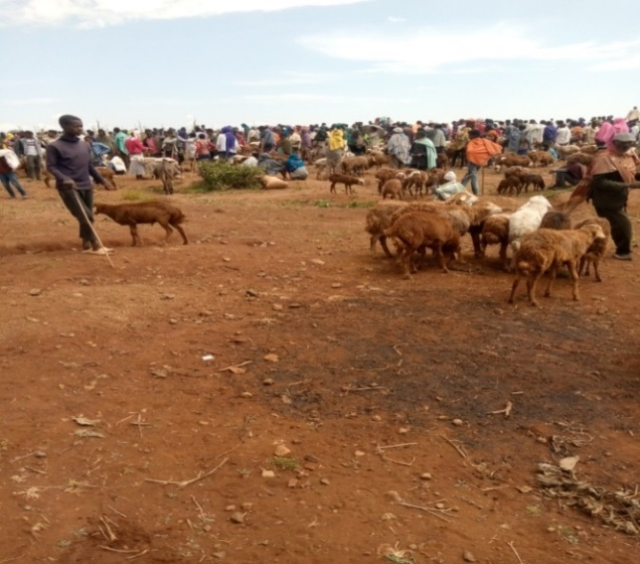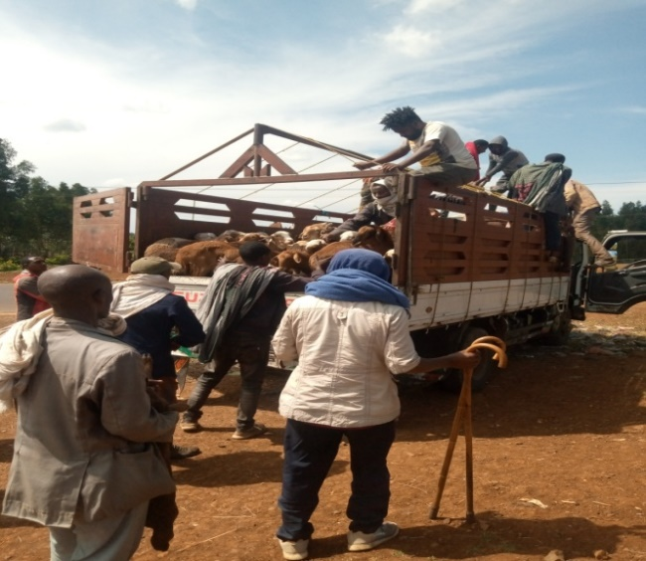
Appendix Figure 1: Animal purchasing and transportation
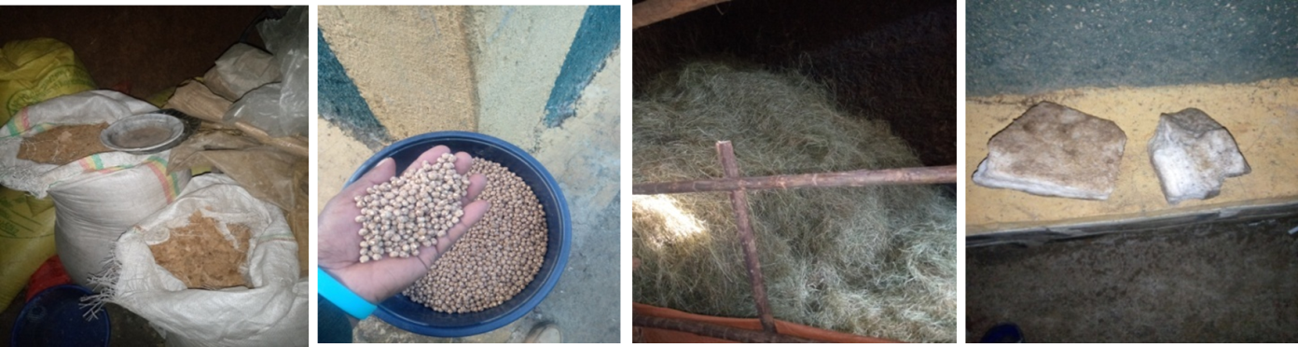
Appendix Figure 2. Experimental feeds (Soybean cake, sweet lupine grain, natural pasture hays and soybean meal from left to right).
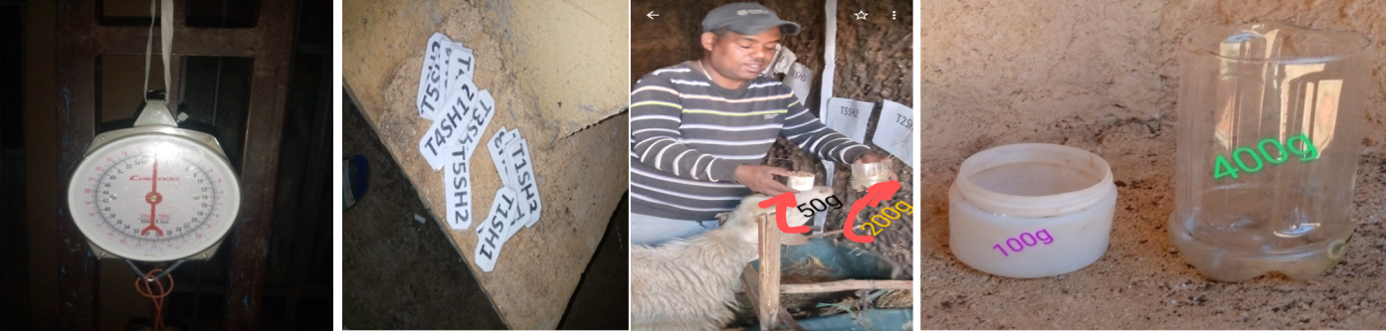
Appendix Figure 3. Materials used to weight, identify animals and deliver feed and water
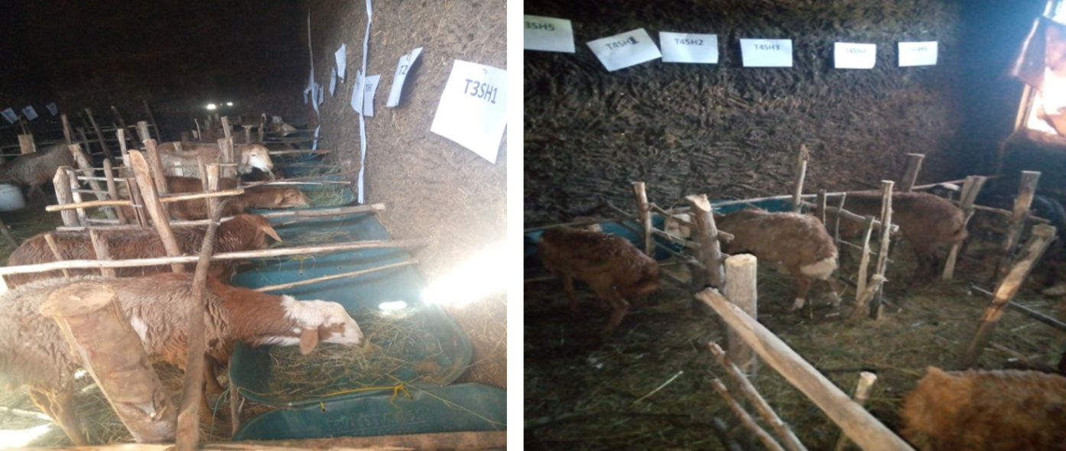Appendix Figure 4. Experimental animals arranged for the feeding trial level with the type of feed they offered
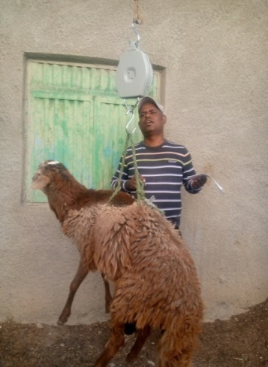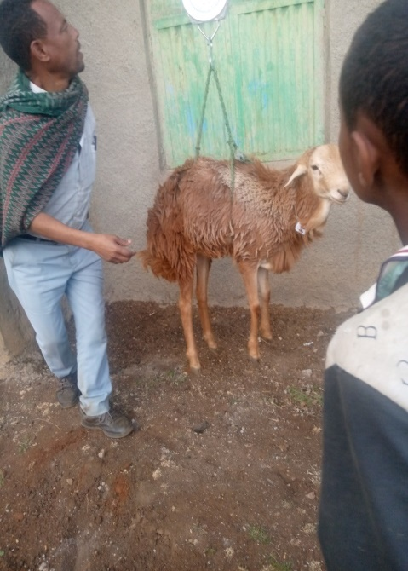
Appendix Figure 5. Weighing of experimental animals with suspended weighting balance

