
DEBRE MARKOS UNIVERSITY
COLLEGE OF HEALTH SCIENCES,
DEPARTMENT OF HEALTH INFORMATICS
UTILIZING DEEP LEARNING ALGORITHMS TO DEVELOP A PREDICTIVE MODEL FOR CLASSIFYING TYPES OF ANTI-RETROVIRAL TREATMENT REGIMEN FAILURE AMONG ADULTS CURRENTLY ON ART AT COMPREHENSIVE AND SPECIALIZED HOSPITALS IN THE AMHARA REGION, ETHIOPIA,2025
BY; MISGIE KASSANEW
ADVISORS:
- MR. ZEGEYE R. (MPH, HI)
- MR. AYINADIS W. (MPH, HI),
A PROPOSAL TO BE SUBMITTED TO HEALTH INFORMATICS DEPARTMENT COLLEGE OF HEALTH SCIENCES DEBRE MARKOS UNIVERSITY IN PARTIAL FULFILLMENT OF THE REQUIREMENTS FOR MASTER OF SCIENCE IN HEALTH DATA SCIENCE

MAY 2025
DEBRE MARKOS, ETHIOPIA

DEBRE MARKOS UNIVERSITY

COLLEGE OF HEALTH SCIENCE
RESEARCH REVIEW ETHICAL COMMITTEEPROPOSAL APPROVAL SHEET
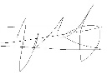
SUBMITTED BY:
MISGIE KASSANEW ------
DATE: 12/10/2017 SIGNATURE

APPROVED BY:
MR. ZEGEYE R. (MPH, HI) 
(MAIN ADVISOR) SIGNATURE
DATE, 30/09/2017
- Aynadis Worku 
(CO-ADVISOR) SIGNATURE
DATE, 30/09/2017
- Muluken Belachew 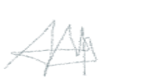
(NAME OF CHAIRMAN, DGC) SIGNATURE
DATE, 30/09/2017
- Aynadis Worku 
(NAME OF DEAN, SGS ) SIGNATURE
DATE, 30/09/2017

Declaration
My name is Misgie Kassanew, hereby declare that this research proposal titled “Utilizing Deep Learning Algorithms to Develop a Predictive Model for Classifying Types of Anti-Retroviral Treatment Failure (First, Second, and Third) Among Adults Currently on ART in Public Health Facilities in the Amhara Region, Ethiopia, 2024” is my original work. I have conducted this research with integrity and adherence to ethical standards. This proposal has not been submitted for any other degree or qualification. All sources of information have been duly acknowledged, and any collaboration or assistance received during the preparation of this proposal has been explicitly noted.
I understand the importance of maintaining academic honesty and integrity throughout the research process.
Name: Misgie Kassanew
Signature: _______________________
Email address: kassanewmisgie@gmail.com
Due Date: ________________________
Contact phone: +251 0934578227

Acknowledgment
Firstly, I would like to express my heartfelt gratitude to Debre Markos University College of Health Sciences, Department of Health Informatics, for the opportunity to prepare this research proposal as part of the requirements for my Master of Science in Health Data Science.
I sincerely appreciate the invaluable support and guidance provided by my advisors, Mr. Zegeye R. (MPH, HI and Mr. Ayinadis W. (MPH, HI), throughout the development of this proposal.

ACRONYMS AND ABBREVIATIONS
AIDS | Acquired Immune Deficiency Syndrome
ANN | Artificial Neural Network
ART | Antiretroviral Therapy
ARV | Antiretroviral
ATV/r | Atazanavir/ritonavir
AUC | Area under ROC Curve
AZT | Azidothymidine
CD4+ | Cluster of Differentiation 4 Positive
DNN | Deep Neural Network
EFV | Efavirenz
FPR | False Positive Rate
HIV | Human Immunodeficiency Virus
LPV/r | Lopinavir/ritonavir
ML | Machine Learning
FMOH | Federal Minister of Health
HAART | Highly Active Anti-Retroviral Therapy
IF | Immunologic Failure
OIs | Opportunistic Infections
PLHIV | People Living With HIV
TB | Tuberculosis
UNAIDS | Joint United Nations Program on HIV and AIDS
VL | Viral Load
WHO | World Health Organization
ASM | Appointment Spacing Model
D4T | Stavudine
ABC | Abacavir
NVP | Nevirapine
3TC | Lamivudine
DRV | Darunavir

Table of Contents
Declaration 4
Acknowledgment 5
ACRONYMS AND ABBREVIATIONS 6
List of Figures 7
List of Tables 8
Abstract 9
1. INTRODUCTION 10
1.1. Background of the Study 10
1.2. Statement of the problem 12
1.2. Justification of this Study 16
1.4. Significance of the study 16
2. LITERATURE REVIEW 17
2.1. First Line ARV treatment failure 17
2.1.1. Socio-demographic factors 17
2.1.2. Clinical Factors 18
2.1.3. Behavioral Factors 19
2.3. Third Line ARV treatment failure 21
2.4. Deep Neural Networks in Predictive Modeling 22
2.4.3. Decision Support and Cost-Effectiveness 22
2.4.4. Predictive Models Utilizing Deep Learning Algorithms 23
2.4.5. Learning Processes in Deep Neural Networks 24
2.4.6. Functions and Activation in Neural Networks 25
2.5. Conceptual frame work 26
2.1. Research question 27
3.1. General Objective 27
Methods and Materials of the Study 28
4.1. Study 28
4.2. area and period 28
4.3. Study Design 30
4.3. Data Source 30
4.4. Study Population 30
4.4.1. Inclusion Criteria: 30
4.4.2. Exclusion Criteria: 31
4.5. Variables 31
Outcome variable 31
Predictor Variables 31
Demographics 31
Clinical Factors were: 31
Treatment-Related Factors 31
4.6. Operational Definition 31
4.7. Modeling Framework for Developing the Predictive Model 33
4.8. Data Collection Tools and Procedures 34
4.9. Data Preprocessing and Management 35
4.10. Feature selection 36
4.11. Addressing Class Imbalance: The SMOTE Method 37
4.12. Model Selection 38
4.13. Architecture Design for Developing a Predictive Model 38
4.14. Model Training for Developing the Predictive Model 41
4.15. Performance Assessment for the Predictive Model 42
4.16. Evaluation Matrix 43
4.17. Ethical Consideration 44
5. Result 45
5.1. Sociodemographic characteristics of participants 45
5.2. Prevalence of ARV Regimen treatment failure and its significant 45
5.3. Treatment and clinical Related characteristics of participants 46
5.4. Predictors of ARV Regimen Treatment Failure 48
5.4.1. Predictors of No ARV Regimen Treatment Failure (Class 0) 48
5.4.2. Predictors of First Line ARV Regimen Treatment Failure (Class 1) 49
5.4.3. Predictors of Second Line ARV Regimen Treatment Failure (class 2) 49
5.5. Result of Class Imbalance 49
5.6. Collinearity Management and Feature Selection 52
5.7. Result in Feature Selection 54
5.8. DNN Predictive Model building 58
5.9. Evaluation Model Performance 59
5.9.1. Evaluation of TabNet DNN performance 59
5.9.2. Evaluation of CNN Model performance 61
5.9.3. Evaluation of FNN Model performance 63
5.9.4. Evaluation of MLP Model performance 66
5.10. Hyperparametric tuning during this experiment 67
Utilized Hyperparameters 68
Hidden Layers 68
Output Layer 69
Methods used for Controlling Overfitting 69
5.11. The overall performance of the selected DNN model 70
6. Discussions 72
7. Conclusion 75
8. Strength and Limitation of this Study 76
8.1. Strengths of the Study 76
8.2. Limitations of the Study 76
9. Recommendations 76
10. References 78
Anex 1 Annex EMR/HIV/AIDS dataset Extraction Tool 84
Questionnaire with Variable Types 87
Anex 2 Information sheet 90

List of Figures
Figure 1:Conceptual framework for utilizing deep learning algorithms to develop a predictive model for classifying types of anti-retroviral treatment failure 29
Figure 2:map of the study area (Amhara region Location Map) 32
Figure 3:Model developing framework 36
Figure 4:Target Variable before Class Imbalance by SMOTE 53
Figure 5:Target Variable After Class Imbalance by SMOTE 53
Figure 6:Correlation Matrix before Controlling collinearity 55
Figure 7:Correlation Matrix after Controlling collinearity 56
Figure 8:Feature Selection by Random Forest for ARV Regimen Treatment failure 60
Figure 9:receiver Operating Characteristics Curve (Roc) From Tabnet Model 62
Figure 10:: receiver Operating Characteristics Curve (Roc) From CNN Model 65
Figure 11:receiver Operating Characteristics Curve (Roc) From FNN Model 67
Figure 12:receiver Operating Characteristics Curve (Roc) From MLP Model 69

List of Tables
Table 1: comparison summary of the studies related to predictive modeling of HIV/AIDS treatment outcome using various types of Deep Neural Networks (DNN): 25
Table 2:: Selected CSH study area for utilizing deep learning algorithms to develop a predictive model for classifying types of anti-retroviral treatment failure at selected comprehensive and specialized Hospital in Amhara Region 2025 30
Table 3:Summarizes the purpose and use of each library in Our Model: 38
Table 4:Confusion Matrix to develop predictive model to classify ART Regimen treatment failure 45
Table 5:Sociodemographic characteristics of the study participants in the Amhara Region Comprehensive and Specialized Hospital, May 2025 (N=32812) 47
Table 6:Treatment and Clinical characteristics of the study participants in the Amhara Region Comprehensive and Specialized Hospital, May 2025 (N=32812) 48
Table 7:: Important Feature selection by Random Forest algorithm for class 1 57
Table 8:Important Feature selection by Random Forest algorithm for class 2. 58
Table 9:Summary of model performance evaluation Metrics for CNN Model 64
Table 10:Summary of model performance evaluation Metrics for FNN Model 67
Table 11:model performance evaluation Metrics for MLP Model 69
Table 12:Summarizing The utilizing Hyperparameters in this Study to develop predictive model to classify ARV regimen treatment failures across three classes. 71
Table 13:The comparison of all deep learning models.by the performance metrics 74

Abstract
Background: HIV/AIDS remained a critical global health challenge, with approximately 40 million individuals living with the virus. In Ethiopia, around 610,335 individuals were affected, facing significant challenges from anti-retroviral treatment (ART) failure. Despite the introduction of ART, rising treatment failure rates were driven by factors such as viral mutation and inadequate adherence to treatment regimens. This study aimed to improve prediction accuracy and provide personalized treatment options.
Objectives: The study aimed to develop a predictive model to classify anti-retroviral (ARV) treatment failure among adults currently on ART at selected comprehensive and specialized hospitals in the Amhara Region of Ethiopia 2025.
Methods and Materials: A cross-sectional study design was employed, utilizing electronic medical records (EMR) from selected hospitals in the Amhara Region. The 32812 data were extracted And pre-processed using Python to ensure suitability for analysis, encompassing cleaning, normalization, and feature extraction. The predictive model leveraged deep neural networks to capture complex patterns, with performance evaluated using metrics such as accuracy, precision, recall, and F1-score. The study was conducted from January to February 2025.
Results in this study Convolutional Neural Network (CNN) emerged as the most effective Classifier, achieving a training accuracy of 99.02% and a testing accuracy of 98.62%. the Key predictors of treatment failure included first-line regimens (1a and 1b), poor adherence levels, presence of opportunistic infections, WHO stages 3 or 4, and switching to less effective second-line regimens. Protective factors against treatment failure encompassed high adherence, absence of OIs, and the initiation of cotrimoxazole prophylaxis
Conclusion: his study evaluated various deep learning algorithms for classifying ARV regimen treatment failures using a dataset of 32,812 participants. Key findings revealed significant gender disparities and highlighted that treatment failures were most prevalent among older adults. The Convolutional Neural Network (CNN) emerged as the most effective model, achieving a training accuracy of 99.02% and a testing accuracy of 98.62%,
Keywords: predictive model, machine learning, deep learning, first line, second line, third line, deep neural network, ART, treatment failure, Bahir Dar, Ethiopia.

INTRODUCTION

Background of the Study
Anti-retroviral treatment failure (TF)) is defined as when the combination of ARV regimen unable to control the progression of HIV disease, replication of virus and prevention of HIV/AIDS related and symptoms like stages 3 & 4 conditions after the completion of 6-month ARV therapy. Treatment failure might be clinical, immunological or virological, and it is a great challenge for the management of HIV/AIDS in resource limited countries including Ethiopia(1–4).
Clinical failure is the occurrence of new or recurrent WHO stage 3 and 4 conditions, advanced HIV disease or opportunity infections after 6 months of effective ARV therapy (5). Virological failure is the occurrence of plasma viral load ≥ 1000 copies per one ml blood in two consecutive measurements within three-month interval with enhancing adherence counseling support after at Least six months ARV therapy (5,6). Immunological Failure; occurs when CD4 cell count is ≤ 250 cells/mm3 following clinical failure, or persistent CD4 cells level below 100cells/mm3. WHO recommended viral load testing currently, as golden standard for monitoring approach to diagnosis and confirm treatment failure (7).
ARV treatment failure significantly challenges HIV/AIDS management, leading to increased healthcare costs and poorer patient outcomes. As the virus mutates in response to ART, the effectiveness of these drugs diminishes. Innovative strategies, including advances in genomics and artificial intelligence (AI), are essential for predicting and managing treatment failures(8,9).
Patients typically start treatment with a first-line regimen combining two nucleoside/nucleotide reverse transcriptase inhibitors (NRTIs) and one non-nucleoside reverse transcriptase inhibitor (NNRTI). If this fails, a second-line regimen is introduced, composed of different NRTIs and a protease inhibitor (PI).
The introduction of antiretroviral therapy has been providing a significance change for reduction of HIV/AIDS related morbidity and mortality, The goals of HAART in patients with HIV infections include: Reduce morbidity and mortality (AIDS and non-AIDS associated causes)Improve the quality of life, Reduce plasma viral load Prevent transmission to others, mother to infant and Prevent drug resistance but, it cannot cure HIV(2,3).Treatment failure is associated with increased mortality, significant costs, and the emergence of drug-resistant strains. Effective management requires resistance testing when first-line ART fails to facilitate the transition to second-line therapies(1).
To address these challenges, clinical prediction models leveraging patient-level data can enhance decision-making in HIV management. These models can utilize statistical analysis or machine learning (ML) techniques, which are increasingly used to identify patterns in complex datasets and predict treatment outcomes(8,10,11),Predictive modeling can improve intervention targeting, enhance cost-effectiveness, and empower practitioners to proactively manage ARV treatment failures, ultimately improving patient outcomes
The introduction of antiretroviral therapy has been providing a significance change for reduction of HIV/AIDS related morbidity and mortality and the gradual evolution of HIV infection from fatal diseases to a chronic non-fatal condition therefore Antiretroviral therapy (ART) is the cornerstone of prevention and management of HIV infection.(12,13).
Ethiopia was adopted fee-based ART program in 2003 and It Initiated the new free based ARV Therapy in 2005. service from 24% in 2010 to 54% respectively in the most affected areas, like eastern and southern Africa region(2,4)

1.2. Statement of the problem
The burden of HIV/AIDS presents a significant public health challenge globally, with approximately 39.9 million people living with HIV as of 2023. Despite some progress in combating the epidemic, there were still 1.3 million new infections and around 630,000 deaths from AIDS-related illnesses in that year. Since the epidemic began, an alarming total of 88.4 million individuals have been infected, leading to 42.3 million deaths attributed to AIDS-related complications. This burden, however, is not evenly distributed, with Sub-Saharan Africa bearing a disproportionate share. In this region, women and girls account for 62% of new infections, reflecting a median HIV prevalence of about 0.8% among the general population, a figure that rises significantly among marginalized groups(1,4,10,14–18).
In 2016, global estimates indicated that approximately 5.5% of patients were on second-line antiretroviral therapy (ART). In sub-Saharan Africa, nearly two out of every 100 HIV patients transitioned to second-line treatment annually. In Ethiopia, those receiving second-line therapy represented 1.5% of the total ART population. Specifically, in the Amhara region, the incidence of second-line treatment failure was recorded at 9.86 cases per 100 person(19,20)
HIV/AIDS also remains a significant public health concern in Ethiopia. As of 2023, approximately 605,238 people were living with HIV, with a slight decline projected to 598,888 in 2024. The country has seen a decrease in new HIV infections, dropping from 8,355 in 2022 to an estimated 7,428 in 2023. Additionally, annual AIDS-related deaths totaled about 10,063 in 2023, with a projection of 9,356 deaths for the following year. Notably, a significant majority—90% of people living with HIV (PLHIV)—knew their status in 2023, and 94% were currently on treatment, with 96% of those on treatment achieving viral suppression. The burden of HIV is particularly high among vulnerable groups, including young people and women, underscoring the need for targeted interventions(2–4,14,21).
In the Amhara region, the burden of HIV/AIDS is similarly concerning. In 2023, around 173,442 individuals were reported to be living with HIV, with a slight decrease expected to 171,308 in 2024. The region recorded 1,545 new infections in 2023, projected to decline to 1,346 in the subsequent year. There were approximately 2,531 AIDS-related deaths in 2023, with an anticipated reduction to 2,271 in 2024. Awareness of HIV status was relatively high in the region, with 92% of PLHIV knowing their status and 97% of those aware currently on treatment. The rates of viral suppression among those receiving treatment were also notable, reflecting the effectiveness of local health programs. The burden is particularly pronounced among young individuals and women, highlighting the necessity for ongoing advocacy and targeted health interventions in the region(3,15,21).
To avert the burden of ARV treatment failure different interventional strategies have taken, thus The WHO recommends regular viral load testing as the standard method for monitoring treatment success and diagnosing TF, with guidelines suggesting that viral load assessments should occur six months after treatment initiation and annually thereafter(4,10,11,15,17,18,22,23).
World Health organization (WHO) and ministry of health have frequently changed different Guidelines to start HAART for newly HIV diagnosed clients to reduce the magnitude of HIV/AIDS related morbidity and mortality away from the initial threshold of ‘less than 200 CD4 cells/mm3 in 2005, to a recommendation of ‘less than 350 CD4 cells/mm3 in 2008. In 2017, adults with WHO clinical stage III & IV irrespective of CD4 cell count or CD4 cell count less than 500 cell/mm3 or all TB/HIV co-infected and pregnant & lactating women irrespective of CD4 cell counts are eligible for ART initiation, and currently test and treat strategy approach) have adopted(3,20,24)
The other guidelines which had developed by the Joint Nations Program on HIV/AIDS (UNAIDS IN 2014 to reduce the burden of HIV/AIDS morbidity and mortality was three ninety strategy which targets that diagnosis of 90% of HIV infected individual, access to treatment for 90% of identified HIV infected person, and 90% viral suppression among those initiated a treatment, new infection less than 500,000 and zero discrimination by the end of 2020(33,35).
The other HIV/AIDS prevention and control strategy was the Fast Track Strategy which was people-centered approach to ending the AIDS epidemic by 2030. The fast track strategy aims that 95-95-95 approach which mean that diagnosis of 95% of HIV infected individual ,access to treatment for 95% of identified HIV infected person, and 95% viral suppression among those initiated a treatment, new infection less than 200,000 and zero discrimination By the end of 2030(25).besides those HIV epidemic prevention program differentiated service delivery model has been adopted[appointment spacing model and recently covid interim guidelines (fast track ART refill)(FTAR) had been implementing and some ARV regimens have excluded combination therapy(1,14,21).
Failure to address ARV treatment failure not only impacts the health and well-being of individuals living with HIV/AIDS but also has broader implications for healthcare systems and society. Addressing this issue is critical to ensuring effective treatment, improving quality of life, and maintaining public health efforts in the fight against HIV/AIDS(4,10,15)
Ethiopia adopted the UNAIDS targets and also rolled out routine viral load testing as the gold standard to monitor treatment outcome of ART(2,4,14,15)
Despite there is designing different interventional and controlling strategy still there is high rate of ARV treatment failure or fail to attain the desire target of treatment success, ARV treatment failure is Key Challenges to manage HIV/AIDS related morbidity and mortality in developing countries including Ethiopia where the diagnostic method and management of ART failure is inadequate (2,4,8,9,14,15,22,23)
Third-line ART has been estimated to be fifteen times more expensive than first-line and six times more expensive than second-line ART at current prices. Current approaches to third-line therapy also require access to routine viral load monitoring and HIV resistance testing. Unlike the implementation of standardized first- and second-line regimens currently in use in most countries, third-line regimens are generally individualized to account for treatment history, toxicities as well as resistance patterns and therefore require a higher cadre of health care(26–30).
The rising prevalence of HIV strains associated with ARV treatment failure underscores the urgent need for effective predictive models that assist healthcare providers in tailoring treatment strategies. Current approaches often fall short in accurately forecasting mutations that lead to treatment failure, resulting in suboptimal regimens. Additionally, the complexity of HIV’s evolutionary dynamics and the challenge of integrating diverse genomic and clinical data into actionable insights complicate the management of ARV treatment failure.
Recent advancements in artificial intelligence (AI) have significantly enhanced our understanding of ARV treatment failure. These developments facilitate rapid and cost-effective analyses of viral genomes, enabling researchers to accurately identify mutations linked to treatment failure. Machine learning and deep learning techniques are crucial for analyzing extensive datasets, uncovering patterns associated with treatment failure, and integrating diverse data sources—including viral genotype, host genetics, and clinical information—to improve the accuracy of predictive models(31,32).
This approach, particularly novel in Ethiopia's Amhara region, addresses a significant gap by not only predicting ARV regimen treatment failure but also classifying it into distinct categories. Traditional models typically focus on factor association studies without providing treatment outcome classifications. By leveraging various predictor variables, deep learning algorithms enhance accuracy in analysing the complex and high-dimensional nature of health data, including interrelated variables such as viral load and CD4 counts. Unlike traditional statistical methods, these models excel at capturing non-linear relationships and offer superior predictive accuracy, especially with large datasets, which is crucial for informed treatment decisions. They automatically extract relevant features from raw data, effectively handle noisy inputs, and scale to accommodate vast amounts of information. Additionally, deep learning can integrate diverse data types, including clinical and genomic data, and utilize advanced techniques like time-series analysis and transfer learning to bolster performance even with limited datasets. Recent advancements in interpretability tools further bridge the gap between deep learning and traditional methods, making model decisions more understandable. Overall, this deep learning approach significantly enhances patient outcomes through comprehensive and accurate analysis in the context of HIV treatment, moving beyond mere factor associations to actionable classifications(33–35).
Therefor, retain the client in first line ARV regimen by utilizing advanced statistical model like deep learning algorithms can enhance accuracy in analysing the complex and high-dimensional nature of HIV/AIDS data, is the vital interventional mechanism for HIV related morbidity and mortality in resource limited settings like Ethiopia where the option of ARV treatment is limited; designing strategies to prevent the premature switching of first line ART is indispensable. Therefore, to achieve this goal, it is important to early identify the determinants of first line ART failure. Identifying and investigating the determinant factors of ARV Regimen treatment failure is a very critical action to prevent the premature switching of first line ARV regimen and to avert epidemic of HIV/AIDS and improve the quality of life for ARV patients(9,10,16,19,27,36–38)

Justification of this Study
Previous research in Ethiopia, particularly in the Amhara region, has identified predictors of ART failure among adults on highly active antiretroviral therapy (HAART). However, these studies primarily used traditional statistical methods, which often overlook the complex interactions among various factors contributing to treatment failure (28,38)..
As HIV treatment regimens evolve, there is a critical need for advanced analytical techniques. Deep learning algorithms, a powerful form of machine learning, can analyze complex datasets and reveal patterns that conventional methods may miss.
Recent advancements in artificial intelligence (AI) have significantly enhanced our understanding of ARV treatment failure. These developments facilitate rapid and cost-effective analyses of viral genomes, enabling researchers to accurately identify mutations linked to treatment failure. Machine learning and deep learning techniques are crucial for analyzing extensive datasets, uncovering patterns associated with treatment failure, and integrating diverse data sources—including viral genotype, host genetics, and clinical information—to improve the accuracy of predictive models(8,9,38).
Therefore, this study aims to develop a predictive model using deep learning to classify types of ART failure—no failure, first-line, second-line, and third-line—among adults at comprehensive and specialized hospitals in the Amhara region (9,38–40).

Significance of the study
The results of this study may be utilized to enhance patient care by developing a predictive model that classifies types of antiretroviral treatment (ART) failure, enabling timely interventions for patients facing treatment challenges. Early identification of ART failure types will facilitate personalized treatment adjustments, ultimately improving patient outcomes and quality of life. By employing deep learning algorithms, this research provides healthcare professionals with a robust analytical tool for evidence-based decision-making, enhancing diagnostic accuracy and treatment management.

Moreover, the finding of this study might contribute to the body of knowledge on HIV/AIDS treatment in Ethiopia, showcasing the effectiveness of advanced computational techniques and encouraging further research in this area. The study also aims to strengthen local healthcare facilities by training personnel in data analysis and predictive modeling, empowering them to manage ART and other health interventions more effectively.
Additionally, the results may inform policymakers and other stakeholders in formulating strategic plans based on the findings. This research will serve as a baseline for future studies, offering valuable insights for upcoming researchers interested in this field.

2. LITERATURE REVIEW
There are different socio-demographic, behavioral and clinical factors that potentially contribute for ART treatment failure specially in developing countries or poor resource setting countries like Ethiopia(10,15,16,18).

2.1. First Line ARV treatment failure

2.1.1. Socio-demographic factors
Several studies have explored socio-demographic factors associated with first-line antiretroviral therapy (ART) treatment failure globally and locally. Age has consistently emerged as a significant factor. Studies conducted in Uganda and Kenya revealed that younger age is positively associated with virological failure, (10,15,16,22,41) In contrast, studies from Cameroon identified higher age as a risk factor for treatment failure (34–36), a finding supported by other studies which indicated that older ART clients have a higher risk of developing treatment failure compared to younger clients(23,39,42)
Gender has also been studied as a determinant of ART treatment failure. A study in Uganda showed that males had a slightly higher proportion of treatment failure compared to females (31), while studies in South Africa similarly reported higher odds of treatment failure among males than females (37, 38). However, a study in Tanzania found no significant association between sex and treatment failure (39). Locally, a study conducted at Dessie Referral Hospital revealed that being female was a protective factor against treatment failure (3).
Geographical and socio-economic factors also play a role. A study in Nigeria found that being far from health centers for follow-up and younger age at ART enrollment were significant factors for first-line ART failure (12, 33). Similarly, a retrospective cohort study in Arba Minch Town indicated that widowed individuals and those living in rural areas had higher odds of treatment failure compared to married individuals and urban residents, respectively (51). Conversely, a case-control study in Jimma revealed that urban residents had higher odds of treatment failure compared to rural residents (52, 53). Employment and education were also significant factors. A study in Woldia reported that unemployed ART clients were at higher risk of treatment failure than employed clients, and those with formal education had higher odds of treatment failure compared to illiterate clients (33).

2.1.2. Clinical Factors
Clinical factors such as ART regimen, baseline health status, and treatment adherence have been shown to significantly influence ART treatment outcomes. In Tanzania, a retrospective cross-sectional study found that clients on AZT-based regimens and those with longer ART durations were more likely to experience first-line treatment failure compared to those on TDF-based regimens or with shorter treatment durations (13, 54). Similarly, studies conducted in Jimma, Tigray, and other parts of Ethiopia reported that longer ART duration was associated with higher odds of treatment failure (2, 8, 14–16).
Baseline clinical indicators also play a crucial role. In Cameroon, a study revealed that clients with low baseline CD4 counts had higher odds of treatment failure compared to those with higher baseline CD4 counts (56–59). A study in Tigray further confirmed that both baseline and recent CD4 counts of less than 200 cells/micro liter were significantly associated with virological failure (71). Additionally, a meta-analysis in Ethiopia identified advanced WHO stages, co-infections, and frequent regimen changes as significant risk factors for first-line ART treatment failure (72).
Adherence to treatment and follow-up practices were also highlighted. Studies conducted in various countries, including Nigeria, South Africa, and Kenya, showed that clients with poor adherence, those who defaulted on follow-ups, or those who were transferred between facilities had higher odds of treatment failure (33, 49, 62). Poor disclosure of HIV status was another significant factor, with studies showing that clients who had not disclosed their status were at higher risk of treatment failure compared to those who had disclosed (59, 63–66).
Other clinical factors include co-morbidities and nutritional status. Studies revealed that clients with TB co-infection or low baseline BMI had higher odds of treatment failure compared to those without TB co-infection or with normal baseline BMI (23, 38, 67, 73). In Kenya, clients with baseline WHO stages 3 or 4 were found to have a higher risk of treatment failure compared to those in stages 1 or 2 (38, 52, 59).

2.1.3. Behavioral Factors
Behavioral factors such as substance use and disclosure of HIV status have also been linked to treatment failure. A study in Morocco revealed that ART clients who smoked or consumed alcohol had higher odds of treatment failure compared to non-smokers and non-drinkers (74). Similarly, a study in Jimma found that clients who smoked cigarettes or chewed khat were more likely to develop first-line treatment failure than non-users (23).
Disclosure of HIV status has been another key factor. A case-control study in Jimma revealed that clients who had not disclosed their HIV-positive status were at a higher risk of experiencing treatment failure compared to those who had disclosed their status (75). Poor disclosure has been consistently associated with poor adherence and worse treatment outcomes.
In summary, socio-demographic, clinical, and behavioral factors significantly contribute to first-line ART treatment failure. Younger or older age, male gender, socio-economic status, poor adherence, clinical conditions such as low baseline CD4 count, TB co-infection, advanced WHO stages, and behavioral factors like substance use and non-disclosure of HIV status have all been identified as significant determinants. These findings underscore the importance of addressing these factors in clinical and public health interventions to improve ART treatment outcomes globally and locally(16,20,23,26–28,30,36–38,42–45).
2.2. Second Line ARV treatment failure
Various studies conducted globally, including those in Africa and Ethiopia, have identified several key predictors of failure in second-line antiretroviral therapy (ART). These factors include:
a CD4 count of less than 100 cells/mm³ at the time of switching to second-line treatment, being categorized as WHO clinical stage IV, inadequate adherence to ART, the presence of co-infection with tuberculosis, older age at the initiation of second-line ART, changes made to the second-line drug regimen, a decrease in weight, a high viral load at the beginning of second-line ART, the use of D4T and NVP-based first-line ART regimens, and the duration of time spent on the first-line ART regimen(4,16,18,22,26,27).
the study conducted with The factors associated with ARV treatment failure among HIV clients on second-line antiretroviral treatment in the Amhara Region, at Felege Hiwot and University of Gondar hospitals revealed that Non-disclosure of HIV Status, Patients who did not disclose their HIV status, Poor adherence to antiretroviral therapy, Not using condoms , Patients with a viral load greater than 150 copies/ml at the time of switching to second-line ART were significantly associated with second line ARV treatment failure(17,26,27,37) .
The systematic review and meta-analysis by Kassie et al. (2024) identified several critical determinants of second-line antiretroviral treatment (ART) failure among HIV patients in Ethiopia. The significant predictors identified include:
Non-disclosure of HIV Status: Patients who did not disclose their HIV status were at a significantly higher risk of experiencing virological failure, Low adherence to antiretroviral therapy, Individuals who did not use condoms, High Viral Load (>150 copies/ml) at Switch to Second-line ART and Those at an advanced WHO clinical stage when switching to second-line ART experienced, A CD4 count below 100 cells/mm³ and presence of tuberculosis co-infection at second line switching time were significantly associated with second line ARV treatment(27,37,42,44).

2.3. Third Line ARV treatment failure
A cross-sectional study conducted in South Africa to assess the predictors of third-line antiretroviral therapy (ART) treatment failure found that poor adherence to ART, being under 40 years of age, non-disclosure of HIV status, and moderate to high levels of depression were associated with a higher risk of third-line antiretroviral therapy (ART) treatment failure(16)
A cross-sectional study conducted in Addis Ababa in 2024 aimed at identifying the predictors of third-line ARV treatment failure found that several factors were significantly associated with treatment failure. These included poor adherence to therapy, low CD4 cell counts at the initiation of second-line ARV treatment, the presence of HIV-related stigma, substance use, low income, opportunistic infections, a duration of ART use exceeding 10 years, and co-infection with tuberculosis(45)
The study conducted in Sub-Saharan Africa stated that the determinants of third-line ARV treatment failure include poor treatment adherence, adherence index, younger age, employment status, social instability, HIV status disclosure, alcohol consumption, depression, self-reported adverse drug reactions (ADRs), cost of transportation, and clinic operational hours(9,11,22,39).
The study conducted in Sub-Saharan Africa identified several determinants of third-line antiretroviral (ARV) treatment failure, including poor treatment adherence, adherence index, younger age, employment status, social instability, HIV status disclosure, alcohol consumption, depression, self-reported adverse drug reactions (ADRs), transportation costs, and clinic operational hours(11,17,19,20,23).
A review of various studies, spanning both global and local contexts, indicates that the predictors of treatment failure for first-line, second-line, and third-line ARV therapies exhibit significant similarities., critical predictors of second-line ART failure included being at WHO clinical stage IV at the time of switching and having a CD4 count below 100 cells/mm³. Additionally, weight loss was associated with higher failure rates(17,18,45).
low CD4 T-cell counts (<200 cells/mm³) and poor adherence to ART were significant predictors of virological treatment failure among patients on first-line therapy. Notably, patients with a body mass index (BMI) of less than 16 kg/m² had an odds ratio (AOR) of 4.2 for treatment failure compared to those with a BMI greater than 18.5 kg/m².(15).

2.4. Deep Neural Networks in Predictive Modeling
Deep neural networks (DNNs), a specialized form of ANN, have emerged as powerful tools for classification tasks within healthcare. DNNs excel at identifying nonlinear relationships in data, outperforming traditional linear methods in complex medical scenarios (For instance, Basit et al. (2014) demonstrated the application of multilayer perceptron models for predicting osteoporosis risk, illustrating the versatility of neural networks across various medical domains. Additionally, Shahid et al. (2019) highlighted the broad applicability of DNNs in healthcare, including clinical diagnostics, cancer prediction, and image analysis, all of which are relevant to predicting ART treatment failure(37,42,43,46,47).

2.4.3. Decision Support and Cost-Effectiveness
The incorporation of ANNs into decision support systems has provided healthcare professionals with effective and cost-efficient tools for resource management. DNNs are particularly adept at generalizing patterns from new data, accommodating noisy inputs, and generating reliable estimates, which are essential for predicting ART outcomes the DNNs are predominantly used for classification, prediction, and clinical diagnosis across diverse healthcare domains, including cardiovascular health and telemedicine(48,49).

2.4.4. Predictive Models Utilizing Deep Learning Algorithms
DNNs are designed to identify patterns and develop models from labeled datasets, making them effective for supervised learning tasks. A key advantage of DNNs is their capacity to progressively learn mappings from inputs to outputs, allowing for the categorization of unobserved samples based on input values(8,11,38).
Typically, an ANN comprises an input layer, one or more hidden layers, and an output layer. In contrast, deep neural networks feature multiple hidden layers, enhancing the complexity and depth of data processing. This architecture enables dynamic learning as algorithms filter information through successive layers, contributing to more nuanced predictions regarding ART treatment failure(38,40).
Table 1: comparison summary of the studies related to predictive modeling of HIV/AIDS treatment outcome using various types of Deep Neural Networks (DNN):
Type of  DNN | Study Conducted Country | Author(s) | Year of  Study | Full Title of Study | Accuracy
MLP | Kenya | Titus Kipkosgei Tunduny | 2017 | A HIV/AIDS Viral Load Prediction  System Using Artificial Neural Networks | 93.76%
MLP | Ethiopia | Binyam Tariku  Seboka et al. | 2023 | Artificial Intelligence and Machine  Learning Based Prediction of Viral Load  and CD4 Status of People Living with HIV  on Anti-Retroviral Treatment in Gedeo  Zone Public Hospitals | 96%
CNN | Various  (Global) | Charles Chukwudalu Ebulue et al. | 2024 | Developing predictive models for  HIV Drug resistance: A genomic and AI  approach | 95%
FNN | Romania | Larder et al. | 2008 | Application of Artificial Neural  Networks for Decision Support in Medicine | Not specified
RNN | USA | Yu-Dong Cai et al. | 1998 | Artificial Neural Network Method  for Predicting HIV Protease Cleavage  Sites in Protein | 92.06%
In studies conducted in Kenya and Ethiopia, MLP and XGB models demonstrated high accuracy in predicting viral load, while CNN and RNN models showcased their versatility in various contexts within HIV research. Additionally, research from Romania and South Africa highlighted the effectiveness of SVM and RF models, underlining their predictive capabilities across different settings. A structured comparison table summarizes these studies, emphasizing the methodologies and outcomes of various DNN approaches in HIV-related predictions(8,9,11,38,39).

2.4.5. Learning Processes in Deep Neural Networks
Neural networks learn by processing input data and comparing it to desired outputs, allowing them to adapt without explicit programming. This self-learning ability enables models to make classifications and predictions based on new information after they have been trained.
Artificial Neural Networks (ANNs) have been utilized in various predictive applications, such as forecasting patient outcomes in hepatitis C and evaluating risks associated with coronary artery disease. They have also proven effective in assessing the health status of HIV/AIDS patients by analyzing publicly available datasets and using multilayer perceptron’s with various inputs. This flexibility highlights the significant impact of AI in improving diagnostic precision and supporting preventive healthcare strategies in the context of HIV(8,40,42).

2.4.6. Functions and Activation in Neural Networks
In a DNN, neurons function as mathematical models that mimic biological neurons, consisting of inputs, weights, and activation functions. Each neuron computes a weighted sum of its inputs, which is then processed through an activation function. This process allows for the transformation of input values into corresponding outputs, facilitating effective classification and prediction of treatment outcomes. Common activation functions, such as the ReLU function for hidden layers and the sigmoid function for output layers, play a critical role in normalizing the weighted sums of inputs, enhancing the model's predictive capabilities(42,43)

Conceptual frame work
Currently Treatment related factors
- adherent (ART)
- ART duration
- Type of DSD
- Current BMI
- Current WHO staging
- Current ARV Regimen
Socio-demographic variables
- Age
- Sex

Baseline Treatment related factors
- WHO stage
- Functional status
- OIS
- Base line CD4 count at enrolment time
- VL
- CPT
- BMI
- TPT
- Base line ART regimen
- Adherence to ART at enrolment

306 | Adherence to ART at enrolment
306 | Adherence to ART at enrolment

ARV Regimen
Treatment Failure
(0,1,2)

Figure 1:Conceptual framework for utilizing deep learning algorithms to develop a predictive model for classifying types of anti-retroviral treatment failure

2.1. Research question
- What is the prevalence of antiretroviral Regimen treatment failure among adults currently receiving ART at comprehensive and specialized hospitals in the Amhara Region?
- What are the key predictors of antiretroviral Regimen treatment failure among adults currently receiving ART at comprehensive and specialized hospitals in the Amhara Region?
- How can a predictive model be developed to identify ARV Regimen treatment failure among adults currently on ART at comprehensive and specialized hospitals in the Amhara Region?
3. Objectives

3.1. General Objective
The main objective of this study is to build a predictive model that classify anti-retroviral ARV drug treatment failure among adults currently receiving ART at comprehensive and specialized hospitals in the Amhara Region 2025
3.2. Specific Objectives
- To assess the prevalence of antiretroviral (ARV) treatment failure among adults currently receiving ART at comprehensive and specialized hospitals in the Amhara Region.
- To identify predictors of antiretroviral Regimen treatment failure among adults currently receiving ART at comprehensive and specialized hospitals in the Amhara Region.
- To develop a predictive model to classify ARV Regimen treatment failure among adults currently on ART at comprehensive and specialized hospitals in the Amhara Region.

Methods and Materials of the Study

Study

area and period
The study was conducted at comprehensive and specialized hospitals in the Amhara region from January 30 to February 30, 2025.
Table 2:: Selected CSH study area for utilizing deep learning algorithms to develop a predictive model for classifying types of anti-retroviral treatment failure at selected comprehensive and specialized Hospital in Amhara Region 2025
Name of Comprehensive and specialized Hospital | HIV Adults Currently on ART
Debre Birhan Comprehensive Specialized Hospital | 2347
Debre Markos Comprehensive Specialized Hospital | 3526
Debre Tabor Comprehensive Specialized Hospital | 2354
Dessie Comprehensive Specialized Hospital | 6654
Felege-Hiwot Comprehensive Specialized Hospital | 6722
Gondar Comprehensive Specialized Hospital | 6646
Tibebe Ghion Comprehensive Specialized Hospital | 179
Woldia Comprehensive Specialized Hospital | 4384
Total Currently on ART Clients at the end of December 2017 | 32812

Amhara Region Located in the northwestern part of the country, the Amhara region is bordered by Tigray to the north, Afar to the east, Oromia to the south, and Benishangul-Gumuz to the west. The region is characterized by diverse landscapes, ranging from lowlands at about 500 meters above sea level to the towering peaks of the Simien Mountains, which rise above 4,500 meters. This geographical diversity includes highlands, valleys, and lakes, making the region a key environmental and cultural area in Ethiopia.
With a total population of approximately 24.85 million, the Amhara region is administratively divided into 22 zones and 235 woredas. Its healthcare system comprises 118 hospitals and 914 health centers. Among these, 406 institutions provide Antiretroviral Therapy (ART) services, including 15 Drop-In Centers (DICs), 101 hospitals, and 290 health centers. As of November 2017, 155,913 individuals in the region were receiving ART services, of whom 152,804 were adults and 3,109 were children.
Situated about 500 kilometers (310 miles) from Addis Ababa, the capital city of Ethiopia, Amhara holds significant historical and cultural importance. It is home to renowned heritage sites such as Lalibela and Gondar, which reflect the region's rich history. In addition to its cultural significance, Amhara plays a vital role in Ethiopia's economy and social fabric. The Amhara region faces significant challenges related to ART regimen treatment failure, adversely affecting health outcomes for individuals living with HIV/AIDS. To address these challenges, several strategic interventions have been implemented, including enhancing patient education on adherence, establishing routine monitoring systems to track health outcomes, and improving access to healthcare services, particularly in rural areas. Ongoing training for healthcare providers on the latest ART management guidelines is essential, along with integrating ART services with mental health support. Despite these efforts, there is a high prevalence of treatment failure, compounded by limited advanced statistical models, such as deep learning, for predicting and classifying ARV treatment outcomes. Challenges like limited healthcare resources and ongoing stigma persist, highlighting the need for supportive policies to sustain these interventions and improve health outcomes in the region.
(https://visitamhara.travel/amhara-region/).
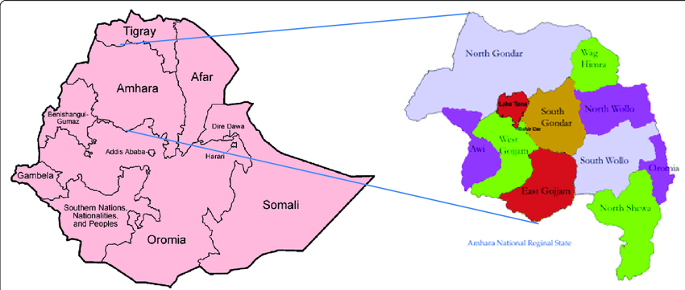

Figure 2:map of the study area (Amhara region Location Map)

Study Design
This research was utilized a cross-sectional study design to develop a predictive model that classify anti-retroviral ARV Regimen treatment failure among adults currently on ART clients at comprehensive and specialized hospitals in the Amhara Region., 2025

Data Source
The study was accessed an electronic medical records (EMR) dataset which a total data set of 32812 including with one target variable and 36 features at selected comprehensive and specialized hospitals in the Amhara Region

Study Population

Inclusion Criteria:
All adult PLHIV clients aged >=15years who had Anti-Retroviral Therapy (ART) follow up were on ART for at least 12 months and who had two consecutive viral load testing after ART initiation and who had declared either treatment failure or not by WHO criteria.

Exclusion Criteria:
- Adults ARV clients aged 15 or above years old with currently on ART who were on ART for 12 months and PLHIV who had incomplete intake form and clinical data were excluded from the study.
- Adults ARV clients aged 15 or above years old with currently on ART who were on ART for <12 months
- Adult ARV clients who were on enhancing adherence counseling (EAC) and who were not completed the EAC session.
- Clients who refer from other antiretroviral treatment health facility with incomplete base line information were excluded.

Variables

Outcome variable
Anti-retroviral ARV Regimen treatment failure (No failure, first Line, and Second line treatment Failure (0,1,2 respectively):

Predictor Variables
Potential predictors were identified based on prior literature and clinical expertise, including:
Demographics: Age, sex,
Clinical Factors were: Baseline CD4 count, viral load at ART initiation, comorbidities
Treatment-Related Factors: basic lab results, Drug regimen, adherence levels, drug side effects

Operational Definition
- No ART Regimen treatment Failure: Patients who maintain viral suppression (undetectable viral load) and adhere to their antiretroviral therapy (ART) regimen without any significant clinical or immunological deterioration.
- First-Line ARV Treatment Failure: Patients who experience virologic failure (e.g., persistently detectable viral load) after being on a first-line ART regimen for at least 6 months, despite adherence to the prescribed treatment. This may also include clinical or immunological failure, characterized by a decline in CD4 count or new opportunistic infections.
- Second-Line ART Regimen Treatment Failure: Patients who have switched to a second-line ART regimen due to first-line treatment failure and subsequently fail to achieve viral suppression after at least 6 months of adherence to the new regimen. This is indicated by persistent detectable viral load or clinical deterioration.
HAART: is the use of a combi nation of three or more antiretroviral to achieve durable suppression of viral replication(50).
Differentiated Service Delivery (DSD) model in the context of Antiretroviral Therapy (ART) refers to a patient-centered approach that tailors HIV treatment services to meet the diverse needs of individuals(2).
Virological failure: Client were considered as treatment failure if two consequence viral load results are >1000 with the provision of enhancive adherence counseling support9 EAC).(51)
Or the combination of ARV regimen unable to control the progression of disease, replication of virus and after the completion of 6-month ARV therapy.(51).
Good Adherence: Drug adherence of 95% or ≤ 2 missed drug doses of 30 doses or ≤ 3 missed drug doses of 60 doses.(51)
Fair Adherence: Drug adherence of 85–94% or 3–5 missed drug doses of 30 doses or 3–9 missed drug doses of 60 doses.(51).
Poor Adherence: Drug adherence of < 85% or ≥ 6 doses of missed ART drug doses of 30 doses or > 9 doses missed ART drug doses of 60 doses(51).

Modeling Framework for Developing the Predictive Model
This framework outlines the systematic approach to developing a predictive model for antiretroviral therapy (ART) treatment failure among individuals currently on ART in Amhara Region public health facilities using deep neural networks (DNNs).

ART data was extracted at electronic medical records (EMR) ART dataset from ARHB at selected CSH

Data was preprocessed
- Handlin missing value
- Encoding
- Manage outliers
- Managed collinearity
- Class imbalance

utilized Soft Ware for data preprocessing and analysis
- Python 3
- Stata
- Excel
- SPSS
- Google Collab

Feature selection
- Used statistical tests (e.g., chi-square, Correlation Coefficients:
- Wrapper Methods:(RFE),
- Random Forest

Model Evaluation
- Accuracy
- Precision
- Recall
- F -score
- ROC Curve

Model selection
Hyperparameter Tuning
Model training
- Feedforward Neural Networks (FNN)
- CNN
- Multi-Layer Perceptron’s (MLP)
- Tab net NN

Data Splitting data to training, testing and validation (70, 15 ,15 respectively)

Figure 3:Model developing framework

Data Collection Tools and Procedures
The primary source of data for this study was the ART clinic at a Comprehensive and Specialized Hospital in the Amhara region, which maintained an electronic database containing records of HIV-positive patients. To facilitate data extraction, the principal investigator conducted an orientation via conference call, explaining the purpose of the data collection, the specific variables to be extracted, and the use of a prepared extraction tool in Excel. The data clerk utilized patient MRN and Unique ART Number to extract information from a total of 32,812 adult HIV/AIDS clients across eight Comprehensive and Specialized Hospitals in the Amhara region were included in this study.
The electronic database contained multiple variables with a variety of integrated features, including clinical-related and treatment-related factors. Data that were not available in the EMR extraction tool, such as ARV regimen at ART enrollment, WHO staging at enrollment, and functional status at enrollment, were extracted individually via the provider view EMR data extraction tool using the patient's unique ART number. Any identifiable information, such as patient names and phone numbers, was removed during extraction to ensure confidentiality. Ultimately, a total of 32 features and one target variable were identified for analysis in this study.

Data Preprocessing and Management
Data preprocessing is a critical step in the data analysis pipeline, especially in deep learning. Various techniques were employed to ensure the quality and suitability of the dataset for modeling, focusing on reducing dataset size, uncovering relationships within the data, normalizing features, and extracting relevant attributes. The quality of the input data directly impacts the learning capability and performance of predictive models.
The EMR datasets often contain missing values due to encoding errors or incomplete entries, typically represented as NaN or Null indicators. The dataset from the Patient EMR exhibited numerous missing values, inconsistencies, and outliers. For example, client age (ranging from 1 to 99) and CD4 count (ranging from 50 to 350) displayed encoding issues. To address these, we calculated the median for numerical features and filled in the gaps accordingly. For string-type features, Python's dropna() function was used to remove incomplete entries, ensuring the dataset remained robust.
The dataset also included several ordinal and nominal features. The sex of clients was encoded as 0 for females and 1 for males using one-hot encoding. Viral load (VL) was categorized as 0 for Undetectable (≤50 copies/ml) and 2 for Low Level Viremia (51-1000 copies/ml). WHO stage categories were encoded as 0 for stage 1, 1 for stage 2, and 2 for stage 3. CD4 counts were grouped, with 0 indicating counts below 200 and 1 for counts above 200. The drug list was categorized into four groups, and the dependent variable, treatment failure status, was recoded as 0 for poor adherence and 1 for good adherence.
To facilitate effective modeling, categorical variables were converted into numerical formats using one-hot or label encoding and Continuous variables were normalized or standardized to ensure comparability across different scales, which is crucial for many machine learning algorithms. This process includes encoding categorical variables, which are discrete and not continuous. In this study, one-hot encoding was used, replacing categorical values with binary indicators.
Table 3:Summarizes the purpose and use of each library in Our Model:
Library | Purpose | Use
numpy | Supports large arrays. | Numerical tasks; foundation for libraries.
pandas | Provides structures for data. | Data manipulation and cleaning.
seaborn | Visualization library based on Matplotlib. | Creates complex plots (e.g., heat maps).
matplotlib.pyplot | For static and interactive visuals. | Plots data and graphs.
sklearn.model_selection.train_test_split | Splits data for training/testing. | Evaluates models with separate sets.
sklearn.preprocessing.StandardScaler | Standardizes features. | Normalizes data for training.
sklearn.feature_selection.SelectKBest | Selects top k features. | Reduces size and boosts performance.
keras.models.Sequential | Creates a stack of model layers. | Simplifies deep learning setup.
keras.layers.Dense | Fully connected layer. | Defines neuron connections in models.
pytorch_tabnet.  tab_model.TabNetClassifier | Implements  TabNet for classification. | Initializes TabNet for tabular data.

Feature selection
In our study, after cross checking collinearity by using correlation matrix (heat ma) we employed various feature selection methods specifically Chi-squared (χ²) , recursive feature extraction (RFE) and Random Forest feature selection technique was utilized.
We utilized Chi-squared feature selection as a statistical method to assess the independence of categorical variables. This approach evaluated how well each feature correlated with the target variable by comparing observed frequencies in a contingency table to the expected frequencies based on the assumption of independence.
Additionally, we employed recursive feature extraction (RFE) and Random Forest as an ensemble learning technique that utilized multiple decision trees to enhance predictive accuracy. This method assessed the importance of each feature based on its contribution to reducing impurity, such as Gini impurity or entropy, within the trees.
By combining these three methods, we aimed to leverage their strengths in identifying relevant features for our analysis beside the technique of these we utilized features by domain knowledge by supporting literatures, addressing both categorical and continuous variables effectively while capturing complex interactions among features. This dual approach facilitated a comprehensive feature selection process tailored to the specific characteristics of our dataset

Addressing Class Imbalance: The SMOTE Method
Many applications in fields automated decision-making, image recognition, and medical data analysis rely on imbalanced data learning. This issue arises when there is a significant disparity in the number of instances between majority and minority classes, which is particularly common in multi-class classifications. In this study, we focused on a three-class target variable, where the outcome variable consisted of ARV Regimen type treatment failure types: 0 for no ARV Regimen type treatment failure types, 1 for first-line ARV regimen treatment failure, and 2 for second-line ARV regimen failure.
The majority class was associated with for no ARV Regimen type treatment failure, while the minority classes represented the ARV regimen failures. Predictive accuracy is often used to evaluate the performance of deep learning algorithms; however, the imbalance in the dataset can skew accuracy and complicate the identification of factors contributing to treatment failure.
To address this challenge, we utilized the Synthetic Minority Oversampling Technique (SMOTE), along with Adaptive Synthetic (ADASYN) sampling and random under-sampling, to effectively balance the classes. SMOTE is an oversampling method designed for imbalanced datasets, generating new samples by interpolating between existing samples and their neighbors. This technique serves as a preliminary step in deep learning algorithms and is effective in managing class imbalance(34,35,52).
Random under-sampling balances the dataset by randomly discarding samples from the majority class until it reaches a desired ratio with the minority classes. ADASYN, on the other hand, adaptively generates synthetic data samples based on the distribution of minority class instances, producing more samples for those that are harder to learn while minimizing bias from the imbalanced data distribution. This combination of techniques helps ensure a more balanced dataset for training deep learning models(53,54).

Model Selection
For the predictive modeling of Antiretroviral Therapy (ART) treatment failure, we selected Deep Neural Networks (DNNs) as the primary algorithm. DNNs are particularly effective for handling complex datasets and capturing intricate patterns within the data, making them suitable for predicting treatment failure across multiple classes (0, 1, 2). This approach leverages the ability of DNNs to learn non-linear relationships, which is critical for accurately predicting outcomes based on a combination of demographic, clinical, and treatment-related features(52,54,55)

Architecture Design for Developing a Predictive Model
The architectural design for the predictive model aimed to effectively classify ART treatment failure into three distinct classes: no ARV regimen failure, first-line ARV regimen failure, and second-line ARV regimen failure. A deep neural network (DNN) was selected to capture complex patterns within the data, utilizing multiple layers and activation functions to optimize performance.
The decision to employ deep learning techniques was based on their ability to manage intricate relationships in the dataset. The architecture included input features, hidden layers, and specific activation functions, all designed to enhance the model's predictive accuracy regarding treatment outcomes. This approach aimed to improve patient care and inform treatment strategies in the context of ART.
In particular, the research was focused on advanced deep learning algorithms, including TabNet, Convolutional Neural Networks (CNN), Feedforward Neural Networks (FNN), and Multi-Layer Perception (MLP). These techniques were chosen for their effectiveness in addressing classification challenges within the healthcare domain.
A comprehensive literature review indicated that these deep learning algorithms are well-suited for complex classification tasks. The selection process was informed by critical factors such as accuracy, training duration, ability to manage missing data, and ease of interpretation(52–54,56).
This framework provided a solid foundation for investigating the classification of ARV regimen treatment failure, ultimately aiming to enhance predictive capabilities and support better ART treatment decisions (48,49,57,58).

Input Layer
The input layer included several relevant features essential for predicting ART treatment failure:
Demographic Information: Age and sex of the patients, which may influence treatment outcomes.
Clinical Data: Key clinical indicators such as CD4 count and viral load, critical for assessing the patient's health status and response to ART.
Treatment History: Information about adherence levels and the type of ART administered, as these factors significantly affect treatment efficacy.
WHO Clinical Staging: The stage of HIV disease, classified by the World Health Organization, impacting treatment decisions and outcomes.
Other Health Indicators: Comorbidities and health-related factors influencing the patient's overall health and treatment response.
Hidden Layers
The model architecture included 2 to 4 hidden layers, adjusted based on the complexity of the data and the relationships among input features. This range allowed sufficient depth to capture intricate patterns while avoiding overfitting.
Type of Hidden Layers:
Dense (Fully Connected) Layers: These layers connected every neuron in the previous layer to every neuron in the next, enabling comprehensive learning of feature interactions.
Dropout Layers: Incorporated to prevent overfitting by randomly deactivating a fraction of input units during training, encouraging the model to learn robust features.
Batch Normalization Layers: Normalized outputs of the previous activation layer, stabilizing and accelerating the training process, particularly beneficial for deep networks.

Output Layer
The output layer consisted of neurons, one for each class (0, 1, 2), representing different categories of treatment failure. This multi-class classification enabled the model to predict a range of outcomes.
Activation Function
Hidden Layers: The ReLU (Rectified Linear Unit) activation function was utilized in the hidden layers to facilitate faster learning and mitigate the vanishing gradient problem.
Output Layer: The SoftMax function was employed to enable multi-class classification, generating probabilities for each class that sum to 1.
Table 2: summarizing common activation functions used in Deep Neural Networks (DNNs) to classify ARV Regimen treatment failure
Activation function | Formula | Advantage/preferred
ReLU | F(X)=Max (0, X) | Commonly used in hidden layers of DNNs for its efficiency and ability to mitigate vanishing gradients.
Leaky ReLU | 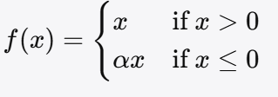 | Used in hidden layers to prevent dead neurons by allowing a small gradient for negative inputs.
ELU | 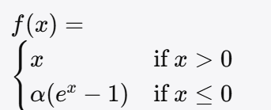 | Preferred in hidden layers for faster convergence and improved performance over ReLU.
Tanh | F(X)=Tanh(X) | Used in RNNs and some DNNs, especially when zero-centered output is beneficial for training.
SoftMax | 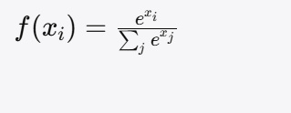 | Applied in the output layer for multi-class classification to convert logits into probabilities.
Sigmoid | 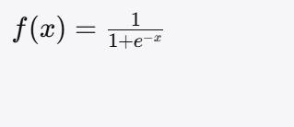 | Used in binary classification tasks, typically in the output layer for models predicting two classes.

Model Training for Developing the Predictive Model
Model training was a critical phase in developing the predictive model for ART treatment failure, classifying outcomes into three distinct classes (0, 1, 2).

Data Splitting
Training data Set: 70% of the dataset was allocated for training the model.
Validation Data set: About 15% of the dataset was used for tuning hyperparameters and preventing overfitting.
Test Set: The remaining 15% was reserved for evaluating the model's final performance.

Model Configuration or Hyperparameter Selection
Learning rate: An initial learning rate (0.001) was set to determine the step size during optimization.
Batch Size: An appropriate batch size (e.g., 32 or 64) was chosen for training iterations.
Epoch: The number of epochs utilized (50-100) was decided for training, allowing the model to learn from the data.

Performance Assessment for the Predictive Model
After The training of Model was completed, its effectiveness was assessed and compared using various metrics. The performance of the predictive models was evaluated through a confusion matrix, which served as a crucial tool in this research. Several essential metrics were utilized to gauge model efficacy, including precision, sensitivity, specificity, F1-score, and the area under the receiver operating characteristic curve (AUC-ROC). AUC-ROC is a widely recognized and effective metric for assessing binary classifiers, indicating the model's predictive capabilities. Specifically, a score of 0.5 signifies a lack of predictive ability, while a score of 1.0 denotes perfect predictive performance.
The confusion matrix Provided the summary of the model’s outputs within a binary classification context, facilitating the calculation of sensitivity, precision, F1-score, and overall accuracy metrics. It offers a detailed view of the total number of correct and incorrect predictions. Furthermore, the formulas for calculating recall (sensitivity), specificity, precision, and accuracy are included below.
The evaluation phase for predictive model regarding ART treatment failure was incorporated a wide array of metrics and techniques to assess its performance across the three classes (0, 1, 2). By utilizing accuracy, precision, recall, F1-score, confusion matrix analysis, cross-validation, ROC curve analysis, and AUC, this evaluation aims to provide a comprehensive understanding of the model's effectiveness and reliability in predicting treatment outcome (44,47,48).

Evaluation Matrix
In this study, the performance of predictive models was assessed by utilizing a dataset with a train-test split and cross-validation. The evaluation focused on several criteria, including accuracy score, ROC curve, precision (P), recall (R), and F-measure, using the test set. The confusion matrix, which displays the number of correct and incorrect predictions made by the classification model, was employed to further analyze the results.
Table 4:Confusion Matrix to develop predictive model to classify ART Regimen treatment failure
Actual | Positive Prediction | Negative Prediction
Positive Class | True Positive (TP) | False Negative (FN)
Negative Class | False Positive (FP) | True Negative (TN)

Accuracy: The accuracy is the proportion of correctly predicted instances out of the total instances.
Accuracy = (True Positives + True Negatives) / (True Positives + True Negatives + False Positives + False Negatives)
Where:
True positive (TP) = Correctly predicted positive instances
True Negative (TN) = Correctly predicted negative instances
False Positives (FP) = Incorrectly predicted positive instances
False Negatives (FN) = Incorrectly predicted negative instances

Precision: Precision is the proportion of correctly predicted positive observations to the total predicted positives.
Precision = True Positives / (True Positives + False Positives)

Recall (Sensitivity): Recall is the proportion of correctly predicted positive observations to all actual positives.
Recall = True Positives / (True Positives + False Negatives)

F1-Score: The F1-Score is the weighted average of Precision and Recall, providing a balance between the two.
F1-Score = 2 × (Precision × Recall) / (Precision + Recall)

ROC: The Receiver Operating Characteristic (ROC) curve plots the True Positive Rate (TPR) against the False Positive Rate (FPR) at various threshold settings.
Interpretation: A well-performing model will have a curve that bows toward the top left corner of the plot.

Ethical Consideration
The study was be conducted after obtaining ethical clearance from the research and ethical committee of Debre Markos University College of Health Sciences, Department of Health Informatics, and subsequently from the APHI. A permission letter was also gained from Debre Markos Branch of APHI with the ethical clearance number 718/007 be secured from the Amhara Regional Health Bureau office and the selected health institution.
Data was extracted from patients' electronic medical records (EMR) as secondary data by ART data clerks and was used solely for research purposes while being kept confidential. To maintain confidentiality, study subjects was not identified by name.
Informed consent was obtained from ART care provider since the data is being collected from existing medical records. However. training was given for data clerk via phone .

5. Result

5.1. Sociodemographic characteristics of participants
A total of 32,812 clients participated in the study, focusing on No ARV regimen failure categorized by sex. Among those experiencing No ARV regimen failure, the total count was 29,859, with males accounting for 61.7% (18,421) and females for 38.3% (11,438). This represents 56.1% of the total sample for males and 34.9% for females. For first Line ARV regimen failure, the total was 2,705, comprised of 52.9% males (1,431) and 47.1% females (1,274). In second Line ARV regimen failure, there were 248 clients, with males making up 45.6% (113) and females 54.4% (135). Overall, males constituted a significant portion of the total sample, particularly in Type first Line failures.

5.2. Prevalence of ARV Regimen treatment failure and its significant
The finding of this study revealed that the prevalence of ARV regimen treatment failure varied significantly among each treatment classes. No ARV regimen treatment failure was the most prevalent, with 29,859 cases, representing approximately 91% of total failures. This group primarily affected clients aged 31-45 (39.9%) and 46-60 (39.2%).
First Line ARV Regimen treatment Failure comprised 2,705 clients, accounting for about 8.2% of the total cases. The age distribution was similar, with significant proportions in the 31-45 age group. Second-line ARV regimen treatment failure included 248 clients, making up approximately 0.8% of total failures, with the highest proportion in the 31-45 age group (44.4%).
In younger age group (15-30 years) represented a smaller percentage of ARV regimen failures, indicating that older age groups are more significantly impacted by treatment failure.
The prevalence of first-line and second-line treatment failures is very significance. Since First-line regimens are typically the first choice due to their efficacy and lower toxicity. A shift to second-line regimens often indicates that the first-line treatment has failed, which can result from factors such as drug resistance or adverse side effects. Second-line treatments usually have a more complex regimen, higher toxicity risks, and limited availability, making it crucial to monitor patients closely.
Additionally, the transition to third-line regimens poses further challenges, as options may be limited due to drug availability and increased toxicity. This prevalence pattern highlights the urgent need for targeted interventions to support older individuals and to address the challenges associated with switching regimens, ultimately improving health outcomes for those affected by HIV/AIDS.
Table 5:Sociodemographic characteristics of the study participants in the Amhara Region Comprehensive and Specialized Hospital, May 2025 (N=32812)
Features | Category | Frequency | Percent (%)
Sex | Female | 19865 | 60.4
Total | Male | 12847 | 39.6
Total | Total | 32812 | 100
Age Group | 15-30 | 4229 | 12.9
Age Group | 30-45 | 13114 | 40
Age Group | 45-60 | 12767 | 38.9
Age Group | >60 | 2702 | 8.2
Age Group | Total | 32812 | 100

5.3. Treatment and clinical Related characteristics of participants
Regarding adherence to ARV treatment, among the 29,859 clients with no treatment failure, 95.5% demonstrated high adherence, highlighting its importance in preventing failure. In contrast, first-line ARV regimen treatment failure (2,705 clients) showed a lower adherence level, with only 47.4% achieving high adherence. For second-line ARV regimen treatment failure (248 clients), 55.2% exhibited high adherence, but a considerable percentage remained in lower adherence.
Table 6:Treatment and Clinical characteristics of the study participants in the Amhara Region Comprehensive and Specialized Hospital, May 2025 (N=32812)
Features | Category | Frequency | Percent (%)
Adherence Level | Good | 31270 | 95
Adherence Level | Fair | 544 | 2
Adherence Level | Poor | 998 | 3
Adherence Level | Total | 32812 | 100
BMI Category | Normal | 27159 | 83
BMI Category | Undernutrition | 2626 | 8
BMI Category | Overweight | 3000 | 9
BMI Category | Total | 32785 | 100
Months on ART | 12-60 months | 2758 | 8
Months on ART | 60-108 months | 4041 | 12
Months on ART | 108-156 months | 10970 | 33
Months on ART | >156 months | 15042 | 46
Months on ART | Total | 32811 | 100
Functional Status at Enrollment | Working | 28768 | 88
Functional Status at Enrollment | Ambulatory | 2322 | 7
Functional Status at Enrollment | Bedridden | 1722 | 5
Functional Status at Enrollment | Total | 32812 | 100
Current Viral Load Status | Undetectable | 29811 | 91
Current Viral Load Status | Low Level Viremia | 2372 | 7
Current Viral Load Status | High Viral Load | 537 | 2
Current Viral Load Status | Total | 32720 | 100
condom use | yes | 28698 | 87.5
condom use | No | 4114 | 12.5
condom use | Total | 32812 | 100
TPT Started | yes | 26813 | 81.7
TPT Started | No | 5999 | 18.3
TPT Started | Total | 32812 | 100
CPT Started | yes | 30300 | 92.3
CPT Started | No | 2512 | 7.7
CPT Started | Total | 32812 | 100
WHO Stage at enrollment | stage 1 | 27988 | 85.3
WHO Stage at enrollment | stage 2 | 2206 | 6.7
WHO Stage at enrollment | Stage 3 | 1598 | 4.9
WHO Stage at enrollment | Stage 4 | 1020 | 3.1
WHO Stage at enrollment | Total | 32812 | 100
Presence of OI at Enrollment | yes | 3842 | 11.7
Presence of OI at Enrollment | No | 28970 | 88.3
Presence of OI at Enrollment | Total | 32812 | 100
Active TB Diagnosed | No | 30892 | 94.1
Active TB Diagnosed | Yes | 1920 | 5.9
Active TB Diagnosed | Total | 32812 | 100
ARV Regimen at enrollment | 2e= AZT+3TC+LPR/r | 74 | 0.2
ARV Regimen at enrollment | 2f=AZT+3TC+ATV/r | 31 | 0.1
ARV Regimen at enrollment | 2h=TDF+3TC+ATV/r | 64 | 0.2
ARV Regimen at enrollment | 1a=d4T+3TC+NVP | 1067 | 3.3
ARV Regimen at enrollment | 1b=d4t+33TC+EFV | 1207 | 3.7
ARV Regimen at enrollment | 1c=ZDV+3TC+NVP | 26100 | 89.9
ARV Regimen at enrollment | 1d= ZDV+3TC+EFV | 3570 | 0.5
ARV Regimen at enrollment | 1e=TDF+3TC+EFV | 186 | 0.6
ARV Regimen at enrollment | 1f=TDF+3TC+NVP | 434 | 1.3
ARV Regimen at enrollment | 2g =TDF+3TC+LPV/r | 79 | 0.2
ARV Regimen at enrollment | Total | 32812 | 100.0

5.4. Predictors of ARV Regimen Treatment Failure

5.4.1. Predictors of No ARV Regimen Treatment Failure (Class 0)
The finding of this study revealed several protective factors against the development of ARV treatment failure in patients categorized as class 0. The key predictors which identified by this result are ARV dispensing Schedule Monthly and 3MMD DSD category at enrollment, 1c (AZT-3TC-EVZ), 1e (TDF-3TC-EVZ), and 1j (TDF-3TC-DTG) initial ARV regimens, good adherence level at enrollment, no presence of Opportunities infection (OIs) at enrollment, Stage 1 &2 Who stage at enrollment time significantly contributes to treatment success. Additionally, he initiation of tuberculosis preventive therapy (TPT) and cotrimoxazole preventive therapy (CPT) were found to be critical in enhancing overall treatment success.

5.4.2. Predictors of First Line ARV Regimen Treatment Failure (Class 1)
The finding of this study also Identified The most important predictors contribute to first line ARV regimen treatment failure which categorized as class 1. The most important predictor features are 6 Appointment spacing model DSD category at enrollment(6ASM), 1a(D4T-3TC-NVP and 1b(D4T-3TC-EVZ ARV regimen at ART initiation time, No initiation of cotrimoxazole prophylaxis (CPT), No condom use, Poor adherence level at enrollment, Presence of presence of opportunistic infections (OIs) at enrollment, and WHO stage at enrollment 3 or 4 and finally and Under nutrition status of BMI were the predictor factors of first line ARV regimen treatment failure, which gives insight for future clinical practices and interventions aimed at improving treatment success rates.

5.4.3. Predictors of Second Line ARV Regimen Treatment Failure (class 2)
The finding of this study can be Identified the most key important features which are contributing as predictor of second line ARV regimen treatment failure which categorized as class 2. Thus The most contributing factors are including Switching to LPV/r base ARV regimen after failing of first Line ARV regimen, ASM DSD model, WHO stage at enrollment T3 and T4 during second line Regimen switching time, lack of condom use, presence of opportunistic infections (OIs) during second line Regimen switching time, Poor adherence level during second line Regimen switching time, functional status at enrollment ambulatory or bedridden during second line Regimen switching time, longer months on ART(>156 months on ART) BMI status of undernutrition, viral load status, diagnose of active TB are the most predictor factors of second Line ARV Regimen treatment failure.

5.5. Result of Class Imbalance
In this study, the three-class target variable representing ARV regimen treatment failure types: 0 for no treatment failure, 1 for first-line treatment failure, and 2 for second-line treatment failure. The majority class was associated with no treatment failure, while the minority classes represented the treatment failures.
Imbalanced datasets can skew predictive accuracy, complicating the identification of factors that contribute to treatment failure. Traditional evaluation metrics may not reflect the true performance of models trained on such datasets, leading to misleading conclusions.
To effectively address this challenge, we utilized the Synthetic Minority Oversampling Technique (SMOTE). SMOTE is a well-established oversampling method specifically designed for imbalanced datasets. It generates new synthetic samples by interpolating between existing samples and their nearest neighbors in the feature space. This approach not only increases the representation of minority classes but also helps maintain the underlying distribution of the data(11).
Research has shown that SMOTE can significantly improve the performance of machine learning models on imbalanced datasets. For instance, studies have demonstrated that applying SMOTE can enhance classification accuracy and reduce the likelihood of overfitting by providing a more balanced training set (Chawla et al., 2002). By creating synthetic samples, SMOTE allows models to learn more effectively from minority class instances, which are often underrepresented in the training data(31–35).
Additionally, SMOTE has been found to improve the performance of models, particularly in complex domains such as healthcare, where the consequences of misclassification can be critical. By addressing class imbalance, SMOTE not only enhances model performance but also contributes to more reliable and interpretable results.
In this study, we implemented SMOTE as a primary method to balance the classes, ensuring a more equitable representation of treatment failure types. This approach aimed to improve the accuracy of our predictive models and facilitate a more nuanced understanding of the factors influencing ARV regimen treatment failures.(11)

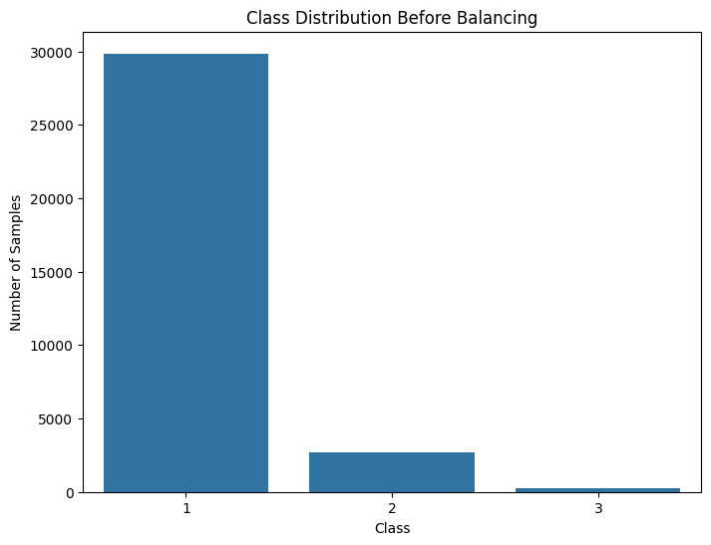
Figure 4:Target Variable before Class Imbalance by SMOTE

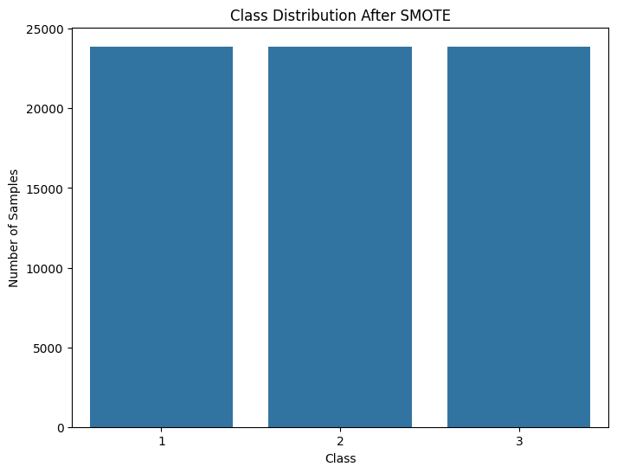
Figure 5:Target Variable After Class Imbalance by SMOTE

5.6. Collinearity Management and Feature Selection
In this study, Collinearity controlling system was conducted to increase the performance of the predictive model by identifying and managing multicollinearity among the selected features. A correlation matrix correlation was done to measure the relationships between the various predictor variables allowing for the visualization of potential collinearities.
To develop a predictive model, a correlation matrix or heatmap was generated, which visually represents the correlation coefficients among the variables. By using a threshold of correlation coefficient (r) >0.8 > 0.8r>0.8, features exhibiting high correlations were identified. This threshold was chosen to ensure that only those pairs of variables that are strongly correlated would be considered for potential exclusion or further analysis.
During the collinearity management process, features with high correlation coefficients (greater than 0.8) was evaluated. After evaluating the correlation heat map there were more than two features were found to be highly collinearity (Current ARV Regimen with viral load status, Type of ARV Regimen with Current ARVregimen and adherence level), based on the finding, one of the collinear features was removed from the dataset to reduce redundancy and simplify the model.

The correlation heatmap served as a crucial tool in this process, enabling a clear visualization of the relationships among variables. By systematically addressing collinearity, the study ensured that the selected features were independent enough to contribute meaningfully to the predictive models.
This collinearity management process ultimately strengthened the reliability of the analysis and supported more accurate interpretations of the results, guiding future recommendations for clinical practice and research.
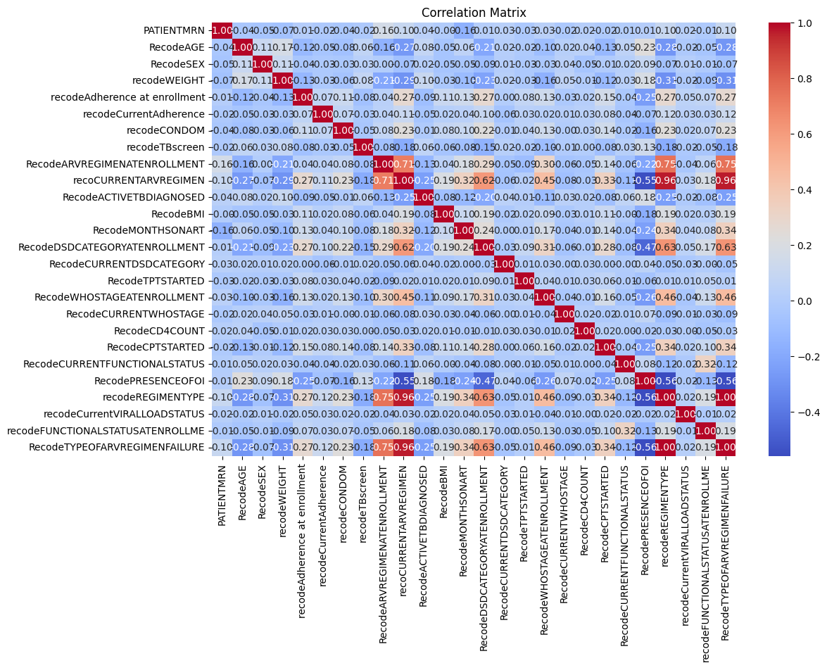
Figure 6:Correlation Matrix before Controlling collinearity
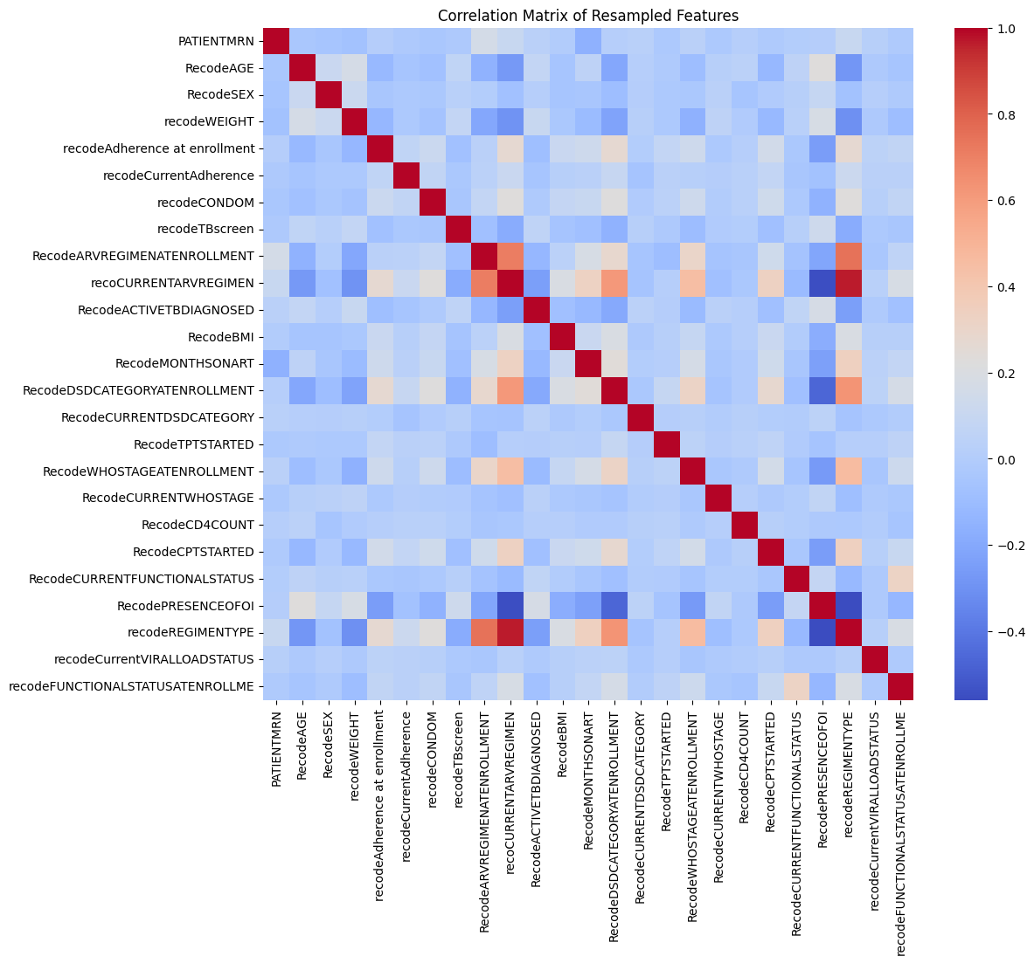
Figure 7:Correlation Matrix after Controlling collinearity

5.7. Result in Feature Selection
In this Study, we employed three feature selection methods: Chi-squared (χ²) feature selection, RFE (logistic regression) and Random Forest. We utilized Chi-squared feature selection as a statistical method to assess the independence of categorical variables. This approach evaluated how well each feature correlated with the target variable by comparing observed frequencies in a contingency table to the expected frequencies based on the assumption of independence and by p-value.
Additionally, we utilized Random Forest as an ensemble learning technique that utilized multiple decision trees to enhance predictive accuracy. This method assessed the importance of each feature based on its contribution to reducing impurity, such as Gini impurity or entropy, within the trees.
Table 5: Important Feature selection by Random Forest algorithm for class 0
name of variable | type of variable | importance
No more than 3MMD DSD category at enrollment | categorical | 0.252494
1c &1e ARV Regimen at enrollment | categorical | 0.233581
CPT Started | categorical | 0.113743
Adherence level at enrollment (Good) | numeric | 0.100257
Use of condom | categorical | 0.090021
Presence of OI (No) | categorical | 0.085210
WHO stage at enrollment 1&2 | categorical | 0.036342
Provided TPT | categorical | 0.021815
Working Functional status at enrollment | categorical | 0.021559
Normal BMI | numeric | 0.011386
Months on ART (Duration of ART) | numeric | 0.008919
Current functional status | categorical | 0.007247
Current adherence level (Good) | numeric | 0.006418
Current DSD | categorical | 0.004429
weight | numeric | 0.002410
Active TB diagnosed | categorical | 0.001586
age | numeric | 0.001084

Table 7:: Important Feature selection by Random Forest algorithm for class 1
Name of variable | Type of variable | information gain
DSD category at enrollment (ASM) | categorical | 0.255685
1a(D4T-3TC-NVP) and 1b (D4T-3TC-EVZ) ARVRegimen at enrollment | categorical | 0.244531
CPT tarted (No) | categorical | 0.109121
Use condom (No) | categorical | 0.094001
Adherence level at enrollment (Fair &Poor) | numeric | 0.090470
Presence OI at enrollment | categorical | 0.080740
WHO stage at enrollment 3&4 | categorical | 0.035048
Provided TPT | categorical | 0.024349
Functional status at enrollment (Ambulator &bed ridden) | categorical | 0.018880
BMI (Undernutrition at enrollment) | numeric | 0.012276
Current adherence level | numeric | 0.009029
Months on ART (>108 Months of ART) | numeric | 0.007556
Current functional status | categorical | 0.005920
Current Differentiated service delivery category | categorical | 0.004452
weight | numeric | 0.003257
Active TB diagnosed | categorical | 0.001480
age | numeric | 0.001268
sex | categorical | 0.000766
current viral load status | categorical | 0.000438
TB screen | categorical | 0.000390
Current WHO stage | categorical | 0.000344

Table 8:Important Feature selection by Random Forest algorithm for class 2.
Name of variable | type of variable | information gain
ARV regimen at enrollment (LPV/r base) | categorical | 0.397986
Differentiated service delivery at enrollment | categorical | 0.163587
WHO stage at enrollment (3&4) | categorical | 0.100908
CPT started | categorical | 0.090189
Use of condom | categorical | 0.077008
Presence of OI | categorical | 0.049336
adherence level at enrollment (Poor) | numeric | 0.038629
Functional status at enrollment (Ambulatory &bed ridden) | categorical | 0.022667
Months on ART (longer months of ART) | numeric | 0.014592
weight | numeric | 0.013140
Current adherence level | numeric | 0.005303
Current Differentiated service delivery category | categorical | 0.005019
BMI (Undernutrition) | numeric | 0.004495
Provided TPT | categorical | 0.003784
Current functional status | categorical | 0.003700
age | numeric | 0.002859
sex | categorical | 0.002266
Current viral load status | categorical | 0.001636
Active TB diagnosed | categorical | 0.001495
TB screened | categorical | 0.001041
Current WHO stage (T2 & T3) | categorical | 0.000362

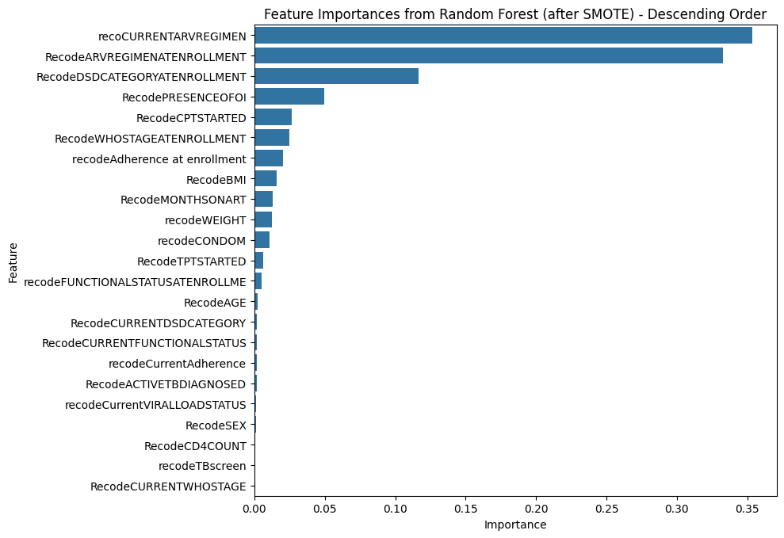
Figure 8:Feature Selection by Random Forest for ARV Regimen Treatment failure

5.8. DNN Predictive Model building
In this study, we were focused on developing predictive models to classify ARV regimen treatment failures into three classes: Class 0 (no treatment failure), Class 1 (first-line treatment failure), and Class 2 (second-line treatment failure). We conducted several model experiments aimed to predicting these treatment failures in patients on ART. At the first step of this model development, we have tried to train different DNN classification model with an unbalanced dataset using different predictor variables. In the second part, we applied a balanced sampling method to improve model performance by using SMOTE balancing method. Then after We developed multiple models, including Convolutional Neural Networks (CNN), TabNet, Feedforward Neural Networks (FNN), and Multi-Layer Perceptrons (MLP), each designed to leverage its strengths in data representation and pattern recognition. This designed model illustrates the potential of using advanced deep learning techniques in healthcare, will show the way for timely interventions and better patient outcomes in ARV therapy management. The results achieved not only meet the study's objectives but also add valuable insights to the growing field of predictive modeling in medical diagnostics(8,11)

5.9. Evaluation Model Performance

5.9.1. Evaluation of TabNet DNN performance
TabNet NN model is one of the most important classifiers of deep learning algorithm specifically designed for tabular data. It combines the strengths of decision trees and deep learning, making it particularly effective for tasks such as classification and regression.
In this study, we evaluated the performance of the TabNet deep learning algorithm for classifying a three-class target variable related to antiretroviral (ARV) regimen treatment failures: class 0 (No ARV regimen treatment failure), class 1 (First-line ARV regimen treatment failure), and class 2 (Second-line ARV regimen treatment failure).
The TabNet model displayed exceptional performance across various evaluation metrics, underscoring its effectiveness as a classifier:
Precision: The model achieved a high macro average precision of 0.965, demonstrating strong accuracy in predicting positive instances. This is particularly critical in contexts where false positives can have significant implications, such as in medical diagnostics.
Recall (Sensitivity): With a macro average recall of 0.975, the model effectively identifies true positives, ensuring that most relevant instances are captured.

F1 Score: The macro average F1 score of 0.970 reflects a well-balanced model that adeptly manages the trade-off between precision and recall. This balance is vital for applications requiring reliable identification of positive instances without a high rate of false negatives.
Overall Accuracy: The remarkable overall accuracy of 0.9807 indicates that the model correctly classifies approximately 98% of the test data, underscoring its reliability and effectiveness in real-world applications.
Sensitivity: The macro Avg sensitivity is 0.96, confirming the model’s strong capability to detect positive instances. Additionally, the specificity for class 0 is 0.99, indicating a very low rate of false positives. This underscores the model's effectiveness in ruling out non-relevant instances, which is essential for high-stakes applications.
showcasing the model's capacity to generalize well to unseen data after training This evaluation aligns with findings from previous studies(9,28,39)

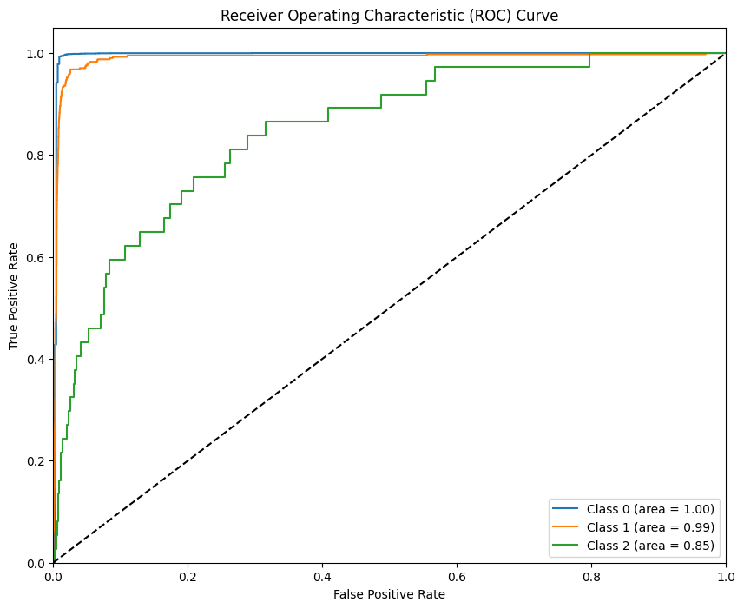
Figure 9:receiver Operating Characteristics Curve (Roc) From Tabnet Model
Table 6: Summary of model performance evaluation Metrics for TabNet DNN
Evaluation Metric | Value
Macro Avg Precision | 0.965
Macro Avg Recall | 0.975
Macro Avg F1 Score | 0.970
Overall Accuracy | 0.9807
Sensitivity (Recall | 0.96
Specificity | 0.99
Training Accuracy | 0.9816
Validation Accuracy | 0.9805
Testing Accuracy | 0.9844

5.9.2. Evaluation of CNN Model performance
In this experiment, we measured the performance of a Convolutional Neural Network (CNN) model designed to classify ARV regimen treatment failures, specifically for three classes:
The CNN model demonstrated excellent performance across all evaluation metrics, which indicates it can classify effectively ARV regimen treatment failures.
Macro Average Precision (0.965): This metric measures the model's ability to correctly identify positive instances across all classes. A precision of 0.965 indicates that when the model predicts a positive case (either Class 1 or Class 2), it is correct 96.5% of the time. This is vital in medical contexts to minimize false positives, which could lead to unnecessary treatments.
Macro Average Recall (0.975): Recall, also known as sensitivity, indicates the model's ability to identify all relevant instances. A recall of 0.975 means that the model correctly identifies 97.5% of all actual positive cases across the classes. This high value suggests that the model is effective in detecting treatment failures, ensuring that most patients who need intervention are flagged.
Macro Average F1 Score (0.970): The F1 score is the harmonic mean of precision and recall, providing single metric that captures both aspects. An F1 score of 0.970 indicates a strong balance between precision and recall. This is particularly important in healthcare, where both false positives and negatives can have significant consequences.
Sensitivity (Recall Class 1) (0.96): This metric specifically measures the model's ability to correctly identify first-line ARV regimen treatment failures. A sensitivity of 0.96 indicates that 96% of ARV regimen treatment failures are correctly identified, highlighting the model's reliability in detecting critical cases.
Specificity (0.99): Specificity measures the model's ability to identify true negatives, in this case, the instances of no treatment failure (Class 0). A specificity of 0.99 means that the model correctly identifies 99% of the patients who do not have treatment failure,
Training Accuracy (0.9902): The model achieved a training accuracy of 99.02%, indicating that it performed exceptionally well on the training dataset. This high accuracy suggests that the model effectively learned the underlying patterns, making it well-suited for real-world applications in medical diagnostics.
Validation Accuracy (0.9823): The validation accuracy of 98.23% reflects the model's ability to generalize to unseen data during training. This impressive performance indicates that the model is not merely memorizing the training data but is also capable of accurately classifying new instances it has not encountered before, which is crucial for its reliability in clinical settings.
Over all Testing Accuracy (0.9862): The testing accuracy of 98.62% further confirms the robustness of the model, demonstrating that it successfully classified a significant portion of the test data. This level of performance is critical for ensuring that the model can effectively identify patients at risk of treatment failure in practical applications, allowing for timely interventions(28).
Table 9:Summary of model performance evaluation Metrics for CNN Model
Metric | Value
Macro Avg Precision | 0.965
Macro Avg Recall | 0.975
Macro Avg F1 Score | 0.970
Sensitivity (Recall | 0.96
Specificity | 0.99
Testing Accuracy | 0.9862
Training Accuracy | 0.9902
Validation Accuracy | 0.9823
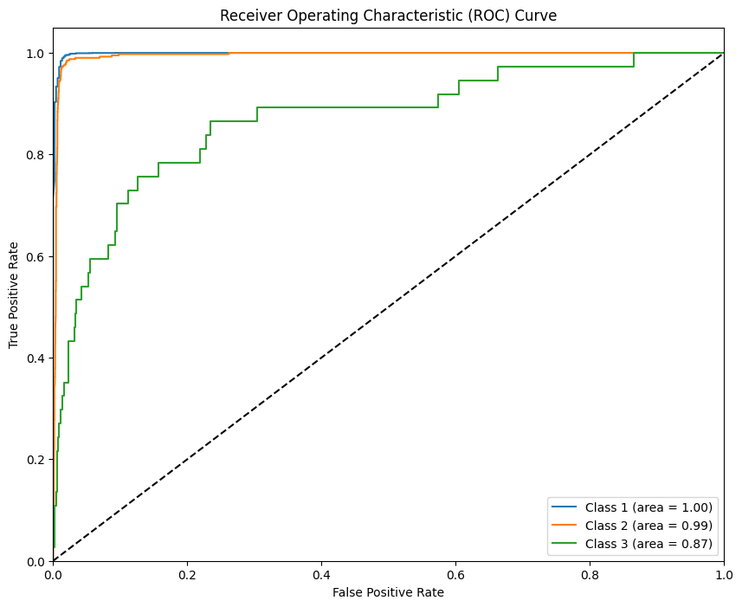
Figure 10:: receiver Operating Characteristics Curve (Roc) From CNN Model

Evaluation of FNN Model performance
In this Study evaluated the Feedforward Neural Network (FNN) model performance in all evaluation metrics which designed to classify ARV regimen treatment failures, specifically for three classes: Class 0: No ARV regimen treatment failure, Class 1: First-line ARV regimen treatment failure and Class 2: Second-line ARV regimen treatment failure
Based on our performance evaluation The FNN model achieve strong performance across all evaluation metrics. base on the evaluation metrics this model can demonstrate the following metrics: -
Macro average precision of 0.949 indicates that the model maintains a high level of accuracy in predicting positive cases across all classes. With a macro average recall of 0.981, the model effectively identifies a significant proportion of true positive cases, ensuring that patients in need of intervention are accurately flagged.
The macro average F1 score of 0.964 reflects a solid balance between precision and recall, which is critical in contexts where both false positives and false negatives can have serious implications for patient care. The overall accuracy of 0.9813 underscores the model's reliability in classifying instances correctly.
These results align with findings in the literature, such as the study by Hint et al. (2022), which demonstrated the applicability of advanced Deep learning techniques in medical diagnostics, particularly in identifying treatment failures. The consistent performance of the FNN model in this study reinforces its potential as a valuable tool for clinicians in managing ARV therapies, enabling timely and effective interventions for patients at risk of treatment failure.
In conclusion, the FNN model not only achieved high precision and recall but also provided robust overall accuracy, making it a promising candidate for classification tasks in the field of healthcare.
Training Accuracy: The training accuracy of 0.9525 indicates that the model performed well on the training dataset, correctly classifying approximately 95.25% of the training instances. This high training accuracy suggests that the model has learned the underlying patterns in the training data effectively.
Validation Accuracy: The validation accuracy of 0.9846 reflects the model's ability to generalize to unseen data during the training process. Achieving an accuracy of 98.46% on the validation set is a strong indicator that the model is not overfitting and can accurately classify instances it has not encountered before. This level of performance is crucial for ensuring that the model remains reliable in practical applications.
Testing Accuracy: The testing accuracy of 0.9813 further confirms the model's robustness, as it indicates that approximately 98.13% of the test data was classified correctly. need to make predictions on new, unseen data.

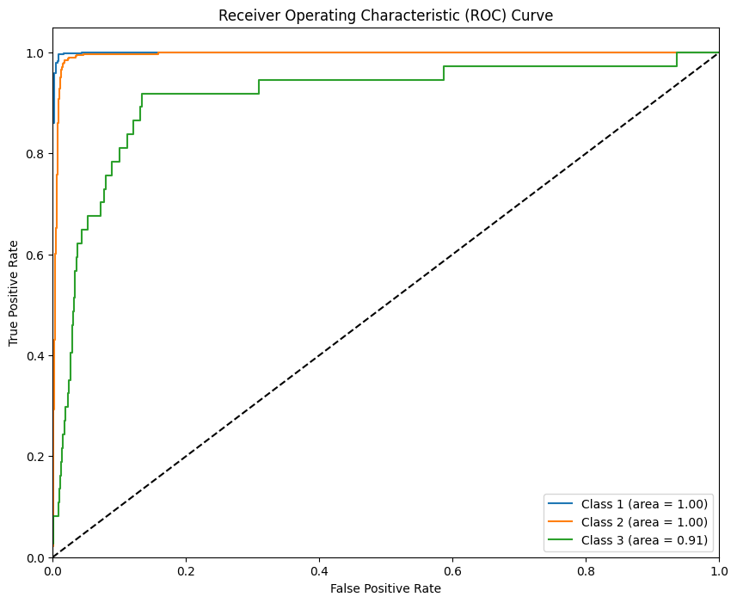
Figure 11:receiver Operating Characteristics Curve (Roc) From FNN Model
Table 10:Summary of model performance evaluation Metrics for FNN Model
Evaluation metrics | Value
Macro Avg Precision | 0.949
Macro Avg Recall | 0.981
Macro Avg F1 Score | 0.964
Overall Accuracy | 0.9813
Sensitivity (Recall) | 0.96
Specificity | 0.99
Training Accuracy | 0.9525
Validation Accuracy | 0.9846
Testing Accuracy | 0.9813

Evaluation of MLP Model performance
Macro Average Precision (0.965): This metric indicates the model's ability to correctly identify positive instances across all classes. A precision of 0.965 means that when the model predicts a positive case, it is correct 96.5% of the time. High precision is crucial in medical contexts to minimize false positives, which could lead to unnecessary treatments.
Macro Average Recall (0.975): Recall measures the model's ability to identify all relevant instances. A recall of 0.975 means that the model correctly identifies 97.5% of all actual positive cases across the classes. This high recall indicates that the model is effective in detecting treatment failures, ensuring that most patients who need intervention are flagged.
Macro Average F1 Score (0.970): The F1 score is the harmonic mean of precision and recall, providing a single metric that captures both aspects. An F1 score of 0.970 reflects a strong balance between precision and recall, which is essential in healthcare settings where both false positives and negatives can have significant consequences.
Overall Accuracy (0.9848): The overall accuracy of 98.48% signifies that the model correctly classified approximately 98.48% of the test data. This high accuracy demonstrates the model's capability to perform well in real-world scenarios, ensuring reliable predictions.
Training Accuracy (0.9718): The training accuracy of 97.18% indicates that the model achieved a high level of performance on the training dataset. This suggests that the model effectively learned the underlying patterns in the data, making it a strong candidate for practical applications in medical diagnostics.
Validation Accuracy (0.9854): The validation accuracy of 98.54% reflects the model's ability to generalize to unseen data during training. This impressive performance indicates that the model can accurately classify instances it has not encountered before, which is crucial for its reliability in clinical settings.
Testing Accuracy (0.9848): The testing accuracy of 98.48% further confirms the robustness of the model, indicating that it successfully classified a significant portion of the test data. This level of performance is critical for ensuring that the model can effectively identify patients at risk of treatment failure in practical applications, allowing for timely interventions.

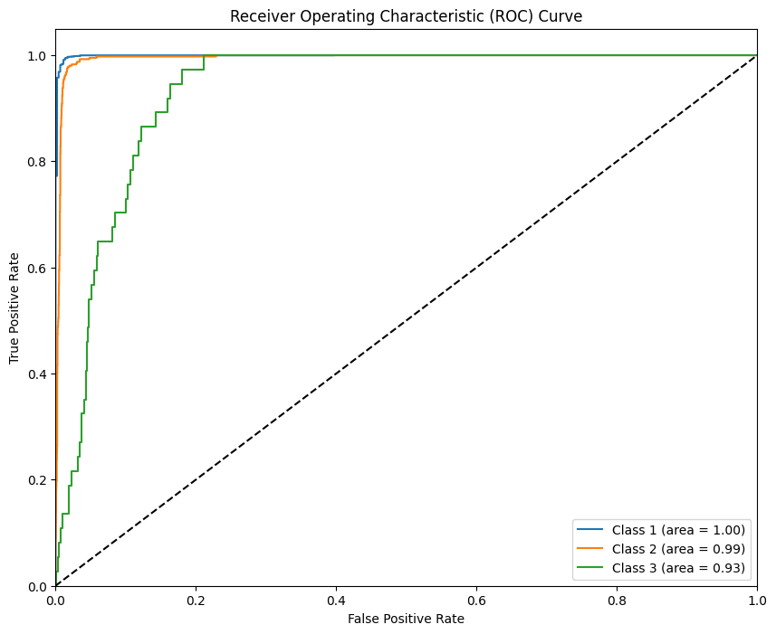
Figure 12:receiver Operating Characteristics Curve (Roc) From MLP Model
Table 11:model performance evaluation Metrics for MLP Model
Evaluation Metrics | Value
Macro Avg Precision | 0.965
Macro Avg Recall | 0.975
Macro Avg F1 Score | 0.970
Overall Accuracy | 0.9848
Training Accuracy | 0.9718
Validation Accuracy | 0.9854
Testing Accuracy | 0.9848

Hyperparametric tuning during this experiment
In this experiment we utilized different hyperparameter, by default hyperparameter all models were not well training which were experiences under poor classification and some of model also get over fitting so we utilized different hyperparameter tuning correctly to classify ARV regimen treatment failures across three classes.
Each model's architecture and hyperparameters were carefully designed to optimize performance while controlling for overfitting.

Utilized Hyperparameters
Learning Rate: The Adam optimizer was utilized with an adaptive learning rate starting at 0.001.
Batch Size: Set to 32, allowing efficient training without overwhelming the models.
Epochs: The models were trained for a maximum of 100 epochs, with early stopping implemented to prevent overfitting.
Dropout Rate: A dropout rate of 0.5 was applied in the hidden layers to further reduce overfitting.
Regularization: L2 regularization with a strength of 0.001 was applied to penalize large weights in dense layers.
Model Architecture
Input Layer
The input layer was configured to accept a shape of (X_train_resampled.shape[1],) corresponding to the number of features in the processed input data.

Hidden Layers
First Hidden Layer: Neurons: 128, Activation Function: ReLU, Regularization: L2 with 0.001, Batch Normalization: Applied to stabilize learning and Dropout: 0.5 to mitigate overfitting.
Second Hidden Layer: Neurons: 64, Activation Function: ReLU, Regularization: L2 with 0.001, Batch Normalization: Applied to stabilize learning., Dropout: 0.5 to further reduce overfitting.

Output Layer
The output layer consisted of num-classes neurons, utilizing a SoftMax activation function for multi-class classification.
Total Neurons and Layers
The architecture comprised: Total Layers: 4 (including input, two hidden layers, and output layer).
Total Neurons: 128 (First Hidden Layer), 64 (Second Hidden Layer), number of classes (Output Layer)

Methods used for Controlling Overfitting
To ensure model robustness, the following strategies were employed:
Dropout Layers: Implemented after each hidden layer to randomly deactivate neurons during training.
L2 Regularization: Applied to encourage simpler models that generalize better.
Early Stopping: Monitored validation accuracy, stopping training if no improvement was observed for 10 epochs.
Table 12:Summarizing The utilizing Hyperparameters in this Study to develop predictive model to classify ARV regimen treatment failures across three classes.
Hyperparameters | Value or Description
Learning Rate | Adam optimizer with an adaptive learning rate starting at 0.001
Batch Size | Set to 32 for efficient training without overwhelming the models
Epochs | Trained for a maximum of 100 epochs, with early stopping implemented to prevent overfitting
Dropout Rate | 0.5 applied in hidden layers to reduce overfitting
Regularization | L2 regularization with a strength of 0.001 to penalize large weights in dense layers
Model Architecture | Details/description
Input Layer | Shape: (X_train_resampled. shape [1]) corresponding to the number of features in the processed data
First Hidden Layer | Neurons: 128, Activation Function: ReLU, Regularization: L2 with 0.001, Batch Normalization: Applied, Dropout: 0.5
Second Hidden Layer | Neurons: 64, Activation Function: ReLU, Regularization: L2 with 0.001, Batch Normalization: Applied, Dropout: 0.5
Output Layer | Number of classes neurons, SoftMax activation function for multi-class classification
Total Layers | 4 (including input, two hidden layers, and output layer)
Total Neurons | 128 (First Hidden Layer), 64 (Second Hidden Layer), number of classes  (Output Layer)

Methods utilized to Control Of | Description
Dropout Layers | Implemented after each hidden layer to randomly deactivate neurons during training
L2 Regularization | Applied to encourage simpler models that generalize better
Early Stopping | Monitored validation accuracy, stopping training if no improvement was observed for 10 epochs

The overall performance of the selected DNN model
In this study we assessed the performance of multiple models based on a comprehensive set of evaluation metrics, including testing accuracy, training accuracy, validation accuracy, macro average precision, recall, F1 score, sensitivity, and specificity based on the performance evaluation matrix:
First, the Convolutional Neural Network (CNN) emerged as the most effective model, achieving a training accuracy of 99.02% and a testing accuracy of 98.62%. Its validation accuracy of 98.23% demonstrates its strong generalization capability across unseen data. The macro average precision and recall both at 96.5% and 97.5%, respectively, highlight CNN's effectiveness in minimizing both false positives and false negatives. The F1 score of 97.0% indicates a well-balanced performance between precision and recall, making CNN a robust choice for predicting treatment failures. This aligns with findings by Zhang et al. (2020), who emphasized CNNs' ability to extract complex features from healthcare data, thereby enhancing diagnostic accuracy. This aligns with the findings conducted in South Africa and Switzerland(28,43) . who emphasized the efficacy of CNNs in extracting complex features from healthcare data.
Second, TabNet secured a solid position with a training accuracy of 98.16% and a testing accuracy of 98.44%. Its validation accuracy of 98.05% signifies reliable performance across different datasets. Similar to the CNN, TabNet achieved macro average precision and recall of 96.5% and 97.5%, respectively, indicating a strong proficiency in accurately classifying treatment failures. The F1 score of 97.0% further emphasizes its ability to balance precision and recall effectively(43,46). TabNet's unique architecture allows it to concentrate on the most relevant features, enhancing its predictive capabilities, particularly in structured data contexts. This makes TabNet a strong contender for clinical applications, especially where interpretability is crucial. (As noted by Arik et al. (2021), TabNet's architecture enables it to focus on the most relevant features, enhancing its predictive capabilities, particularly in structured data contexts.
Third, the Multi-Layer Perceptron (MLP) exhibited commendable performance with a training accuracy of 97.18% and a testing accuracy of 98.48%, alongside a validation accuracy of 98.54%. While its macro average precision of 96.5% and recall of 97.5% reflect solid capabilities, the MLP may not capture complex patterns as effectively as the top two models. The F1 score of 97.0% suggests that while MLPs can model relationships well, they might fall short in scenarios requiring intricate feature interactions. Research by He et al. (2019) supports the use of MLPs in medical predictions, noting their effectiveness in modelling non-linear relationships, although they may not consistently outperform more advanced architectures. Research by He et al. (2019) supports the use of MLPs in medical predictions, noting their ability to model non-linear relationships, although they may not always outperform more advanced models(46,57)
Fourth, the Feedforward Neural Network (FNN) ranked lowest among the evaluated models, with a training accuracy of 95.25% and a testing accuracy of 98.13%. Its validation accuracy of 98.46% indicates a reasonable performance; however, its macro average precision of 94.9% and recall of 98.1% reveal a higher incidence of false positives compared to the other models. The F1 score of 96.4% suggests that while the FNN is effective in identifying true positives, it struggles with precision. Liu et al. (2021) highlight that simpler architectures like FNNs may encounter challenges in capturing complex relationships within the data, which could limit their effectiveness in clinical applications. highlighted that simpler architectures like FNNs may face challenges in capturing complex relationships in data, potentially limiting their effectiveness in clinical setting(59)s.
Table 13:The comparison of all deep learning models.by the performance metrics
Model | Training | Validation | Testing | Macro Avg | Macro Avg | F1 Score
Model | Accuracy | Accuracy | Accuracy | Precision | Recall | F1 Score
CNN | 99.02% | 98.23% | 98.62% | 96.50% | 97.50% | 97.00%
TabNet | 98.16% | 98.05% | 98.44% | 96.50% | 97.50% | 97.00%
MLP | 97.18% | 98.54% | 98.48% | 96.50% | 97.50% | 97.00%
FNN | 95.25% | 98.46% | 98.13% | 94.90% | 98.10% | 96.40%

Discussions
The primary objective of this study was to evaluate various deep learning algorithms for classifying ARV regimen treatment failures into three distinct classes: Class 0 (no treatment failure), Class 1 (first-line treatment failure), and Class 2 (second-line treatment failure). Utilizing a substantial dataset of 32,812 participants and 24 critical features. In this study 32,812 participants were included develop the predictive model to classify and to assess the factors contributing to ARV regimen treatment failures. Notably
This study revealed a significant prevalence of ARV regimen treatment failure, with no treatment failure being the most common (29,859 cases, or 91% of total failures), primarily affecting clients aged 31-45 (39.9%) and 46-60 (39.2%). First line ARV regimen failure was observed in 2,705 clients (8.2% of cases), leading to a necessary shift to second-line regimens for those affected. This transition signifies not only the failure of initial treatments, often due to drug resistance or adverse side effects, but also introduces challenges as second-line and third-line regimens are typically less available and more toxic. The second-line failure in 248 clients (0.8%), concentrated in the same age group (44.4%), further complicates treatment options, emphasizing the need for close monitoring and support. This pattern highlights the urgent necessity for targeted interventions to assist older individuals and effectively manage the complexities of regimen switches, ultimately aiming to improve health outcomes for those living with HIV/AIDS.
This study identifies different Key protective factors against ARV regimen treatment failure include high adherence levels, absence of opportunistic infections (OIs), WHO stages 1 and 2 at enrollment, and the initiation of cotrimoxazole prophylaxis (CPT) and condom use. Conversely, important predictors of treatment failure involve 1a (D4T-3TC-NVP) and 1b (D4T-3TC-EVZ) at ART initiation time, 6 Month Appointment Spacing Model , presence of OIs, WHO stages 3 or 4 at enrollment, poor adherence, under-nutrition indicated by BMI, switching to LPV/r-based regimens after first-line failure, functional status (ambulatory or bedridden), prolonged duration on ART (>156 months), and elevated viral load with a diagnosis of active TB This finding is similar with the study conducted in Ethiopia and other African countries which showed that poor adherence increased the odds of virological treatment failure (7,9,28,33,34,41,55,56).
In this study being males and order age group contributed for ARV Regimen treatment failure which is align the study conducted in Dessie referral hospital, Uganda, South Africa which showed that ARV Regimen treatment failure was more likely to occur among male than females(60–63). This might be due to males have a behavior which exposure for alcohol drinking and socially related factors which results to patients to take medications improperly; moreover, interrupt the therapy and hence allow more viral replication which in more compromised the immune system and depletion of cd4 numbers that resulted in ARV treatment failure.
In this study ARV clients who had documented history of opportunities infection at the enrolment time is the contributing predictor for ARV regimen failure. This finding is in tandem with study conducted in Ethiopia SA and Cameron(7,10,11,31,32,,46,49,50).This might be due to that different opportunities infection would be impaired the response of immune system of clients and deteriorated CD4 cells count which leads to high replication of viral load finally resulted to virological treatment failure.
This study also indicated that 6-month ASM is the predictor factors for first- and second-line ARV Regimen failure, which evidenced by our finding. for this fining the possible explanation might be due to ARV clients that had prescribed medication for six months could be faced different factors like the drug might be not stored within at room temperature that leads decreased the potent of drug .and client might be interrupt their medication due to poor adherence since they would apart from clinician for six-month duration that resulted clients might be developed poor adherence and emotional disturbance. Like depression and mental health problem, which leads improper ARV medication. Besides those factors ARV clients might be inappropriately screened at early for eligible criteria for stable clients for ASM, hence those factors allow for high viral replication that resulted for treatment failure.
This study also showed that documented history of poor adherence for their ARV medication. Is the most important predictor for first- and second-line ARV Regimen failure This finding is similar with the study conducted in Ethiopia and other African countries (7,9,28,33,34,41,55,56). the possible reason for this explanation might be due poor adherence can lead patients to take medications improperly; discontinued, interrupt the therapy and hence high viral replication would be increased infection of more CD4 cells and eventual depletion of cd4 counts and leads to develop advanced stage of HIV finally resulted in first-line ART treatment failure.
This finding also revealed that clients who had documented history of condom use with their sexual partner is the protective predictor factors for ARV Treatment failure with their sexual partners, For this finding possible justification, it might be due to clients who had not condom use with their sexual partners might be acquired different viral strains from his/her sexual partners that were differed from his /her previously acquired virus that leads to develop drug resistant virus resulted to high viral replication which leads to treatment failure (virological treatment failure).
In this study, the model was optimized using key hyperparameters, including an adaptive learning rate of 0.001 with the Adam optimizer, a batch size of 32, and a maximum of 100 epochs with early stopping to prevent overfitting. A dropout rate of 0.5 was applied in the hidden layers, alongside L2 regularization (0.001) to mitigate excessive weight growth. The model architecture comprised four layers: an input layer reflecting the number of features, two hidden layers with 128 and 64 neurons respectively using ReLU activation, and a final output layer employing SoftMax for multi-class classification. This structure and the chosen parameters are crucial for enhancing model performance and ensuring effective training.
The findings of this study indicate that CNNs and TabNet are the most effective classifiers for predicting ARV regimen treatment failures, with CNN demonstrating the highest overall performance. MLPs and FNNs, while still valuable, did not match the robustness of the top two models. This emphasizes the importance of selecting appropriate algorithms based on data characteristics and the clinical implications of the predictions made(35,53–55,73).
This study evaluated several deep learning models for predicting ARV regimen treatment failures, employing techniques to address class imbalance and enhance feature selection. The Convolutional Neural Network (CNN) emerged as the most effective model, achieving a training accuracy of 99.02% and a testing accuracy of 98.62%. Its validation accuracy of 98.23% demonstrates robust generalization across unseen data. The macro average precision and recall at 96.5% and 97.5%, respectively, highlight the CNN's effectiveness in minimizing false positives and false negatives. The F1 score of 97.0% indicates a well-balanced performance between precision and recall, reinforcing its suitability for clinical applications. This success may be due to the CNN's architecture, which excels at extracting intricate patterns from input features, thereby enhancing diagnostic accuracy. this study aligns with the study conducted in Assiut University is located Egypt and other African Countries(35,52–56,73)

Conclusion
The primary objective of this study was to develop predictive model for the classification of ARV regimen treatment failures, utilizing a substantial dataset of 32,812 participants. The findings provided critical insights into treatment dynamics, revealing significant gender disparities—61.7% of participants with no treatment failure were male, and 52.9% of those with first-line failures were also male.
This study successfully evaluated various deep learning algorithms for classifying ARV regimen treatment failures into three distinct classes using a dataset of 32,812 participants and 24 critical features. The findings revealed a significant prevalence of ARV regimen treatment failure, predominantly affecting clients aged 31-45 and 46-60, with no treatment failure being the most common outcome. Key predictors of treatment failure included first-line regimens (1a and 1b), poor adherence levels, presence of opportunistic infections, WHO stages 3 or 4, and switching to less effective second-line regimens. Protective factors against treatment failure encompassed high adherence, absence of OIs, and the initiation of cotrimoxazole prophylaxis. The study highlighted the importance of targeted interventions for older individuals and the need for close monitoring during regimen transitions.
Among the models evaluated, the Convolutional Neural Network (CNN) emerged as the most effective, achieving a training accuracy of 99.02% and a testing accuracy of 98.62%. This exceptional performance demonstrates the CNN's robust generalization capabilities and its effectiveness in minimizing both false positives and negatives, which underscores its potential for clinical application in managing ARV therapies, for classifying and predicting treatment failures, demonstrating robust accuracy and precision Overall, these insights contribute significantly to understanding and improving treatment outcomes for individuals living with HIV/AIDS.

Strength and Limitation of this Study

8.1. Strengths of the Study
- Used a Large Sample Size: The study's utilized dataset of 32,812 participants enhances the reliability and generalizability of the findings.
- Apply Advanced Analytical Techniques: The application of deep learning algorithms provides nuanced classifications of treatment failures, significantly improving predictive accuracy.
- Identification of Key Predictors: The study effectively identifies both protective factors and predictors of treatment failure, offering critical insights for clinical practice and targeted interventions.

8.2. Limitations of the Study
- Potential Bias: Reliance on self-reported adherence and health behaviors may introduce bias that affects data accuracy.
- Cross-Sectional Design: The study's design limits the ability to make causal inferences regarding the influence of predictors on treatment outcomes over time.

Recommendations
For MOH
- Implement and scaleup Advanced Model Development: Utilize deep learning algorithms to analyze patient data for predicting ARV treatment failures. This can help identify at-risk patients and tailor interventions effectively.
- Strengthen ARV Adherence Programs: Implement initiatives that incorporate predictive analytics to enhance patient adherence to ARV medications through personalized support and Counseling.
For ARHB
- Targeted Interventions for High-Risk Groups: Develop data-driven programs focused on high-risk populations, such as older individuals and males, using insights from predictive models to address specific behavioral and social support needs.
- Continuous Monitoring and Evaluation: Establish systems for ongoing assessment of treatment adherence and efficacy, utilizing advanced analytics to track patient outcomes and adjust interventions accordingly.
For ART Care Providers
- Implement Predictive Screening Tools: Use deep learning models to routinely screen for risk factors associated with opportunistic infections and treatment failure, allowing for timely and targeted interventions.
- Strengthen ARV Adherence, early screening Opportunities infection, providing CPT and TPT Prophylaxis for eligible ARV clients.
- Integrate and Implement initiatives that incorporate predictive analytics to enhance patient adherence to ARV medications through personalized support.
- Routine Screening for OIs: Implement regular screenings for opportunistic infections and provide timely interventions to mitigate their impact on treatment outcomes.
- Integrate and support Mental Health: Integrate mental health support into ART services to address emotional disturbances that may affect adherence and overall treatment success.

10. References
1. National Comprehensive HIV Prevention, Care and Treatment Training Participant Manual.
2. National Comprehensive HIV Prevention, Care and Treatment Training Participant Manual.
3. National-Strategic-Plan-Triple-EMTCT-Oct-2021.
4. Wedajo S, Degu G, Deribew A, Ambaw F. Treatment failure, death, and predictors among PLWHIV on second-line antiretroviral therapy in Dessie Comprehensive Specialized Hospital, northeast Ethiopia: A retrospective cohort study. PLoS One. 2022 Jun 1;17(6).
5. Teju D. First-line antiretroviral treatment failure and associated factors in HIV patients at the University of Gondar Teaching Hospital , Gondar , Northwest Ethiopia. 2016;141–6.
6. Status C. Determinants of First Line Antiretroviral Treatment Failure among Patients on Highly Active Antiretroviral Therapy in selected Public Hospitals Jimma , Southwest Ethiopia a Case Control Study. 1–32 p.
7. Sciences H, Sciences H. Determinants of first line antiretroviral immunologic treatment failure among adult HIV Patients at Dessie Referral Hospital , may , 2015 UNIVERSITY OF GONDAR SCHOOL OF MEDICINE AND Determinants of first line antiretroviral immunologic treatment failure a. 2015;
8. Sibanda W, Pretorius P. Artificial Neural Networks-A Review of Applications of Neural Networks in the Modeling of HIV Epidemic General Terms. International Journal of Computer Applications. 2012.
9. Charles Chukwudalu Ebulue, Ogochukwu Virginia Ekkeh, Ogochukwu Roseline Ebulue, Chukwunonso Sylvester Ekesiobi. Developing predictive models for HIV Drug resistance: A genomic and AI approach. International Medical Science Research Journal. 2024 May 5;4(5):521–43.
10. Tesfahun Tsegaye A, Wubshet M, Awoke T, Addis Alene K. Predictors of treatment failure on second-line antiretroviral therapy among adults in northwest Ethiopia: a multicentre retrospective follow-up study. Available from: http://bmjopen.bmj.com/
11. Charles Chukwudalu Ebulue, Ogochukwu Virginia Ekkeh, Ogochukwu Roseline Ebulue, Chukwunonso Sylvester Ekesiobi. Developing predictive models for HIV Drug resistance: A genomic and AI approach. International Medical Science Research Journal. 2024 May 5;4(5):521–43.
12. Feleke R, Geda B, Teji Roba K, Weldegebreal F. Magnitude of antiretroviral treatment failure and associated factors among adult HIV-positive patients in Harar public hospitals, Eastern Ethiopia. SAGE Open Med. 2020;8:205031212090607.
13. Mulisa D, Tesfa M, Kassa GM, Tolossa T. Determinants of first line antiretroviral therapy treatment failure among adult patients on ART at central Ethiopia : un-matched case control study. 2019;1–13.
14. Unaids. 2024 global AIDS report — The Urgency of Now: AIDS at a Crossroads [Internet]. 2024. Available from: http://www.wipo.int/
15. Wedajo S, Degu G, Deribew A, Ambaw F. Treatment failure, death, and predictors among PLWHIV on second-line antiretroviral therapy in Dessie Comprehensive Specialized Hospital, northeast Ethiopia: A retrospective cohort study. PLoS One. 2022 Jun 1;17(6).
16. Evans D, Hirasen K, Berhanu R, Malete G, Ive P, Spencer D, et al. Predictors of switch to and early outcomes on third-line antiretroviral therapy at a large public-sector clinic in Johannesburg, South Africa. AIDS Res Ther. 2018 Apr 10;15(1).
17. Seid A, Cherie N, Ahmed K. Determinants of virologic failure among adults on second line antiretroviral therapy in wollo, amhara regional state, northeast ethiopia. HIV/AIDS - Research and Palliative Care. 2020;12:697–706.
18. Berhane AA, Chimdesa HF, Awedew AF, Bekele NA, Teferi HM, W/Yohannes G. Virologic suppression rate and associated factors for third-line HIV treatment in Addis Ababa, Ethiopia. BMC Infect Dis. 2024 Dec 1;24(1).
19. Alene M, Awoke T, Yenit MK, Tsegaye AT. Incidence and predictors of second-line antiretroviral treatment failure among adults living with HIV in Amhara region: A multi-centered retrospective follow-up study. BMC Infect Dis. 2019 Jul 9;19(1).
20. Lailulo Y, Kitenge M, Jaffer S, Aluko O, Nyasulu PS. Factors associated with antiretroviral treatment failure among people living with HIV on antiretroviral therapy in resource-poor settings: a systematic review and metaanalysis. Syst Rev. 2020 Dec 1;9(1).
21. HIV NATIONAL STRATEGIC PLAN.
22. Edessa D, Sisay M, Asefa F. Second-line HIV treatment failure in subSaharan Africa: A systematic review and metaanalysis. PLoS One. 2019 Jun 1;14(7).
23. Mengistu ST, Ghebremeskel GG, Ghebrat HB, Achila OO, Yohannes NA, Ghebrenegus AS, et al. Determinants of therapy failure among adults on first-line antiretroviral therapy in Asmara, Eritrea: a multicenter retrospective matched case–control study. BMC Infect Dis. 2022 Dec 1;22(1).
24. National Comprehensive HIV Prevention, Care and Treatment Training Participant Manual.
25. Hiv N, Hiv N. Fast-Track Targets.
26. Kassie GA, Wolda GD, Woldegeorgis BZ, Gebrekidan AY, Haile KE, Meskele M, et al. Second-line anti-retroviral treatment failure and its predictors among patients with HIV in Ethiopia: A systematic review and metaanalysis. PLOS Global Public Health. 2024 Apr 1;4(4).
27. Kassie GA, Wolda GD, Woldegeorgis BZ, Gebrekidan AY, Haile KE, Meskele M, et al. Second-line anti-retroviral treatment failure and its predictors among patients with HIV in Ethiopia: A systematic review and metaanalysis. PLOS Global Public Health. 2024 Apr 1;4(4).
28. Mitiku Afework M. Developing the Predictive Model for Antiretroviral Therapy Adherence Status of Human Immunodeficiency Virus Patients Care Using Deep Neural Network.
29. Tunduny TK. Electronic Theses and Dissertations [Internet]. 2017. Available from: http://su-plus.strathmore.edu/handle/11071/5684
30. Siraj J, Feyissa D, Mamo Y, Zewudie A, Regesa T, Ejeta F, et al. Antiretroviral treatment failure and associated factors among HIV patients on the first-line antiretroviral therapy at Mizan-Tepi University teaching hospital, Southwest Ethiopia: A cross-sectional study. Medicine (United States). 2021 Dec 23;100(51):E28357.
31. Yang J, El-Bouri R, O’Donoghue O, Lachapelle AS, Soltan AAS, Eyre DW, et al. Deep reinforcement learning for multi-class imbalanced training: applications in healthcare. Mach Learn. 2024 May 1;113(5):2655–74.
32. Eltrass AS, Tayel MB, Ammar AI. Automated ECG multi-class classification system based on combining deep learning features with HRV and ECG measures. Neural Comput Appl. 2022 Jun 1;34(11):8755–75.
33. Bokhorst JM, Nagtegaal ID, Fraggetta F, Vatrano S, Mesker W, Vieth M, et al. Deep learning for multi-class semantic segmentation enables colorectal cancer detection and classification in digital pathology images. Sci Rep. 2023 Dec 1;13(1).
34. Khan MHM, Boodoo-Jahangeer N, Dullull W, Nathire S, Gao X, Sinha GR, et al. Multi- class classification of breast cancer abnormalities using Deep Convolutional Neural Network (CNN). PLoS One. 2021 Aug 1;16(8 August 2021).
35. Abdul Hadi S, Putcha V, Abdul Hadi Vaishnavi Putcha S. A Deep Learning Multi-Class Time Series Classification Approach for Human Activity Recognition A Deep Learning Multi-Class Time Series Classification Approach for Activity Recognition from a Single Chest-Mounted Sensor. Available from: https://www.researchgate.net/publication/366121073
36. Siraj J, Feyissa D, Mamo Y, Zewudie A, Regesa T, Ejeta F, et al. Antiretroviral treatment failure and associated factors among HIV patients on the first-line antiretroviral therapy at Mizan-Tepi University teaching hospital, Southwest Ethiopia: A cross-sectional study. Medicine (United States). 2021 Dec 23;100(51):E28357.
37. Rosen-Zvi M, Aharoni E, Selbig J, Rosen-Zvi M, Aharoni E, Selbig J. HIV-1 Drug Resistance Prediction and Therapy Optimization: A Case Study for the Application of Classification and Clustering Methods. Vol. 5400, LNAI. Springer-Verlag; 2009.
38. Seboka BT, Yehualashet DE, Tesfa GA. Artificial Intelligence and Machine Learning Based Prediction of Viral Load and CD4 Status of People Living with HIV (PLWH) on Anti-Retroviral Treatment in Gedeo Zone Public Hospitals. Int J Gen Med. 2023;16:435–51.
39. Onoya D, Nattey C, Budgell E, Van Den Berg L, Maskew M, Evans D, et al. Predicting the Need for Third-Line Antiretroviral Therapy by Identifying Patients at High Risk for Failing Second-Line Antiretroviral Therapy in South Africa. AIDS Patient Care STDS. 2017 May 1;31(5):205–12.
40. Sibanda W, Pretorius P. Artificial Neural Networks-A Review of Applications of Neural Networks in the Modeling of HIV Epidemic General Terms. International Journal of Computer Applications. 2012.
41. Johnston V, Fielding KL, Charalambous S, Churchyard G, Phillips A, Grant AD. Outcomes Following Virological Failure and Predictors of Switching to Second-line Antiretroviral Therapy in a South African Treatment Program [Internet]. 2012. Available from: www.jaids.com
42. Kimaina A, Dick J, DeLong A, Chrysanthopoulou SA, Kantor R, Hogan JW. Comparison of machine learning methods for predicting viral failure: a case study using electronic health record data. Stat Commun Infect Dis. 2020 Dec 23;12(s1).
43. Mamo DN, Yilma TM, Fekadie M, Sebastian Y, Bizuayehu T, Melaku MS, et al. Machine learning to predict virological failure among HIV patients on antiretroviral therapy in the University of Gondar Comprehensive and Specialized Hospital, in Amhara Region, Ethiopia, 2022. BMC Med Inform Decis Mak. 2023 Dec 1;23(1).
44. Onoya D, Nattey C, Budgell E, Van Den Berg L, Maskew M, Evans D, et al. Predicting the Need for Third-Line Antiretroviral Therapy by Identifying Patients at High Risk for Failing Second-Line Antiretroviral Therapy in South Africa. AIDS Patient Care STDS. 2017 May 1;31(5):205–12.
45. Berhane AA, Chimdesa HF, Awedew AF, Bekele NA, Teferi HM, W/Yohannes G. Virologic suppression rate and associated factors for third-line HIV treatment in Addis Ababa, Ethiopia. BMC Infect Dis. 2024 Dec 1;24(1).
46. Assefa H. PREDICTIVE MODEL TO DETECT FIRST-LINE ANTIRETROVIRAL THERAPY FAILURE AMONG HIV/AIDS PATIENTS IN ZEWDITU HOSPITAL, ADDIS ABABA A Thesis Presented.
47. Mitiku Afework M. Developing the Predictive Model for Antiretroviral Therapy Adherence Status of Human Immunodeficiency Virus Patients Care Using Deep Neural Network.
48. Assefa H. PREDICTIVE MODEL TO DETECT FIRST-LINE ANTIRETROVIRAL THERAPY FAILURE AMONG HIV/AIDS PATIENTS IN ZEWDITU HOSPITAL, ADDIS ABABA A Thesis Presented.
49. Nina Kaonga N. Developing a predictive model to identify sub-optimal antiretroviral therapy adherence in Namibia. 2016.
50. Bekele Asfaw A, Nigusie A, Shewanow T, Kebede Gudina E, Getnet M, Amdisa D, et al. Determinants of First-line Antiretroviral Treatment Failure Among Patients on Antiretroviral Therapy in Public Hospitals Jimma, Southwest Ethiopia a Case-Control Study. Rehabilitation Science. 2019;4(2):13.
51. FMOH Ethiopia. National Consolidated Guidelines for Comprehensive Hiv Prevention , Care and. 2018;1–238.
52. Rashid F, Abate J, Abdi A. Multiclass Classification and Identification of the External Eye Diseases using Deep CNN. Indian J Sci Technol [Internet]. 2024 Mar 20;17(12):1107–16. Available from: https://indjst.org/articles/multiclass-classification-and-identification-of-the-external-eye-diseases-using-deep-cnn
53. Hwang Y, Song J. Recent deep learning methods for tabular data. Commun Stat Appl Methods. 2023;30(2):215–26.
54. Victor Elijah A, Abdullah A, JhanJhi N, Supramaniam M, Abdullateef BO, Jaya S. Ensemble and Deep-Learning Methods for Two-Class and Multi-Attack Anomaly Intrusion Detection: An Empirical Study [Internet]. Vol. 10, IJACSA) International Journal of Advanced Computer Science and Applications. 2019. Available from: www.ijacsa.thesai.org
55. Al-Shoukry S, Jawad BJM, Musa Z, Sabry AH. DEVELOPMENT OF PREDICTIVE MODELING AND DEEP LEARNING CLASSIFICATION OF TAXI TRIP TOLLS. Eastern-European Journal of Enterprise Technologies. 2022;3(3–117):6–12.
56. Leke-Betechuoh B, Marwala T, Tim T, Lagazio M. Prediction of HIV Status from Demographic Data Using Neural Networks.
57. Assefa H. PREDICTIVE MODEL TO DETECT FIRST-LINE ANTIRETROVIRAL THERAPY FAILURE AMONG HIV/AIDS PATIENTS IN ZEWDITU HOSPITAL, ADDIS ABABA A Thesis Presented.
58. Chimbetete C, Katzenstein D, Shamu T, Spoerri A, Estill J, Egger M, et al. HIV-1 drug resistance and third-line therapy outcomes in patients failing second-line therapy in Zimbabwe. Open Forum Infect Dis. 2018 Feb 1;5(2).
59. Getaneh Y, Egziabhier AG, Zealiyas K, Tilahun R, Girma M, Deressa T, et al. HIV-1 Treatment Failure among Population Taking Antiretroviral Therapy in Ethiopia [Internet]. Vol. 1, Journal of AIDS and HIV Treatment Research Article. 2019. Available from: https://www.scientificarchives.com/journal/journal-of-aids-and-hiv-treatment
60. Shipley WR, Hammer RD, Lennington WJ, Macon WR. Paraffin immunohistochemical detection of CD56, a useful marker for neural cell adhesion molecule (NCAM), in normal and neoplastic fixed tissues. Applied Immunohistochemistry and Molecular Morphology. 1997;5(2):87–93.
61. Sciences H, Sciences H. Determinants of first line antiretroviral immunologic treatment failure among adult HIV Patients at Dessie Referral Hospital , may , 2015 UNIVERSITY OF GONDAR SCHOOL OF MEDICINE AND Determinants of first line antiretroviral immunologic treatment failure a. 2015;
62. Bulage L, Ssewanyana I, Nankabirwa V, Nsubuga F, Kihembo C, Pande G, et al. Factors Associated with Virological Non-suppression among HIV-Positive Patients on Antiretroviral Therapy in Uganda, August 2014-July 2015. BMC Infect Dis. 2017;17(1):1–11.
63. Kwobah CM, Mwangi AW, Koech JK, Simiyu GN, Siika AM. Factors Associated with First-Line Antiretroviral Therapy Failure amongst HIV-Infected African Patients : A Case-Control Study. World J AIDS. 2012;2012(2):271–8.
64. Bayu B, Tariku A, Bulti AB, Habitu YA, Derso T, Teshome DF. Determinants of virological failure among patients on highly active antiretroviral therapy in University of Gondar Referral Hospital, Northwest Ethiopia: A case-control study. HIV/AIDS - Research and Palliative Care. 2017;9:153–9.
65. Mulisa D, Tesfa M, Mullu Kassa G, Tolossa T. Determinants of first line antiretroviral therapy treatment failure among adult patients on ART at central Ethiopia: Un-matched case control study. BMC Infect Dis. 2019;19(1):1–13.
66. Asfaw AB, Tekelehaimanot AN, Shewanew T, Gudina EK, Getnet M, Amdisa D, et al. Determinants of First Line Antiretroviral Treatment Failure among Patients on Highly Active Antiretroviral Therapy in selected Public Hospitals Jimma, Southwest Ethiopia a Case Control Study. Research Square. 1–32 p.
67. Minch A, Cohort R, Misker D, Demissie M, Mellie H. AIDS & Clinical Research Effect of Highly Active Antiretroviral Therapy on Incidence of Opportunistic Infections among HIV Positive Adults in Public Health. 2014;5(8).
68. Babo YD, Alemie GA, Fentaye FW. Predictors of first-line antiretroviral therapy failure amongst HIV-infected adult clients at Woldia Hospital, Northeast Ethiopia. PLoS One. 2017;12(11):1–19.
69. Meriki HD, Tufon KA, Afegenwi MH, Nyindem BA, Atanga PN, Anong DN, et al. Immuno-haematologic and virologic responses and predictors of virologic failure in HIV-1 infected adults on first-line antiretroviral therapy in Cameroon. Infect Dis Poverty. 2014;3(1):1–11.
70. Asfaw AB, Tekelehaimanot AN, Shewanew T, Gudina EK, Getnet M, Amdisa D, et al. Determinants of First Line Antiretroviral Treatment Failure among Patients on Highly Active Antiretroviral Therapy in selected Public Hospitals Jimma, Southwest Ethiopia a Case Control Study. Res Sq. :1–26.
71. Joseph Davey D, Abrahams Z, Feinberg M, Prins M, Serrao C, Medeossi B, et al. Factors associated with recent unsuppressed viral load in HIV-1-infected patients in care on first-line antiretroviral therapy in South Africa. Int J STD AIDS. 2018;29(6):603–10.
72. Davey DJ, Abrahams Z, Feinberg M, Prins M. Factors associated with recent unsuppressed viral load in HIV-1-infected patients in care on first-line antiretroviral therapy in South Africa. 2018;(January).
73. Nawaz M, Sewissy AA, Soliman HA. Multi-Class Breast Cancer Classification using Deep Learning Convolutional Neural Network [Internet]. Vol. 9, IJACSA) International Journal of Advanced Computer Science and Applications. 2018. Available from: www.ijacsa.thesai.org

Anex 1 Annex EMR/HIV/AIDS dataset Extraction Tool
Part I: socio-demographic variables
Circle the corresponding number of response and say incomplete (IC) when the data Was not documented
Patient Code | Variable Name | Type of Variable | Description of Variable (Measurement)
101 | Age at enrollment in years | Continuous | Age of the patient at the time of enrollment
102 | Current age in years | Continuous | Patient’s current age
103 | Sex | Categorical | 1. Male 2. Female
104 | Religious | Categorical | 1) Orthodox 2) Muslim 3) Protestant 4) Catholic 5) Others
105 | Marital status (at enrollment) | Categorical | - Never married  - 2. Married  - Separated 4.  - Divorced 5.  - Widowed
106 | Marital status (currently) | Categorical | 1. Never married 2. Married 3. Separated 4. Divorced 5. Widowed
107 | Level of education at enrollment | Categorical | 1. No education 2. Primary 3. Secondary 4. Tertiary
108 | Residence at enrollment | Categorical | 1. Urban 2. Rural
109 | Occupation at enrollment | Categorical | 1. Not employed 2. Employed 3. Farmer 4. Merchant/Retailer 5. Daily laborer/Migrant worker 6. Others (specify)
Part II: Baseline Information
Patient Code | Variable Name | Type of Variable | Description of Variable (Measurement)
201 | Baseline CD4 count at enrollment | Continuous | CD4 count of the patient at enrollment
202 | Opportunistic infections at enrollment | Categorical | List of opportunistic infections
203 | Functional status at the time of enrollment | Categorical | 1. Working 2. Ambulatory 3. Bedridden
204 | Functional status (currently) | Categorical | 1. Working 2. Ambulatory 3. Bedridden
205 | WHO stage (at enrollment) | Categorical | 1. Stage I 2. Stage II 3. Stage III 4. Stage IV

Part IV: Antiretroviral Treatment Related Variables
Patient Code | Variable Name | Type of Variable | Description of Variable (Measurement)
301 | Duration of HIV test in months | Continuous | Duration of HIV testing in months
302 | Criteria for ARV initiation | Categorical | 1. Test and treat strategy 2. Based on baseline CD4 3. Based on WHO staging
303 | Is the client on ART | Binary | 1. Yes 2. No
304 | Initial regimen of ART at enrollment | Categorical | - .1c=ZDV+3TC+NVP  - 1d= ZDV+3TC+EFV  - 1e=TDF+3TC+EFV  - 1f= TDF+3TC+NVP  - 1g=ABC-3TC-EVZ  - 1h=ABC+3TC+NVP  - .1j=TDF+3TC+DTG  - .1k=AZT+3TC+DTG  91i=other specify  second line ART  - 2e= AZT+3TC+LPR/r  - 2f=AZT+3TC+ATV/r  - 2g=TDF+3TC+LPV/R  - 2h=TDF+3TC+ATV/r  - 2i=ABC=3TC+LPV/r  - 2j=other (specify)---------  3rd Line ART regimen  - 3a=DRV+DTG+AZT+3TC  - 3b= DRV+DTG+TDF+3TC  - 3d=DRV+ABC+EVZ+3tc  3c=other(specify)--------------
305 | Duration on ART | Continuous | Total months on ART; Date of start
306 | Adherence to ART at enrollment | Categorical | 1. Good 2. Fair 3. Poor
307 | Adherence to ART currently | Categorical | 1. Good 2. Fair 3. Poor
308 | Any change or switch of ARV regimen | Binary | 1. Yes 2. No
309 | Switching time after original treatment | Continuous | Total months until switching; Date of switching
310 | First line regimen | Categorical | Current first-line ART regimen (specify)
311 | Reason for change or switch of ARV regimen | Categorical | 1. Toxicity 2. Pregnancy 3. TB co-treatment 4. Drug phase out 5. Treatment failure 6. Others (specify)
Part V: Behavioral Factors
Patient Code | Variable Name | Type of Variable | Description of Variable (Measurement)
401 | Disclosure status | Categorical | 1. Yes 2. No
402 | Addiction | Categorical | Specify type of addiction
403 | Does the client use condoms | Binary | 1. Yes 2. No

Questionnaire with Variable Types
Patient Code | Variable Name | Type of Variable | Description of Variable (Measurement)
101 | Age at enrollment in years | Continuous | Age of the patient at the time of enrollment
102 | Current age in years | Continuous | Patient’s current age
103 | Sex | Nominal | 1. Male 2. Female
104 | Religion | Nominal | 1) Orthodox 2) Muslim 3) Protestant 4) Catholic 5) Others
105 | Marital status (at enrollment) | Nominal | 1. Never married 2. Married 3. Separated 4. Divorced 5. Widowed
106 | Marital status (currently) | Nominal | 1. Never married 2. Married 3. Separated 4. Divorced 5. Widowed
107 | Level of education at enrollment | Nominal | 1. No education 2. Primary 3. Secondary 4. Tertiary
108 | Residence at enrollment | Nominal | 1. Urban 2. Rural
109 | Occupation at enrollment | Nominal | 1. Not employed 2. Employed 3. Farmer 4. Merchant/Retailer 5. Daily laborer/Migrant worker 6. Others (specify)
201 | Baseline CD4 count at enrollment | Continuous | CD4 count of the patient at enrollment
202 | Opportunistic infections at enrollment | Nominal | List of opportunistic infections
203 | Functional status at the time of enrollment | Nominal | 1. Working 2. Ambulatory 3. Bedridden
204 | Functional status (currently) | Nominal | 1. Working 2. Ambulatory 3. Bedridden
205 | WHO stage (at enrollment) | Nominal | 1. Stage I 2. Stage II 3. Stage III 4. Stage IV
301 | Duration of HIV test in months | Continuous | Duration of HIV testing in months
302 | Criteria for ARV initiation | Nominal | 1. Test and treat strategy 2. Based on baseline CD4 3. Based on WHO staging
303 | Is the client on ART | Binary | 1. Yes 2. No
304 | Initial regimen of ART at enrollment | Nominal | Multiple specified regimens (1a, 1b, etc.)
305 | Duration on ART | Continuous | Total months on ART; Date of start
306 | Adherence to ART at enrollment | Ordinal | 1. Good 2. Fair 3. Poor
307 | Adherence to ART currently | Ordinal | 1. Good 2. Fair 3. Poor
308 | Any change or switch of ARV regimen | Binary | 1. Yes 2. No
309 | Switching time after original treatment | Continuous | Total months until switching; Date of switching
310 | First line regimen | Nominal | Current first-line ART regimen (specify)
311 | Reason for change or switch of ARV regimen | Nominal | 1. Toxicity 2. Pregnancy 3. TB co-treatment 4. Drug phase out 5. Treatment failure 6. Others (specify)
401 | Disclosure status | Nominal | 1. Yes 2. No
402 | Addiction | Nominal | Specify type of addiction
403 | Does the client use condoms | Binary | 1. Yes 2. No

Anex 2 Information sheet
Title of the research: UTILIZING DEEP LEARNING ALGORITHMS TO DEVELOP A PREDICTIVE MODEL FOR CLASSIFYING TYPES OF ANTI-RETROVIRAL TREATMENT FAILURE (FIRST, SECOND, AND THIRD) AMONG ADULTS CURRENTLY ON ART IN PUBLIC HEALTH FACILITIES IN THE AMHARA REGION, ETHIOPIA, 2025
Principal Investigator (PI): Misgie Kassanew
Institution: DEBRE MARKOS UNIVERSITY
COLLEGE OF HEALTH SCIENCES,
DEPARTMENT OF HEALTH INFORMATICS
Introduction
Dear participants, I am Misgie Kassanew, a trained data collector assigned by a researcher from Debre Markos University, College of Medicine and Health Sciences, to evaluate “UTILIZING DEEP LEARNING ALGORITHMS TO DEVELOP A PREDICTIVE MODEL FOR CLASSIFYING TYPES OF ANTI-RETROVIRAL TREATMENT FAILURE.” This research aims to enhance our understanding of ART treatment outcomes. The main objective of this study is to build a predictive model that classifies anti-retroviral (ARV) drug treatment failure among adults currently on ART at public health facilities in the Amhara Region.
Purpose of the Research Project
The research team and the principal investigator are jointly conducting this study in public health facilities within the Amhara Region. This study will generate evidence on effective, practical, and sustainable prediction and recommendation programs aimed at improving ART treatment outcomes. Findings from the study will serve as a pilot study for further research in this field.

Description of the Study Procedure
To collect our data, we invite your facility to participate in our project. If you are willing, it is important that you understand the study and provide your consent.
Risks/Discomforts of Being in This Study
There are no reasonably foreseeable (expected) risks associated with this study, except for the time required for participation.
Confidentiality
We will ensure the confidentiality of all information collected from the electronic medical records (EMR) related to HIV. The records of this study will be maintained securely, with access restricted to authorized personnel only. All electronic data will be anonymized and encoded to protect your facility’s identity. Additionally, we will not include any information in any reports or publications that could potentially identify your facility or any individuals involved.
Benefits/Payments
The information obtained from your facility will help to identify problems related to anti-retroviral treatment failure and assist in designing appropriate measures. However, no payment will be provided for your participation.
Right to Refuse or Withdraw
Participation in this study is entirely voluntary. You may refuse to take part in the study at any time without affecting your relationship with the investigator. You have the right not to answer any question and to withdraw completely from the interview at any point during the process.
Right to Ask Questions
You have the right to ask questions about this research study and to have those questions answered by the interviewer before, during, or after the research. If you have any further questions about the study, feel free to contact me by the following address. at any time.
Name: Misgie Kassanew Kassanew
Phone Number: +251934578227
Email: kassanewmisgie@gmail.com

