Assessing potential, accessibility and constraints of gum, resin and incense products using GIS and Remote sensing techniques in Bale and Eastern Bale zones of south-eastern Ethiopia.
By:
Behailu Legese (MSc.)
Derara Kunbushu (MSc.)

A research Submitted to

College of Social Science and Humanities Research and Technology Transfer Coordinator

Madda Walabu University Research, Community Engagement and Technology Transfer Vice President
Madda Walabu University

June 2021
Robe, Ethiopia


Assessing the potential, accessibility of gum, resin and incense products in the lowlands of Bale zone south-eastern:

By
Behailu Legese
Derara Kunbushu
A research submitted to
Madda Walabu University Research, Community Engagement and Technology Transfer Vice President

Madda Walabu University
June 2021

Madda Walabu University
Madda Walabu University Research, Community Engagement and Technology Transfer Vice President
This is to certify that this proposal prepared by Behailu Legese and entitled “Assessing the potential, accessibility and constraints of gum, resin and incense products in the lowlands of Bale zone south-eastern” and submitted for solving societal problems related to potential rangeland particularly in the lowland of Bale Zone is original and was not addressed previously as confirmed by the signature.
___________________ _____________ ____/____/____
Principal Investigator Signature Date
___________________ _____________ ____/____/____
Director, School/Institute/College Signature Date
___________________ _____________ ____/____/____
School Research and Technology Signature Date
Transfer Coordinator

List of acronyms
DEM | Digital Elevation Model
ERDAS | Earth Resources Data Analysis System
FAO | Food and Agricultural Organization
GCP | Ground Control Point
GIS | Geographic Information System
GPS | Global Positioning System
RS | Remote Sensing
NTFPs | Non timber forest products
OBIA | Objective Based Image Analysis

Table of Contents
List of Figure vii
List of Table viii
Executive summery ix
CHAPTER ONE 1
1. INTRODUCTION 1
1.1. Background of the study 1
1.2. Statement of the Problem 2
1.3. Research Objective 4
1.3.1. General Objective 4
1.3.2. Specific Objective 4
1.4. Research question 4
1.5. Scope of the study 4
1.6. Significance of the study 4
Chapter Two 6
2. Review Literature 6
2.1. Definition and terminologies of Gum, Resin and Incense 6
2.2. General over view of Gum, Resin and Incense tree species in Ethiopia 6
2.2. Potential of gum, resin and incense products 9
2.3. Accessibility and constraints of gum, resin and incense products 10
CHAPTER THREE 11
3. MATERIAL AND METHOD 11
3.1. Study Area Description 11
3.2. Data and Materials 13
3.3. Methods 14
3.3.1. Sample Size and Sampling Techniques 16
3.4. Method of Data Analysis 17
3.4.1. Multiple Linear Regressions 17
CHAPTER FOUR 19
4. Result and Discussion 19
4.1. Coverage and potential of gum, resin and incense products 19
4.2. Accessibility of gum, resin and incense products 21
4.3. Major Constraints of gum, resin and incense products 22
4.4. Multiple linear regression of constraints of the production 23
4.4.1. Hypothesis test of multiple linear regression model 24
4.4.2. Goodness of fit of multiple linear regression model 25
5. Conclusion and Recommendation 28
5.1. Conclusion 28
5.2. Recommendation 29
Reference 30

List of Figure
Figure 1: Location of study area 11
Figure 2 slope map of the study area 12
Figure 3 Flow chart 15
Figure 4 Gum resin and incense potential area 20

List of Table
Table 1 Data types and sources 14
Table 2 Software’s and Devices 14
Table 3 Sample size proportion of the study area 16
Table 4 potential of gum resin and incense product 21
Table 5 Accessibility of the production area 21
Table 6 ANOVA test 23
Table 7 The results of multiple linear regression analysis 24
Table 8 Model summary 25

Executive summery
The dry lands of Ethiopia are endowed with rich diversity of plant species that produce commercial oleo-gum resins. One of these species is Boswellia papyrifera, known to produce a widely traded aromatic product called frankincense or gum olibanum. Although Ethiopia is one of the main producers and exporters of oleo-gum resins, little has been done to survey the vegetation resources that provide these products, as well as their economic contributions to rural households in the country. The present supply satisfies less than 15% of the domestic demand Comparisons of actual production with available potential in the various regions show that the present supplies fall far shorter than the potentials. Little study was conducted in Ethiopia. It is even more pressing in dry-lands of Ethiopia where there is only few options to survive and desertification is expanding at an alarming rate. Therefore, it is important to assess the potential, accessibility and constraints of gum, resin and incense using GIS and remote sensing techniques, in Bale zone, south eastern Ethiopia. To do so the study will be use both qualitative and quantitative research techniques to analyze the socioeconomic data. The qualitative data will be analyze using multiple linear regressions for explaining or modeling the relationship between our response variable, constraints of the production of NTFPS using SPSSS version 20.wheras qualitative data will be analyzed using narration. Beside, spatial data of SPOT and road shape file will be used for potential coverage of the NTFPs using Object based image analysis technique (OBIA) and to get accessibility area of the product. In addition to this, frequent field observation will carried out to collect the ground truth of Land-Cover using handheld Global Positioning System (GPS). The study result reviled that in the study area the potential of the product is decreasing due to different reason of deforestation, overgrazing, bush encroachment, resettlement and inappropriate tapping. Regarding to accessibility of the product area majority respondents replied the answer inaccessible the remaining 33.2% are replied accessible.no only in the study usually the product is dominant on steep rocky slopes, lava flows or sandy valleys. Finally, the major constraint in the production of gum resin product is remoteness as well as the rugged and undulating topography of the habitat where the gum producing species grow, lack of access roads and infrastructure/ facilities to the potential production areas, equipment and supplies, collection and transportation of harvested natural gums very difficult.
Keywords: OBI, GIS, RS, Boswellia papyrifera

CHAPTER ONE

INTRODUCTION

Background of the study
Ethiopia is a home for uniquely diverse flora and fauna resources. The flora of Ethiopia comprises about 6,500-7,000 species of higher plants out of which 12% are endemic. The forest resource has significantly and steadily declined both in size (deforestation) and in quality (degradation) to a only about 3.56% (WBISP, 2004). It is also well endowed with various species of Acacia, Boswellia and Commiphora that are known to produce gum arabic, frankincense and myrrh, respectively. Available estimates prompt that the total area of oleo-gum resin bearing woodlands cover about 2.9 million ha of land in the country with over 300,000 metric tons of natural gum production potential (Girmay, 2000).
The dry lands of Ethiopia are endowed with rich diversity of plant species that produce commercial oleo-gum resins. One of these species is Boswellia papyrifera, known to produce a widely traded aromatic product called frankincense or gum olibanum. Production of frankincense for commerce has a long history in Ethiopia.(Lemenih and Teketay, 2003; www.ethioexport.org). It is also one of the world’s leading producers of incense, notably frankincense (product of Boswellia spp.) and myrrh and myrrh-like resins, products of Commiphora spp. (Lemenih and Teketay 2003).
Frankincense and myrrh are phytotoxically safe raw materials in industries like pharmaceuticals and food industries. They are used in folk medicines, flavoring, beverages and liqueurs, cosmetics, detergents, creams and perfumery, paints, adhesives and dyes manufacturing (Tilahun, 1997; Getachew and Wubalem, 2004).
Both myrrh and frankincense are highly valued for their aromatic fragrances and are common ingredients in incense, perfume and potpourris, soaps, detergents, creams and lotions, and are often included in meditation blends, as it strengthens the psyche and aids in deepening the meditative state (FAO, 1995). It is also widely used in unprocessed form for fragrances in many religious rituals, in Orthodox and Roman Catholic Churches as well as in the Muslim religion (Coulter, 1987; Farah, 1994; FAO, 1995).
As Ethiopia is one of the world’s largest producers of frankincense (gum-olibanum), the exploitation of olibanum is one of the top income and employment generation activities in the remotest parts of Ethiopia and therefore a very important source of revenue for the country and the rural people (Tadesse e.t.a.l (2007). Studies conducted at household level in one region of Ethiopia reviled that the gum resins business provides income about 3 times greater than the contribution of crop farming (Kindeya, 2002; Mulugeta et al., 2003). For instance, in Ethiopia, Boswellia papyrifera provides the widely known and traded frankincense that accounts more than 80% of the export revenues that the country is earning from gum and resin resources (Eshete et al., 2011; Eshete et al., 2012).Though, the gums and gum resins sub-sector are playing significant economic role both at the local and national level today in Ethiopia, and their contribution is growing every year (Demel and Mulugeta, 2005). Therefore, studies like assessing the coverage, potential, accessibility of gum, resin and incense products in the lowlands of Bale zone south-eastern Ethiopia is vital for source of income and employment opportunities for the local communities, foreign currency for the country e.t.c.

Statement of the Problem
Clearing of the woodlands for farming and settlement, deliberately set fire, and harvesting for fuel wood are becoming the major threat to the future of the oleo-gum resin producing vegetation’s as well as the biological resources associated with them (Abeje, 2002).
Although Ethiopia is one of the main producers and exporters of oleo-gum resins, little has been done to survey the vegetation resources that provide these products, as well as their economic contributions to rural households in the country (EFAP, 1993; NCSS, 1993; Tilahun, 1997; Getachew, 1999). Demand for frankincense and myrrh is also still high in Ethiopia for fumigation and religious rituals. The present supply satisfies less than 15% of the domestic demand (Tilahun, 1997). ) Comparisons of actual production with available potential in the various regions show that the present supplies fall far shorter than the potentials. For instance, the Tigray region, which is the largest producer of gum-resin in the country utilizes lower than a quarter of its potential (Tadesse e.t.a.l 2002) .Despite the tendency for a decline in the amount of oleo-gum resins sold on the world market over the past 15–20 years (Anderson, 1993; FAO, 1995), there still remains good commercial demand for those resins that meet international quality specifications (Anderson, 1993).
Boswellia papyrifera (Del.) Hochst is among the key dry land tree species native to Ethiopia and widely known for its non-timber forest product (NTFP), frankincense production. Besides, it has also other numerous environmental and socio-economic benefits. Nevertheless, the population of the species is in critical condition of degradation due to extensive human encroachment and natural factors.
Even if the drylands of Ethiopia, which constitute over 70% of the landmass, have few livelihood options to offer due to their harsh environmental conditions (Lemenih and Teketay, 2003, 2004). The gum resins business provides income about 3 times greater than the contribution of crop farming (Kindeya, 2002; Mulugeta et al., 2003). Nevertheless, Due to Remoteness as well as the rugged and undulating topography of the habitat where the gum producing species grow, lack of access roads and infrastructure/ facilities such as residential quarters and inadequacy of transport facilities to the potential production areas have made mobilization of labour force, equipment and supplies, collection and transportation of harvested natural gums very difficult.
Little study was conducted in Ethiopia such as, Semegnew and Abiyot 2016 Investigate the population status of gum and resins bearing species in two purposively selected districts, Jor and Lare. Wibalem etal.2007, Natural gum and resin bearing species of Ethiopia and their potential applications.Binyiam 2012, Carbon Stock Potentials of Woodlands and Land Use and Land Cover Changes in North Western Lowlands of Ethiopia.
It is even more pressing in dry-lands of Ethiopia where there is only few options to survive and desertification is expanding at an alarming rate. Therefore, it is important to assess the potential, accessibility and constraints of gum, resin and incense using GIS and remote sensing techniques, in Bale zone, south eastern Ethiopia to promoting sustainable production and marketing of frankincense and other commercial plant gums is a key to the sustainable development of these vast dry lands of the country.

Research Objective

General Objective
Assessing potential, accessibility and constraints of gum, resin and incense using GIS and Remote sensing techniques in Bale and Eastern Bale zones of south-eastern Ethiopia.

Specific Objective
- To assess the coverage and potential of gum, resin and incense products
- To assess accessibility of gum, resin and incense products
- To assess the constraints of NTFP

Research question
Based on the above objectives, the following research questions of the study were considered.
- How much area covered by gum, resin and incense product?
- How much are the potential of gum, resin and incense product?
- Is it accessible to get gum, resin and incense product?
- What are the constraints of NTFPs?

Scope of the study
The study were focus on Assessing the potential, accessibility of gum,resin and incense products in the lowlands of Bale zone south-eastern: i.e, Guradhamole, Rayitu, Dawe Kachen, Dello Mena, Madawalabu.

Significance of the study
In developing country like Ethiopia of arid and semi-arid areas where the livelihood option is mainly depend upon livestock rearing is vital to conduct study like assessing the potential, accessibility of gum, resin and incense products in the lowlands of Bale zone south-eastern to diversify the livelihood of the community: So, geographic information system and remote sensing tools is vital to assess the potential of NTFPs and accessibility of the products for producing to the maximum product. Therefore, this research is significant for local community as well as regional and national government to implement feasible measures to use the potential of the products as economic opportunity to diversify the livelihood of the local community.
The findings drawn from this paper provides a source of information for eventual research follow-up, by identifying specific and important topics that should be considered in greater detail for those interested in the same theme of the study.

Chapter Two

Review Literature

Definition and terminologies of Gum, Resin and Incense
Gum: Any of a variety of substances obtained from plants. Typically they are insoluble in organic solvents but form gelatinous or sticky solutions with water. Most gums are complex polysaccharides. Gum arabic (or gum acacia) is obtained from various acacia trees; it is used in the manufacture of confectionery, cosmetics, linctuses and other medicinal products, and gummed labels. Gum resins are mixtures of gums and natural resins. Gums are produced by the young xylem vessels of some plants (mainly trees) in response to wounding or pruning. The exudate hardens when it reaches the plant surface and thus provides a temporary protective seal while the cells below divide to form a permanent repair. Excessive gum formation is a symptom of some plant diseases
Resin: Synthetic resins are used in making plastics. Natural resins are acidic chemicals secreted by many trees (especially conifers) into ducts or canals. They are found either as brittle glassy substances or dissolved in essential oils.

General over view of Gum, Resin and Incense tree species in Ethiopia
Ethiopia is one of the countries well-endowed with various species of Acacia, Boswellia and Commiphora that are known to produce gum arabic, frankincense and myrrh, respectively. Available estimates prompt that the total area of oleo-gum resin bearing woodlands cover about 2.9 million ha of land in the country with over 300,000 metric tons of natural gum production potential (Girmay, 2000). The trees produce resin in the dry season and provide people with meaningful economic activities in a period with few other economic activities (Mulugeta et al., 2003).
Boswellia is an indigenous lowland tree species found in Acacia-Commiphora woodlands, wooded grasslands and Combretum-Terminallia or broad-leaved deciduous woodlands of Ethiopia. It grows at an altitudinal range of 950-1,800 m, a temperature range of 20-25° C and with rainfall of less than 900 mm per annum. The ecological distribution of the species is confined to lowlands subjected to hot and arid conditions (Vollesen, 1989).
Frankincense (Gum olibalum) is oleo-gum resin obtained from several species of Boswellia trees. Frankincense is produced and exported by few countries. Somalia and Ethiopia are the major producers and exporters (Farah, 1994; FAO, 1995). Three types of frankincense products are recognized in Ethiopia, namely the Tigray, Ogaden and Borena types. The Tigray type is the gum resin obtained from Boswellia papyrifera and the most widely traded frankincense (with over 90% of the natural gum export). This is the type of frankincense produced in the west, north and northwestern parts of Ethiopia. The Ogaden and Borena types represent frankincense produced in the eastern as well as southeastern and southern parts of the country, respectively (Girmay, 2000). Boswellia papyrifera (Del.) Hochst Boswellia papyrifera is an indigenous tree of Ethiopia that belongs to the family Burseraceae. It is a deciduous tree that reaches to the height of 12 m or more at maturity. It is widely distributed in Ethiopia, Eritrea, Nigeria, Cameron, Central Africa Republic, Sudan, Chad and North East Uganda (Vollesen, 1989). In Ethiopia it is found in dry
Acacia-Commiphora woodland and wooded grassland of western Tigray, Gondar and Shewa regions (Bekele et al., 1993), usually dominant on steep rocky slopes, lava flows or sandy valleys, with 950-1,800 m.a.s.l. altitudinal range and temperature of 20-25°C, and rainfall less than 900 mm per year (Vollensen, 1989; Azene et al., 1993, Fitchl and Admasu Adi, 1994),.
Frankincense trees produce leaves with small showers of rain that start in April. The leaves drop sometime in November at the beginning of the dry season. The plant can be propagated from seeds and cuttings (Azene et al., 1993; Fitchl and Admassu Adi, 1994).
The gum arabic-yielding acacia species grow in semi-arid areas and the vast majority of gum arabic, which enters international trade, originates in the so-called gum belt of Sub-Saharan Africa, extending from the northern parts of West Africa eastwards to Sudan and Ethiopia. A little gum is of Indian origin (Chikamai, 1996). Gum arabic of commerce is produced from A. senegal, A. seyal and A. polyacantha, which are only distinguished on the basis of different production areas (Chikamai, 1996; Getachew and Wubalem, 2004). Acacia senegal (L.) Willd (1806) Acacia senegal is a deciduous shrub or tree up to 15 m high, crown variable, flat to rounded; bark yellowish-brown to purplish black, rough or smooth, scaly (Dagnew, 2006). A. senegal thrives on dry rocky hills, in low-lying dry savannas. This hardy species survives many adverse conditions, and seems to be favoured by low rainfall and absence of frost. It ranges from Warm Temperate Thorn through Tropical Thorn to Tropical Dry Forest Life Zones. It is very drought resistant. It grows on sites with annual rainfall mainly between 300-400 mm, and 5-11 month dry periods. It tolerates high daily temperatures (mean maximum temperatures of up to 45°C or more), dry wind, and sandstorms. A. senegal prefers coarse-textured soils such as fossil dunes, but it will also grow on slightly loamy sands and skeletal soils such as Lithosols (Cossalter, 1991). Common in dry and moist lowland agroclimatic zones of the Afar plain, Western Wello, Shewa, Bale, and Hararge. It tolerates high daily temperature and a long dry season. Widespread in dry scrub, wooded grassland, 600-1,700 m (Azene et al., 1993). Available from sea level to 1,000 m in altitude with annual rainfall of 250 mm (Thirakul, 1993). A. senegal is propagated well in seeds. Seed should be harvested before pods have dried for easy collection and to avoid insect attack. Another method of propagating is by shoot cuttings and coppicing (Dagnew, 2006).
Due to the increased demand of Gum arabic in international market and the socioeconomic importance of A. senegal in the country reforestation of the species is being carried out since the last few years by governmental and non governmental organizations of Amhara and Tigray regional states. Nevertheless, the existing gum production in the country is carried out in natural forests. Production, processing and marketing of gum arabic Gum exudes from cracks in the bark of wild trees. In Africa, it is regularly tapped from trees, which are about six years old by making narrow transverse incisions in the bark of stems and branches in February and March. In about a month, tears of gum form on the surface and are gathered. Trees begin to bear between 4-18 years of age and are said to yield only when they are in an unhealthy state owing to poor soil, lack of moisture or damage. In Sudan and Nigeria, virtually all gum from A. senegal is obtained by tapping the trees; there is very little natural exudation. A. senegal does produce gum naturally and all of the gum which is collected comes from harvesting natural exudates (Dagnew, 2006). In Ethiopia gum arabic is collected both from naturally oozing (Southern part of Ethiopia) and by tapping (Northern part). Yields of gum arabic from individual trees are very variable. A figure of 250 g of gum per tree per season is often cited as an average yield from individual trees (Dagnew, 2006). Other uses of A. senegal A. senegal is an amazing tree. It grows where almost nothing else will survive, enriches the soil with nitrogen, and provides nutritious fodder and gum arabic. Specifically, gum arabic is an extraordinary harvest from A. senegal which can bring security to the fragile exis tence of people in the arid lands who depend on livestock or dry-land farming (Holmes, 1997). Wood from A. senegal is an excellent slow-burning fuelwood giving intense heat and little smoke, it also used for charcoal making (FAO, 1995). A. senegal is important for desertification control through sand dune stabilization and wind breaks. It has role in agricultural systems by restoring soil fertility (Cossalter, 1991). It is an important tree for agroforestry systems in arid and semi-arid areas of Sudan and Western Ethiopia (Asfaw and Thulin, 1989). It is browsed by livestock, especially goats and camels, and is reputed to fatten livestock and enrich milk. It is a good source of bee food (Dagnew, 2006). Acacia seyal Deciduous and indigenous tree of the savanna woodland and the semi-arid lowland forest, in between 700-1,800 m of altitude, commonly found gregariously on the rock hillsides or in the drier parts of Acacia thicket (Thirakul, 1993). It is flat topped or umbrella shaped small to medium sized tree to 17 m and available to 1,200-2,100 (Vollesen, 1989), 2,100 m in Welo, Gonder, Gojam, Shewa, Arsi, Hararige, Illubabor, Kefa, Sidamo, Tigray, and other areas of Ethiopia where the area is seasonally flooded black-cotton soil in river valleys and wooded grassland of dry and moist medium/ woyena dega agroclimatic zones (Azene et al., 1993; MacLachlan, 2002). Easily recognized from a distance by its typical shining greenish white or greyish white bark (Thirakul, 1993; MacLachlan, 2002). Having strong white thorns to 8 cm long (MacLachlan, 2002). The milky white pairs of prickles, straight bifurcated, are mostly swollen at the base (Thirakul, 1993).
The resin of this species is the raw material of the renowned myrrh. Myrrh is also collected from other species of Commmiphora such as C. africana, C. erythraea, C. gileadensis, etc. but the best quality is from C. myrrha (Azene et al., 1993; MacLachlan, 2002). Gum production is carried out by collecting exudates from trees in natural stands by random picking from naturally and/or accidentally exuding trees by peasants and pastoralists. Gum collection is considered secondary as it is carried out while executing other activities perceived to be more important namely firewood collection and livestock.

2.2. Potential of gum, resin and incense products
Africa is the world’s leading producer and exporter of gum arabic, frankincense and myrrh. Sudan accounts for 80% of the world’s gum arabic production, followed by Senegal, Nigeria, Mauritania, Mali, Ethiopia, Chad, Tanzania and Niger, according to their importance (Seif el Din and Zarroung, 1996). The European Community is by far the biggest regional market for gum arabic. Imports averaged about 28,000 tonnes/year, with a peak of over 32,000 tonnes in 1991 (FAO, 1995).
At the national scale, between 1996 and 2003, Ethiopia exported 16,019 tons of natural gums (gum arabic, frankincense, myrrh and opopanax), which worth 20,473,058 USD. The gums and gum resins sub-sector are playing significant economic role both at the local and national level today in Ethiopia, and their contribution is growing every year (Demel and Mulugeta, 2005).
Annual production of gum Arabic from A. senegal and A. seyal species in the period 1988-1999 was 300- 400 tone. A. senegal comprises about 70 % and A. seyal about 15–25% of the species that contribute up to 95% of the total gum entering international trade. The remaining 5% which is relatively low quality gum is contributed mainly by A. Polyacantha and A. drepanolobium (Getachew and Wubalem, 2004).

2.3. Accessibility and constraints of gum, resin and incense products

The trees are always in lowland areas (malariaprone) and scattered in very steep and remote slopes, what makes their harvest very hard and difficult.
Provision of social infrastructures is related to how well they distributed and can serve the users. From the users’ perspective, accessibility to social infrastructure is indicated by how well they can access the facility, in this case, in terms of distance traveled by users. Therefore, the evaluation of existing service provision was conducted by checking the number of people which could reach the schools within the specified travel distance. More specifically, spatial accessibility was analyzed using a road network based service area analysis which answers the question “what is the likely service area of the schools based on actual travel distance?”. The service area ensures that the people could find facilities in a certain traffic distance. In this regard, an area to be considered accessible, it should be enclosed by a polygon generated by specified travel distance from a facility along with a road network.

CHAPTER THREE

3. MATERIAL AND METHOD

Study Area Description
Location: The study area, situated in lowlands of Bale zone it lays between 5⁰0‘0’’N up to 8⁰0‘0’’N latitude and 40⁰0‘0’’E up to 42⁰0‘0’’E longitude (Fig 1). In the study area there are traditional way of range land management it contains a total of ten woredas i.e., Guradamole, , Rayitu, Dawe Kachen, Dawe Serer, Delo Mena, Madda Walabu.
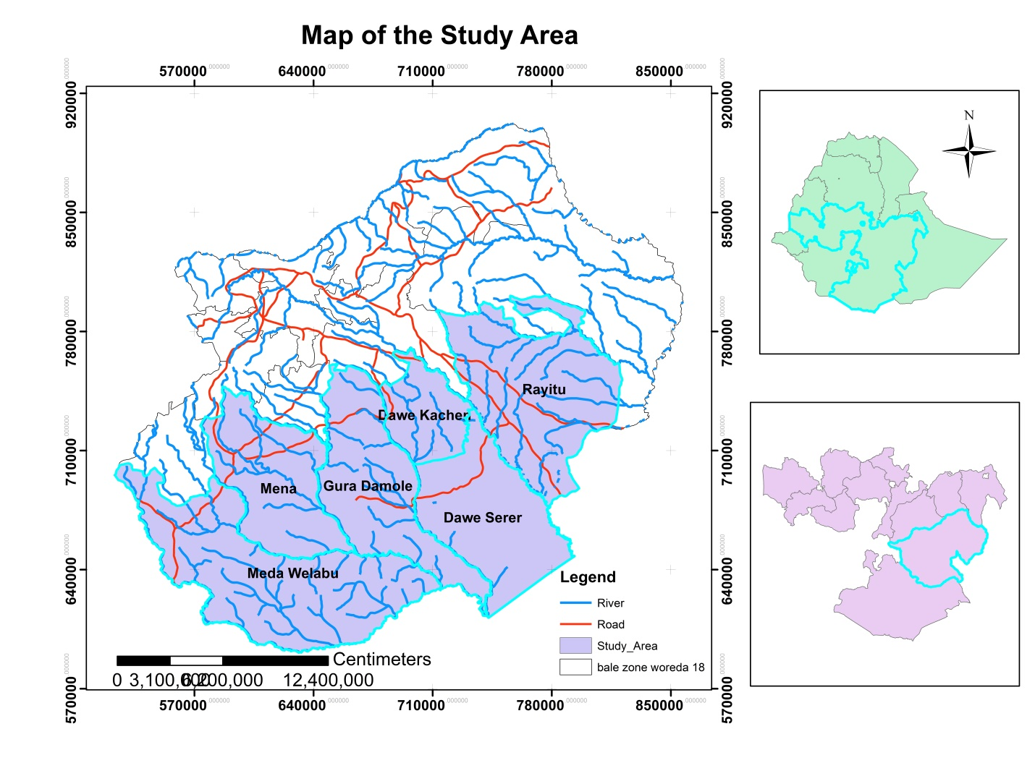
Figure 1: Location of study area

Topography: Bale has a great physiographic diversity. It is characterized by highlands, lowlands and rugged areas, incised river valleys, deep gorges and flat topped plateaus. The surfaces rise from about less than 300m above sea level (Southeast Rayitu, Gurra Damole and Madda Walabu) to a high range culminating into mountain Tulu Dimtu (4377m), the highest peak in the zone. The highland plateaus embrace the Sannate plateaus (Bale Mountain National Parks) and Mount Tulu Dimtu. The highlands of the zone gradually descend in elevation toward southeastern Somalia border, where it drops to less than 500m above sea level (Atlas of Bale zone, 2004). The study area contains six weredas of which two are from bale and four from the East Bale.
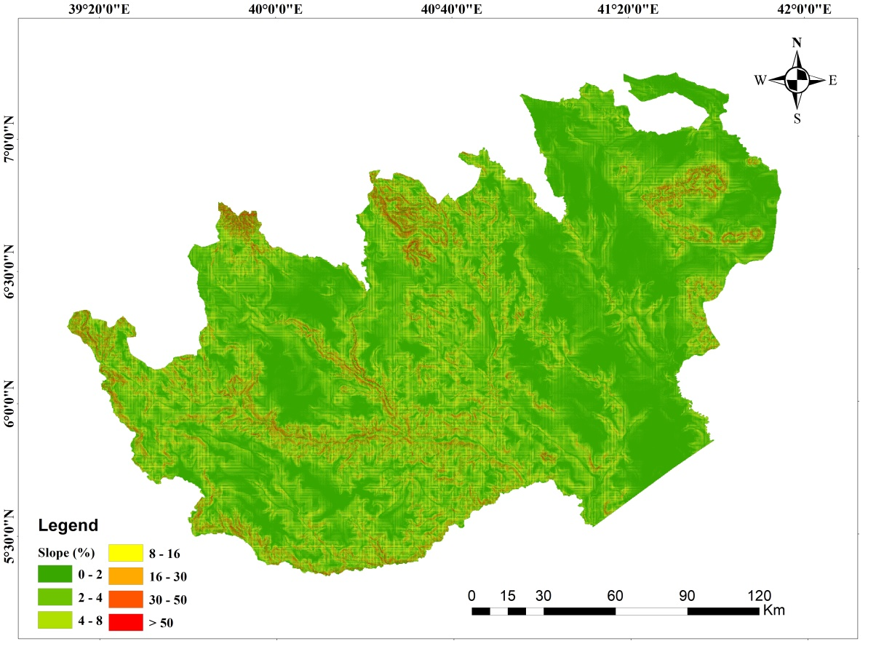
Figure 2 slope map of the study area

Climate: Bale zone has diverse landscape that causes varied microclimate of an area. This accounts for the possibility of producing variety of crops. Climate plays decisive roles on the activities of agriculture. Agriculture, on the other hand, is an important economic sector, on which the life of the majority depended. In addition, climate, particularly, temperature and rainfall are the two determinant elements for the success of agricultural production.
Temperature: Bale zone is characterized by a great diversity of thermal zones as a result of its wide range of altitudinal extents. According to the socio-economic profile of the zone, the temperature is summarized as warm temperature zone, moderately warm temperature zone, moderately cool temperature, and cool thermal zone. In general, the climate of Bale zone is highly governed by altitude and the agro-climate zones.
Rainfall: Bale zone has two types of rainfall regime. These are long rainy season and the two rainy seasons. The long rainy season extends from March to April with high rain fall during June, July and August. The two rainy season of rainfall regime influenced by equatorial westerly and easterly winds with rainfall during spring and autumn.
Vegetation: The distribution of natural vegetation in Bale zone is a direct reflection of altitude and climate. As a result, varied vegetation types which includes: Afro and sub Afro -Alpine vegetation, coniferous forest, junipers forest, podocarpus forest, broad leafed forest, wood land and savanna, grass lands, steppe, gallery, and Halophytic vegetation are found (Atlas of Bale zone, 2004).
Soils: In Bale zone there are about 30 types of soils. The major ones are: Vertisols, Cambisols, Luvisols, Nitosols, Solonchaks and Leptosols (Atlas of Bale zone, 2004). The intensive use of land for crop production in the zone urges the need for maintaining soil fertility.

Data and Materials
SPOT data were collected from Ethiopian Geospatial agency. This digital dataset were imported and integrated in the GIS environment. In addition to this, frequent field observations were carried out to collect the ground truth of Land-use/Land-Cover using handheld Global Positioning System (GPS).
For effective and informative data gathering the study used questioner both close and open-ended questions. The participants are categorized in groups of peoples consisting of Natural resource, SME who are organized for the production of NTFPs. The questionnaires are mainly intended to solicit information required to make qualitative and quantitative analysis on the potential of NTFPs. The entire questionnaires are expected to be held in the language of choice of participants.
Table 1 Data types and sources
Data type |  | Data Sources
GCP |  | GPS reading point to be collected from each LULC
Imageries | Years | Resolution | Sources | Application
Landsat 8 (OLI) | 2020 | 30m | USGS website | Cover Mapping
Spot | Recent | 5m | Ethiopian geospatial agency | Cover map

Table 2 Software’s and Devices
Software and instruments | Application
ArcGIS 10.5 | Data visualization and prepare map layout
ERDAS IMAGINE 2015 | Image preprocessing and classification
Google Earth | Ground verification
GPS (Garmin 72) | Collect Ground Control Point (GCP)

Methods
There are numerous classification methods. From the perspective of the image classification methods, there are two basic categories Object based Image Classification and Pixel based Image Classification methods are available. For this study the OBIA method were used for generating the gum, incense and resin cover map of the study are. To do so, segmentation is always the first step of any process in eCognition developer and it generates the image objects on which the classification process were performed. The important part is for the segmentation process to identify objects which a representative of the features you wish to classify and are distinct in terms of the features available within by using spectral values, shape and texture of the object in the Image. OBIA groups pixels into homogeneous objects. The analyst defines statistics in the classification process to generate land cover. Working with objects rather than pixels have numerous benefits over traditional pixel based analysis (Y. Gao, 2007).
Accessibility of the area is important to collect and export the products easily. Therefore, accessibility of one area are determined by infrastructure development like road and slope the data of road from Ethiopian geospatial agency and slope from digital elevation model of 30m were collected and reclassified and finely the coverage, road and slope data were victories to now the area of NTFPs accessible to collect the product. The flowchart shows the sequential steps involved to carry out this study as shown in Figure 2.

Figure 3 Flow chart

Sample Size and Sampling Techniques

Sampling Techniques
The study utilized different types of sampling techniques for the qualitative and quantitative data analysis parts of the study. For the qualitative analysis, purposive sampling techniques were employed to select respondents. However, simple random sampling methods was applied to identify respondents for the questionnaire survey.

Sample Size
The total sample size were used for the study is determined using (Krejcie, R. V., & Morgan, D. W., 1970) sample size determination formula. Accordingly, the following formula is applied:
$$n=\frac{Z^{2}*N*p*q}{e^{2}\left(N-1\right)+ Z^{2}*p*q}$$
Where,
N = the population size$387326$,
e= 0.05 (since the estimate should be within 5 % of true value)
z = 2.0046 (as per table of area under normal curve for the given confidence level of 95.0%).
n = required sample size and P = the population proportion (assumed to be .50 since this would provide the maximum sample size).

$$n=\frac{{2.0046}^{2}*387326*0.5*0.5}{{0.05}^{2}\left(387326-1\right)+ {2.0046}^{2}*0.5*0.5}$$

$$n=\frac{389,109.74855}{9683125+ 1.0046}$$

$$n=\frac{389,109.74855}{968.32255}$$
$$n=401.8 ≈402$$
Table 3 Sample size proportion of the study area
Location | House hold | Sample size
D/ Kachen | 38,349 | 39.8018672
Dolo Mena | 100,487 | 104.29399
Guradamole | 35,222 | 36.5563995
M/ Welabu | 120,245 | 124.80053
Rayitu | 38,110 | 39.5538126
D/serer | 54,913 | 56.9934009
Total | 387,326 | 402
Source 2017 projected population of bale zone

Method of Data Analysis
This research was employed both qualitative and quantitative research techniques to analyze the socioeconomic data. Quantitative data were analyzed using SPSS and presented using tables percentages, and multiple linear regressions. Besides, qualitative data were analyzed and presented the using descriptive statistics.

Multiple Linear Regressions
Furthermore, Regression analysis was used for explaining or modeling the relationship between a single variable Y called the response, output or dependent variable, and one or more predictor, input, independent or explanatory variables, X₁, X_{2,} ...,Xp. When p =1, it is called simple linear regression but when p>1 it is called multiple regression.
The main objectives of regression analysis include: Prediction of future observations; Assessment of the effect of, or relationship between, explanatory variables on the response; and a general description of data structure. The study were used multiple linear regressions for explaining or modeling the relationship between our response variable, constraints of the production of NTFPS and explanatory variables, and to assess the effects of various explanatory variables on constraints of the production of NTFPS in selected Woredas.
Accordingly the regression model is:
y_{i} = β₀₊ β₁x_{1i+} β₂x_{2i+} β₃x_{3i+} β₄x_{4i+} β₅x_{5i+}ε_{i}
Where y is response variable and represent constraints of the production of NTFPS and x_{1,} x_{2,} x_{3,} x_{4,} and x_{5,} are independent variables and Topography of the habitat ,remoteness, lack of access road transport, labor force and market respectively.
The parameter β₀ is the y-intercept, which represents the expected value of constraints (Y) when each explanatory variable (X) is zero. The other parameters (β₁,...., β₅) in the multiple regression equation are sometimes called partial slopes. In general, each β_{j} ≠ 0 represents the expected change in response (Y) for a unit increase in X_{j} explanatory variable while holding all other explanatory variables constant.

CHAPTER FOUR

Result and Discussion
Natural gums and resins are among dry land resources in Sub-Saharan Africa including Ethiopia that contribute to improved livelihoods of local communities in terms of food security, industrial supply, income generation and foreign exchange earnings.

Coverage and potential of gum, resin and incense products
Ethiopia is supposed to have a large coverage of gum and resin bearing species, widely distributed throughout its arid and semi-arid agro-ecological zones (Tadesse et al., 2002). But there is lack of reliable information on the potential and actual production levels of gums and resins at the national scale in Ethiopia due to poor documentation by purchasing firms and producers, lack of proper forest management and accountable forest product control offices that are responsible for quantifying and/or controlling the production processes, open access harvest and uncontrolled trade of forest products, particularly gums and resins in different parts of the country; and uncontrolled trade across borders with neighboring countries as well as between enterprises in the country.
Even though the production is not well recorded the sector oleo-gum resin collection and sale is reported to provide an income which ranked second after livestock in the livelihood of the pastoral community (Lemenih et al., 2003) and the same author in the year 2005 reviled that Ethiopia exported 13, 299 tons of natural gum and earned Birr 141,064,151 the figure does not include the informal trans-border trade with Somali, Kenya and Sudan. Collection of gums and resins is performed during the dry seasons when the trees have shed their leaves. Good collection is often made between December and February as well as June and August. These months are not only periods for better yield but also time for obtaining good quality gums and resins.

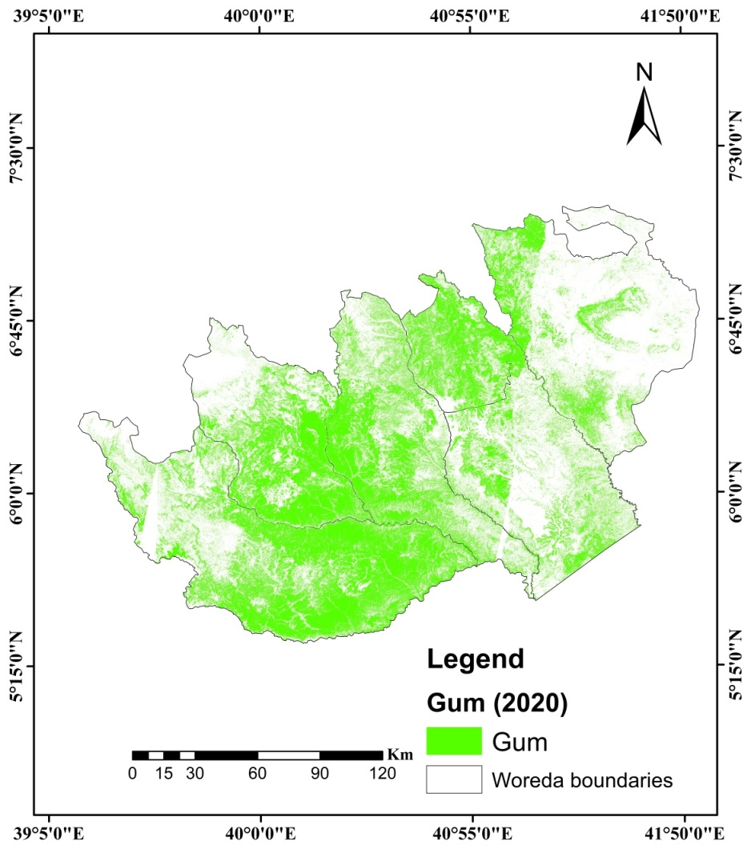
Figure 4 Gum resin and incense potential area
Table (4) shows that the potential of the product the table reviled that the potential of the product in the study area are decreasing due to different reason of deforestation ,overgrazing ,bush encroachment, resettlement and inappropriate tapping e.t.c. Despite the enormous socioeconomic importance of Acacia, Boswellia and Commiphora species, they are declining at an alarming rate due to degradation due to agricultural expansion, overgrazing, fire, poor incense harvesting practices, shifting cultivation, termite and other infestations (Wubalem et al., 2002)
The woody vegetation resources that produce gums and resins are declining both in terms of size (deforestation) and quality of stands (degradation) at an alarming rate associated with expansion of crop and livestock production as well as human settlement, overgrazing, fuel wood and charcoal production, anthropogenic fire and poor tapping practices (Gebrehiwot 2003, Lemenih et al. 2003, Lemenih and Teketay 2003a, Tadesse et al. 2003, Dalle 2004, Dalle et al. 2005, Eshete et al. 2005, Tadesse et al. 2007).
Table 4 potential of gum resin and incense product
How do you see the potential of the product
Response | Frequency | Percent
Increasing | 24 | 5.97
Decreasing | 378 | 94.03
Total | 402

Accessibility of gum, resin and incense products
In order to assess accessibility of the products we try to ask the following question for the respondents. Table (5) shows that dose the production area accessible or not? From the total respondents majority 64.9 % which in account 266 of them replied the answer inaccessible the remaining 33.2% are replied yes which means accessible. Usually the product are dominant on steep rocky slopes, lava flows or sandy valleys, with 950-1,800 m.a.s.l. altitudinal range and temperature of 20-25°C, and rainfall less than 900 mm per year (Vollensen, 1989; Azene et al., 1993, Fitchl and Admasu Adi, 1994).
Table 5 Accessibility of the production area
Accessibility of the production area
Response | Frequency | Percent
Yes | 136 | 33.83
No | 266 | 66.18
Total | 402 | 100

Major Constraints of gum, resin and incense products
The regression analysis is very significant to analyze the statistical relationship of a dependent variable Y with explanatory variables, X₁, X_{2,} ..., Xp. When p =1, it is called simple linear regression but when p>1 it is called multiple regression. The regression analysis is important for predicting future observations and assessment of the effect, or relationship between explanatory variables on the response and a general description of data structure. Among regression analysis, the study used multiple linear regressions for modeling the relationship between dependent and independent variables. The regression model used in the study represents as follows.
$$Y=β0+β1X1+β2X2+β3X3+β4X4+β5X5…+ β11X11$$
Where: Y is the response variable and represents the cause of mobility and X1, X2, X3, X4, and X11, are independent variables of lack of access road, traveling long distance, tack of access to market, steep slope and remoteness, lack of tapping skills, ruggedness of topography, inadequacy of transport services, lack collection equipment ,deforestation, overgrazing and encroachment, respectively. The parameter β0 is the Y-intercept, which represents the expected value of mobility (Y) when each explanatory variable (X) is zero. The other parameters (β1, ...., β5) in the multiple regression equation are sometimes called partial slopes. In general, each β_{j} ≠ 0 represents the expected change in response (Y) for a unit increase in X explanatory variable while holding all other explanatory variables constant.
Hypothesis
lack of access road, traveling long distance, tack of access to market, steep slope and remoteness, lack of tapping skills, ruggedness of topography, inadequacy of transport services, lack collection equipment ,deforestation, overgrazing and encroachment were the independent variables that affect the livestock mobility in Bale lowlands. These variables were used to evaluate livestock mobility in a multiple regression model. The null hypothesis of the study was the independent variables have no power to predict the livestock mobility at a 5% level of significance.

Multiple linear regression of constraints of the production
Eleven independent variables namely lack of access road, traveling long distance, tack of access to market, steep slope and remoteness, lack of tapping skills, ruggedness of topography, inadequacy of transport services, lack collection equipment, deforestation, overgrazing and encroachment were modeled and evaluated in the regression analysis as presented in the table below at 5% level of significance. The ANOVA test shows that the regression model of the variable explained mobility (where F= 28.995; P= 0.05)
Table 6 ANOVA test
ANOVAª
Model |  | Sum of Squares | Df | Mean Square | F | Sig.
1 | Regression | 13.958 | 11 | 1.269 | 28.995 | .000^{b}
1 | Residual | 17.418 | 398 | .044
1 | Total | 31.376 | 409
- Dependent Variable:
- Predictors: (Constant),

Table (6) presented the least-squares estimates of β_{0,} β_{1,} β_{2,} β_{3,} β_{4,} β_{5,} β_{6,} β_{7,} β₈ β_{9,} β_{10,} and β₁₁ that are derived from the multiple regression models. The least-squares estimator of the intercept, β₀ is 2.053and is labeled as constant. The least-squares estimators of -.222,.032, -.007, .115, .028 and .070, -.301, .083, -.148, .181, and.198 are associated with the explanatory variables lack of access road, traveling long distance, tack of access to market, steep slope and remoteness, lack of tapping skills, ruggedness of topography, inadequacy of transport services, lack collection equipment ,deforestation, overgrazing and encroachment, respectively.

Table 7 The results of multiple linear regression analysis
Coefficientsª
Model | Unstandardized Coefficients |  | Standardized Coefficients | T | Sig.
Model | B | Std. Error | Beta | T
(Constant) | 2.053 | .046 |  | 44.718 | .000
Lack of access road | -.222 | .058 | -.377 | -3.805 | .000
Traveling long distance | .032 | .028 | .054 | 1.125 | .261
Lack of access to market | -.007 | .053 | -.011 | -.125 | .901
Steep slope and remoteness | .115 | .056 | .207 | 2.069 | .039
Lack of tapping skills | .028 | .050 | .050 | .555 | .579
Ruggedness of topography | .070 | .029 | .102 | 2.422 | .016
Inadequacy of transport services | -.301 | .044 | -.427 | -6.878 | .000
Lack collection equipment | .083 | .042 | .138 | 1.981 | .048
Deforestation | -.148 | .030 | -.268 | -4.924 | .000
Overgrazing | .181 | .055 | .198 | 3.299 | .001
Encroachment | .198 | .052 | .297 | 3.832 | .000

Hypothesis test of multiple linear regression model
At least one β j ≠ 0; this merely says that there is some predictive value somewhere in the set of predictors (lack of access road, traveling long distance, tack of access to market, steep slope and remoteness, lack of tapping skills, ruggedness of topography, inadequacy of transport services, lack collection equipment ,deforestation, overgrazing and encroachment) (Table 7). Because the p-value, shown as .000, is less than 0.05, The H0 is rejected and it is possible to conclude that one or more of our independent variables has some predictive power of predicting the response variable causes for constraint at 5% level of significance. Accordingly, because the P-value of lack of access to road, as the constraint of production, is much less than 0.05, it is possible to conclude there is significant evidence to reject the H0: β1=0. Thus, access to road is the major cause of constraint and has additional predictive power in the presence of the other ten explanatory variables. Access to water resources decreases the constraints of production by 22.2 units as compared to its absence when the rest variables are kept constant. The extent of inadequacy of transport has significantly influenced the production and its P-value is less than 5% level of significance. Hence, it can be concluded that there is significant evidence to reject the null hypothesis H0: β2=0. Thus, the extent of inadequacy of transport has additional predictive power in the presence of the other four explanatory variables. For a unit increase in the level of inadequacy of transport, the chances of constraint decrease by 30.1 units when the rest variables remain constant.
As the P-values for traveling long distance, lack of access to market, steep slope and remoteness ,lack of tapping skills, ruggedness of topography, lack collection equipment and overgrazing are greater than 0.05, we can conclude that there is no significant evidence to reject the null hypothesis at 5% level of significance. Thus, the above variables have no additional predictive power in the presence of the other four explanatory variables.

Goodness of fit of multiple linear regression model
Table 10 presented the overall model summary of five variables used in the study. Accordingly, R, R square and Adjusted R Square of the model were .667ª, .445 and .430, respectively. Hence, it is possible to define the coefficient of determination as to the proportion of the variation in the responses Y that is explained by the model relating Y to X1, X2, ..., X11. Therefore, the study revealed that 44.5% of the variability of constraint was due to lack of access road, traveling long distance, tack of access to market, steep slope and remoteness, lack of tapping skills, ruggedness of topography, inadequacy of transport services, lack collection equipment ,deforestation, overgrazing and encroachment
Table 8 Model summary
Model Summary^{b}
Model | R | R Square | Adjusted R Square | Std. Error of the Estimate
1 | .667ª | .445 | .430 | .209

According to w.Taddese 2007 the major constraint in the production of gum resin product are remoteness as well as the rugged and undulating topography of the habitat where the gum producing species grow, lack of access roads and infrastructure/ facilities such as residential quarters and inadequacy of transport facilities to the potential production areas, equipment and supplies, collection and transportation of harvested natural gums very difficult. This is true in the study area as you have seen it in the figure (3) of the potential areas of the product found in remote and rugged topographic area and which is very far from the main infrastructure of road and from the center of the town that is why the production is not as such satisfactory regarding to the potential in the study area.
Besides, Deforestation, over grazing, resettlement and other land use change impacts. Clearing of the woodlands for farming and settlement, deliberately set fire, and harvesting for fuel wood are becoming the major threat to the future of the oleo-gum resin producing vegetation’s as well as the biological resources associated with them (Abeje, 2002). According to legese and Balew , 2021, bushland, farmland and settlement rapidly expanded at the expense of other land covers. In the contrary, grassland and shrubland have declined from 1990 to 2020. Forest cover also slightly decreased during the study period. The study also revealed that land covers were degraded from time to time due to human-induced problems mainly the rapid expansion of farmland and settlement. Continuous land degradation combined with bushland encroachment also affects the potential of the product. Not only this together with other damages such as overgrazing, fire and clearance for agriculture, improper tapping is causing a widespread damage including hampering natural regenerations. (Tadesse et.al,2007). The result of the study also supports the above findings.
Furthermore, Inappropriate tapping observed that the proportion of trees damaged/attacked by the unidentified worm was higher in tapped trees than those with untapped trees (Abeje, 2002) Lack of trained manpower in tapping natural gums, interference from human and domestic animals have, in one way or another, contributed to the low volume and quality of products (Girmay, 2002)
Severe deforestation rate and fire regime are also another threats in the area, that affecting the productivity of gum and resin bearing species, genetic diversity of woodland species composition and ecological importance of dryland (WBISPP, 2005).
According to Limenih and Kassa 2011, The major factors challenging gums and resins production in ethiopia are Lack of access to roads, Lack of health facilities, Lack of water, Poor food availability and Shortage of labour force.
The woody vegetation resources that produce gums and resins are declining both in terms of size (deforestation) and quality of stands (degradation) at an alarming rate associated with expansion of crop and livestock production as well as human settlement, overgrazing, fuelwood and charcoal production, anthropogenic fire and poor tapping practices (Gebrehiwot 2003, Lemenih et al. 2003, Lemenih and Teketay 2003a, Tadesse et al. 2003, Dalle 2004, Dalle et al. 2005, Eshete et al. 2005, Tadesse et al. 2007).
Worku et.al2011, Despite the big potential of gums and resins to contribute to the development and conservation of drylands, there are several constraints that affect their full utilization in the Borana lowlands. The major identified constraints were: a lack of appropriate institutions and capacity, infrastructure facilities, appropriate tapping knowledge/technologies, access to market, market information and fair markets prices, or scarcity of capital, established cooperatives awareness by local communities about the sustainable management and utilization of woodlands containing gum and resin resources; conversion of the woodlands to farmlands; overgrazing; recurrent drought; bush encroachment; termites attacking woody species; traditional taboo, which considers collection of gums and resins to be business of the poor.
Most of the large populations of gum and resin bearing species are located far from residence centers and usually off roads, on sites characterized by a lack of potable water, high temperatures, and disease prevalence such as malaria. Gums and resins have thus to be transported several kilometers to access the available markets, usually carried by humans since there are no other means of transportation. The current low prices associated to such a tedious production activity are discouraging not only local harvesters but also the private sector. A significant number of respondents (about 61%) complained about the lack of appropriate technologies that increase efficiency and quality of products collected from the woodlands.

Conclusion and Recommendation

Conclusion
Ethiopia is supposed to have a large coverage of gum and resin bearing species, widely distributed throughout its arid and semi-arid agro-ecological zones. Even though the production is not well recorded the sector oleo-gum resin collection and sale is reported to provide an income which ranked second after livestock in the livelihood of the pastoral community. The potential of the product the in the study area reviled that the potential of the product in the study area are decreasing due to different reason of deforestation ,overgrazing ,bush encroachment, resettlement and inappropriate tapping.
Regarding to accessibility of the product area majority respondents replied the answer inaccessible the remaining 33.2% are replied accessible.no only in the study usually the product are dominant on steep rocky slopes, lava flows or sandy valleys.
Finally the major constraint in the production of gum resin product are remoteness as well as the rugged and undulating topography of the habitat where the gum producing species grow, lack of access roads and infrastructure/ facilities such as residential quarters and inadequacy of transport facilities to the potential production areas, equipment and supplies, collection and transportation of harvested natural gums very difficult.

Recommendation
- The country in general and the regional government in particular can’t get appropriate benefit from the resource due to lack of reliable information and poor documentation on the potential and actual production levels of gums and resins therefore the national government should by pass appropriate documentation strategy to control the production level.
- Potential of the product in the study area are decreasing due to different reason of deforestation ,overgrazing ,bush encroachment, resettlement and inappropriate tapping
- Usually the product are dominant on steep rocky slopes, lava flows or sandy valleys
- The regional government in collaboration with NGOs should solve the issue of infrastructure since the major factors challenging gums and resins production in Ethiopia are lack of infrastructure like access to roads, of health facilities, water, Poor food availability and Shortage of labour forces e.t.c.
- The study focus on potential and accessibility and constraint of non-timber forest products therefore further study is mandatory regarding to socio economic importance the product for the pastoralist of Ethiopia.

Reference
ADEFIRES WORKU a , MULUGETA LEMENIH b , MASRESHA FETENE c & DEMEL TEKETAY ,SOCIO-ECONOMIC IMPORTANCE OF GUM AND RESIN RESOURCES IN THE DRY WOODLANDS OF BORANA, SOUTHERN ETHIOPIA , Forests, Trees and Livelihoods, 2011, Vol. 20, pp. 137–156 © 2011 A B Academic Publishers—Printed in Great Britain
Alesso, S. P., P. Araujo, and R. Tapias. 2003. Aprovechamiento de la Goma de Brea en Bosque Secundarios del Parque Chaqueno Seco. Influencia del Tama ~ no de las Heridas ~ sobre la Produccion. Quebracho 10:60–70.
Asfaw H., Thulin M., 1989. Mimosoideae. In: Flora of Ethiopia, pittosporaceae to araliaceae (Hedberg I., Edwards S., eds). The National Herbarium, Biology Department, Addis Ababa University and The Department of Systematic Botany, Uppsala University, Vol. 3. Addis Ababa. pp 71-96.
Azene B., Birnie A., Tengnas B., 1993. Useful trees and shrubs for Ethiopia. Identification, propagation and management for agricultural and pastoral communities. Regional Soil Conservation Unit, SIDA, Nairobi.
Chikamai B., 1996. A review of production, markets and quality control of Gum Arabic in Africa. Technical cooperation programme. FAO of the United Nations. Project No. TCP/RAF/4557. Rome.
CSA .1999. Statistical Abstract (1998). Addis Ababa.
Cossalter C., 1991. Acacia senegal: gum tree with promise for agroforestry. NFT Highlights, No. 91-02.
Dagnew Y., 2006. Population status of Acacia Senegal (Linne) willdenow and its gum quality in the central rift valley of Ethiopia. MSc Thesis. The Department Of Farm Forestry, Wondo Genet College Of Forestry, School of Graduate Studies Awassa University, Awassa, Ethiopia. 77 pp.
Eshete, A. Sterck, F. and Bongers, F., 2011. Diversity and production of Ethiopian dry woodlands explained by climate and soil stress gradients. Forest Ecology and Management 261: 1499-1509.
Eshete, A., Sterck, F.J., and Bongers, F., 2012. Frankincense production is determined by tree size and tapping frequency and intensity. Forest Ecology and Management 274: 136-142.
F.A.O. (Food and Agricultural Organization), 1995. Flavours and fragrances of plant Origin. Non-wood forest products 1, Rome.
Farah A.Y., 1994. The milk of the Boswellia forests: frankincense production among the pastoral somali. Uppsala University, Uppsala.
Garriga, M., and H. Haas. 1997. Informaciones sobre la Recoleccion, Elaboraci on y Comercializacion de la Goma de Brea, A ´ rbol de las Regiones Semiaridas y A´ ridas de la Argentina. Quebracho 5:70–76.
Getachew D., Wubalem T., 2004. Socio-economic importance and resource potential of Non-Timber Forest Products of Ethiopia. Proceedings on conservation of genetic resources of Non Timber Forest Products (NTFPs) in Ethiopia. EARO-IPGRI, 5-6 April 2004, Addis Ababa, Ethiopia. pp. 13-36.
Girmay F., 2000. The status of gum arabic and resins in Ethiopia. Report of the Meeting of the Network for Natural Gum and Resins in Africa (NGARA) 29th-31st May, Nairobi, Kenya. pp. 14-22.
Holmes I., 1997. Gum Arabic – Life in a saturated market. In: Conservation, management and utilization of plant gums, resins and essential oils (Mugah J.O., Chikamai B.N., Mbiru S.S., Casadei E., eds). Proceedings of a Regional Conference for Africa Held in Nairobi, Kenya, 6-10 October 1997. Nairobi.
Lemenih, M. and Kassa, H. (eds) 2011 Opportunities and challenges for sustainable production and marketing of gums and resins in Ethiopia. CIFOR, Bogor, Indonesi
Lemenih, M., Teketay, D., 2003. Frankincense and myrrh resources of Ethiopia: II. Medicinal and industrial uses. SINET: Ethiopian Journal of Science 26, 161–172.
Lemenih, M., Teketay, D., 2004. Natural gum and resin resources: opportunity to integrate production with conservation of biodiversity, control of desertification and adapt to climate change in the drylands of Ethiopia. In: Proceedings of a Workshop on Conservation of Genetic Resources of Non Timber Forest Products (NTFPs) in Ethiopia, 5–6 April 2004. Addis Ababa, pp. 37–49
Maclachlan M., Getaneh E., Tafere F., 2002. Manaual of highland Ethiopian trees and shrubs. Revised and expanded. English and Amharic version. Prepared for development agents of «dega» areas in Regon 3. SIM Forestry study project. Injibara, Awi zone, Region Ethiopia. 465 pp.
Mulugeta L., Tarekegn A., Olsson M., 2003. Gum and resin resources from some Acacia, Boswellia and Commiphora species and their economic contribution in Liban, Southeastern Ethiopia. Journal of Arid Environments 55, 465-482.
Semegnew and Abiyot 2016. Diversity and Regeneration Status of Gum and Resin Bearing Woody Species In Gambella Low Land, Southwest Ethiopia.
Tadesse W, Desalegn G, Alia R (2007) Natural gum and resin bearing species of Ethiopia and their potential applications. Forest Systems 16: 211-221.
Tadesse W, Teketay D, Lemenih M, Fitwi G (2002) Country report for Ethiopia. Review and Synthesis on the State of Knowledge of Boswellia Species and Commercialization of Frankincense in the Dry Lands of Eastern Africa, Food and Agriculture Organization of the United Nations, Rome, pp: 14-31.
Vollesen K., 1989. Burseraceae. In: Hedberg I., Edwards S., eds. Flora of Ethiopia, Volume 3. National Herbarium, Addis Abeba University, Addis Abeba and Uppsala University, Uppsala. pp. 442-478.
Von Mu¨ller, A. R., R. O. Coirini, and U. O. Karlin. 2007. Evaluacion socioec onomica de la produccion de goma de brea en el Chaco A ´ rido. Multequina 16:83–98.
WBISP (Woody Biomass Inventory and Strategic Plan project), 2004. Forest Resources of Ethiopia, Addis Abeba.
W. Tadesse , G. Desalegn and R. Alia 2007, Natural gum and resin bearing species of Ethiopia and their potential applications. Investigación Agraria: Sistemas y Recursos Forestales 2007 16(3), 211-221 ISSN: 1131-7965

